99 Time

Short Description

**Summary**

Make mine a 99! 99 Time Slots is a mouthwatering online slot game based on the popular ice cream commercial. The reels are filled with ice cream cones, sundaes and ice cream trucks, which are sure to have you licking your lips for more as you win big! There are FREE Spins, Scatters and Wilds, giving you loads of chances for some delicious wins! You don’t want to miss the ice cream truck, so play 99 Time Slots now!

**Formats**

* Stand Alone
* Embedded
* Mobile

**Recommended categories**

* Sweet Slots

Marketing Materials

The materials can be downloaded from [here](https://files.eyecon.com/index.php/s/OZwEhRtUaUIKbEK)

Screenshots

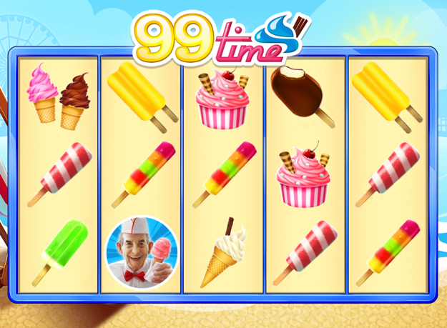

Game Properties & Features

|  |  |
| --- | --- |
| **Properties** | |
| Versions | Standalone, Mini, Mobile |
| RTP (%) | 95 |
| Number of Reels | 5 |
| Number of Lines | 25 |
| Min. Bet | 1 credit |
| Max Bet | 50 credits |
| Game Play | Hard |
| Volatility | High |
| Hit Rate playing 1 line | 1 in 24.8 |
| Combined Feature Hit Rate | 1 in 134.7 |
| Default Bet | 1 credit per line |
| Supports Free Spins | Yes |
| **Features** | |
| Free Spins | Up to 25 |
| Substitute | Prizes are doubled |
| Prize Pick Feature | Up to 100X your bet |