AUTUMN GOLD

Short Description

Harvest your fortunes in this year’s bumper slot Autumn Gold! Play a leafy 9 lines across 3 golden reels. Rake in your fortunes with 9 golden Free Games and jump into the exciting Prize Pick feature. It’s your chance to have your pie and eat it too!

Marketing Materials

The materials can be downloaded from [here](https://files.eyecon.com/index.php/s/pnJGPUleGEKnjFk)

Screenshots

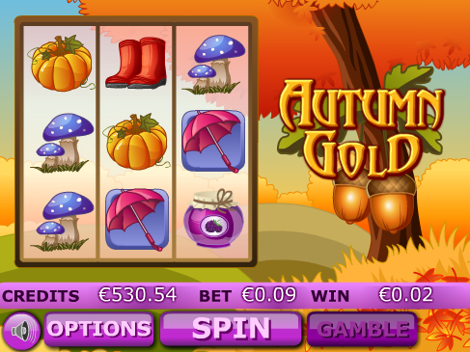

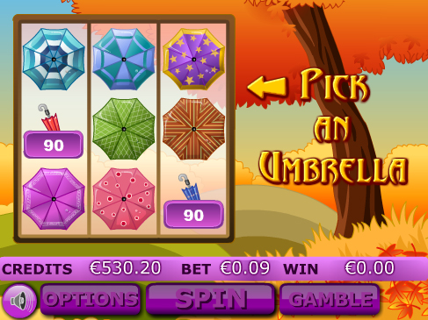

Game Properties & Features

|  |  |
| --- | --- |
| **Properties** | |
| Versions | Mini, Mobile |
| RTP (%) | 95 |
| Number of Reels | 3 |
| Number of Lines | 15 |
| Min. Bet | 1 credit |
| Max Bet | 900 credits |
| Game Play | Hard |
| Volatility | High |
| Hit Rate playing 1 line | 1 in 16 |
| Combined Feature Hit Rate | 1 in 75 |
| Default Bet | 1 credit per line |
| Supports Free Spins | Yes |
| Recommended Categories | * Flowers, Fruit & Veg * Big Wins/Volatile |
| **Features** | |
| Free Spins | Up to 15 |
| Substitute | Autumn Gold Logo |