Game Information for Native Casino App

Introduction
This document aims to capture game information and images for the Native Casino app. Please fill out all the yellow boxes.
This document is required for each game.

General information

Game name
What is the name of your game and the translation to Simplified Chinese? Include a trade mark if applicable.
English | Autumn Gold
Simplified Chinese | 金秋
Traditional Chinese | 金色秋季
Japanese | オータムゴールド
Korean | 오텀 골드
Malay | Emas Musim Luruh
Spanish | Otoño dorado

Game code
What is the game code?
pop_autumngold_eye

Winning lines or ways (slot games only)
How many winning lines or ways does your game have?
9 Line

Jackpot
Are jackpots supported in your game? If so, state the jackpot identifier.
Via another game code yes – but this game code is for the non jackpot version

Bet per lines
What is the default bet per line ranges? Please provide in different currencies if such information is available
GBP|EUR|USD [ 1, 2, 5, 8, 10, 15, 20, 30, 50, 75, 100, 125, 150, 200, 250, 300, 500, 1000 ]

Game descriptions
Provide a description of your game in a few sentences for all the lobby languages:
Languages | Description
English (International) | Autumn Gold Slots is a 3 reel and 9 payline online slot game, featuring beautiful autumn colours and symbols such as boots and an umbrella, pumpkins, cute squirrels and, of course, autumn leaves. The weather may be getting a bit cooler, but the wins in Autumn Gold are hotter than ever! It’s a quick and easy game to play with loads of chances to win some generous prizes! So, grab your autumn coat and start spinning now! You won’t regret it.
Chinese Simplified | 《金秋》是一款设有 3 个卷轴和 9 条赔付线的在线老虎机游戏，游戏以美丽金秋为景，融入靴子和雨伞、南瓜、可爱松鼠和秋叶等图案。也许天气转凉，但金秋世界却因奖金而热力四射！游戏轻松快速，有大量赢取丰厚奖金的机会！立即披上秋季外套，转动卷轴吧！您一定不会后悔。
Chinese Traditional | 《金色秋季》是一款 3 捲軸、9 條獲勝線的線上老虎機遊戲，帶有漂亮的秋季主題顏色和各種圖案，包括靴子、傘、南瓜、可愛的松鼠，當然還有深秋的落葉。天氣或許開始轉涼了，但《金色秋季》的獲勝熱度可是只增不減！這款遊戲節奏快、玩法簡單，且可輕鬆贏得各種大獎！披上你的秋季外套，現在就開始遊戲吧！你不會後悔的。
Japanese | オータムゴールドスロットは、3リールと9つのペイラインを有するオンラインスロットゲームです。美しいオータムカラーやブーツ、傘、カボチャ、かわいいリス、落ち葉などのシンボルをフィーチャーしています。気候は涼しくなってきているかもしれませんが、オータムゴールドでのウィンはどこよりも熱いです！高額賞金を獲得するチャンスが多く、誰でも簡単に、素早くプレイすることができます。オータムコートを手に取って今すぐスピンを開始しましょう！絶対に後悔はしません。
Korean | 오텀 골드 슬롯은 3 개의 릴과 9 개의 페이라인이 있는 온라인 슬롯 게임으로, 부츠와 우산, 호박, 귀여운 다람쥐와 물론, 가을 단풍과 같은 아름다운 가을 색들과 심벌들이 특징입니다. 날씨가 조금 더 시원해질 수 있지만, 오텀 골드의 승리는 그 어느 때 보다 더 뜨겁습니다! 이것은 관대한 상금들을 받을 수 있는 많은 기회들을 가지고 플레이하는 빠르고 쉬운 게임입니다! 이제, 당신의 가을 코트를 붙잡고 지금 스핀을 시작하세요! 후회하지 않을 것입니다.
Malay | Slot Autumn Gold ialah permainan slot dalam talian 3 gelendong dan 9 garis bayaran, menampilkan warna dan simbol musim luruh yang menarik seperti buk dan payung, labu, tupai comel dan, tentu sekali daun musim luruh. Cuaca mungkin menjadi lebih dingin, tetapi kemenangan dalam Autumn Gold Luruh adalah lebih panas daripada sebelum ini! Ini ialah permainan yang cepat dan mudah untuk dimainkan dengan banyak peluang untuk memenangi beberapa hadiah yang lumayan! Jadi, ambil kot musim luruh anda dan mula memutar sekarang! Anda tidak akan menyesal.
Spanish | Autumn Gold Slots es una tragaperras en línea de 3 rodillos y 9 líneas de pago, con hermosos colores y símbolos otoñales, tales como botas, un paraguas, calabazas de Halloween, ardillas y, por supuesto, hojas caídas. El clima puede ser algo más fresco en otoño, ¡pero los premios de Autumn Gold están que arden! ¡Es un juego rápido y fácil de jugar con muchas posibilidades de ganar generosos premios! ¡Saca el abrigo del armario y empieza a girar los rodillos! No te arrepentirás.

Images
Note: the assets should be placed in the folders which have the following structure:
- icons with game names should be placed here: games\<game_code>\icons\icons_with_game_names\

Screenshots
The following screenshots are required on mobile in landscape. In case game is available in Portrait only, then screenshots in Portrait (461 x 819) should be provided.
Image type | Screenshot name | Dimensions | Format
Main game in English | screen_<game_code>_main | 819 x 461 | PNG
Significant win in English | screen_<game_code>_big_win | 819 x 461 | PNG
Bonus scene in English | screen_<game_code>_bonus | 819 x 461 | PNG

Game icons
The following game icons are required:
Image Name | Dimensions | Format | Where used in app | Screenshot
<game_code>_icon_5x5 | 240 x 240 | PNG | Quick Switch between games feature | 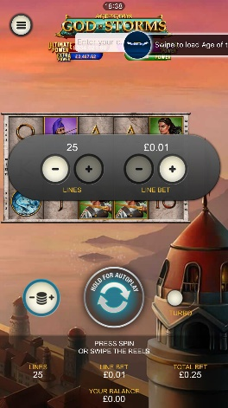
<game_code>_icon_10x10 | 540 x 540 | PNG | Main WL layout: game tiles icons in Lobby, on Game Advisor, Broken games etc. | 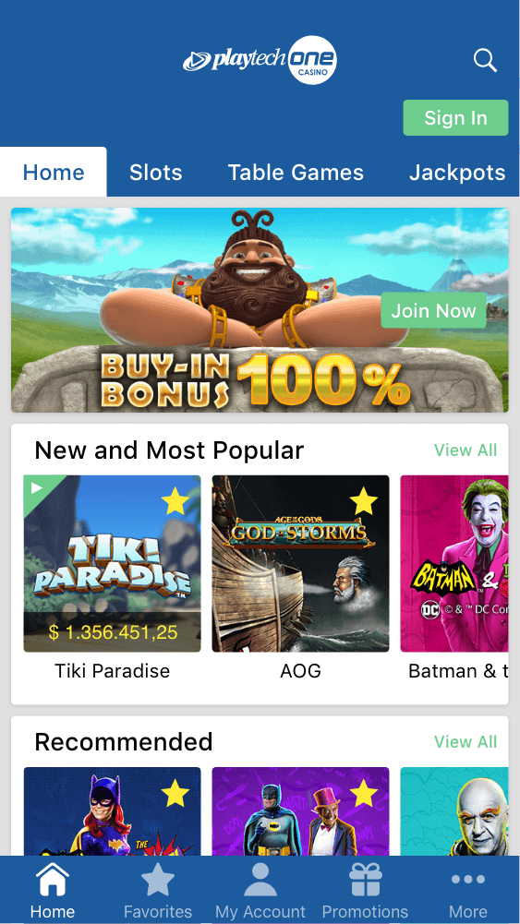  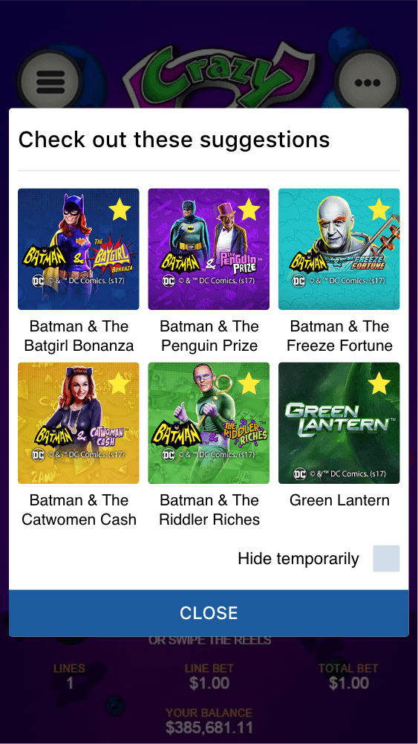
<game_code>_icon_30x5 | 1104 x 336 | PNG | Game Info screen header for tablets | 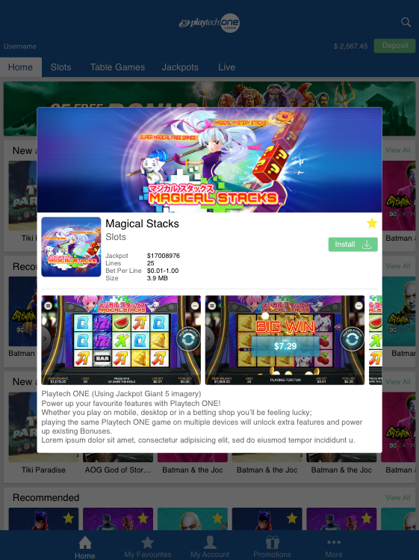
<game_code>_icon_30x10 | 1788 x 540 | PNG | My Favourites screen | 