Game Information for Native Casino App

Introduction
This document aims to capture game information and images for the Native Casino app. Please fill out all the yellow boxes.
This document is required for each game.

General information

Game name
What is the name of your game and the translation to Simplified Chinese? Include a trade mark if applicable.
English | Bouncy Balls 2
Simplified Chinese | 弹弹球2
Traditional Chinese | 彈彈球2
Japanese | バウンシーボール2
Korean | 바운시 볼 2
Malay | Bola Melantun 2
Spanish | Pelotas saltarinas 2

Game code
What is the game code?
pop_bfad477a_eye

Winning lines or ways (slot games only)
How many winning lines or ways does your game have?
n/a (reactors style game)

Jackpot
Are jackpots supported in your game? If so, state the jackpot identifier.
Via another game code yes – but this game code is for the non jackpot version

Bet per lines
What is the default bet per line ranges? Please provide in different currencies if such information is available
GBP|EUR|USD [10, 20, 50, 100, 200, 300, 400, 500, 1000, 1500, 2000 ]

Game descriptions
Provide a description of your game in a few sentences for all the lobby languages:
Languages | Description
English (International) | Playtech’s legendary Bouncy Balls is back! Boasting an amazing Eyecon make-over including stunning graphics and a Free Spin feature, Bouncy Balls 2 will keep you on your toes. Match 5 or more of the familiar faces consecutively and the bouncy balls will explode, allowing more symbols to take their place - but keep an eye out for new additions to the team. Spin to form Clusters by landing 5 or more of the same symbols linked horizontally or vertically. This triggers Cascades where new balls will drop in, giving the chance for new Clusters to form and more wins for the player. This game will leave you bouncing for joy!
Chinese Simplified | Playtech的传奇弹弹球荣誉回归了！弹弹球2有着令人惊叹的眼魂外观，包括精美的图案和免费旋转功能，让你目不转睛。连续匹配5个或更多熟悉的面孔，弹球就会爆炸，让更多的符号取代它们的位置——但是要注意团队中的新成员。通过水平或垂直相连的5个或更多相同符号，旋转形成集群。这会触发瀑布，新球会落进来，就有机会形成新的集群，同时玩家更有可能获胜。这款游戏一定会让你高兴得手舞足蹈！
Chinese Traditional | Playtech的傳奇彈彈球榮譽回歸了！彈彈球2有著令人驚歎的眼魂外觀，包括精美的圖案和免費旋轉功能，讓你目不轉睛。連續匹配5個或更多熟悉的面孔，彈球就會爆炸，讓更多的符號取代它們的位置——但是要注意團隊中的新成員。通過水平或垂直相連的5個或更多相同符號，旋轉形成集群。這會觸發瀑布，新球會落進來，就有機會形成新的集群，同時玩家更有可能獲勝。這款遊戲一定會讓你高興得手舞足蹈！
Japanese | Playtechのあの伝説のバウンシーボールが帰って来た！驚愕のグラフィックとフリースピン機能を含む Eyecon の素晴らしいリメイクが際立つ、バウンシーボール２はあなたをとりこにしてしまいます。親しんだ5つ以上の顔を一列に並べるとバウンシーボールは破裂します。さらにシンボルが登場でき、一団に加える新たな追加キャラにも目を配りましょう。スピンをかけて、同じシンボルを5個以上縦か横に連ねるクラスターを作り出しましょう。これにより、カスケードには新たなボールが降りて来ます。新しいクラスターを作り、プレイヤーにはより多くの賞金が得られるチャンスが生まれます。バウンシーボールで弾みながらお楽しみを！
Korean | Playtech의 전설적인 Bouncy Balls가 돌아왔습니다! 놀라운 그래픽과 프리 스핀 기능 등 Eyecon을 통해 새롭게 달라진 Bouncy Balls 2는 긴장을 놓을 새를 주지 않습니다. 5개 이상의 익숙한 면을 연속으로 맞추면 바운시 볼이 폭발하며 더 많은 심볼이 그 자리를 차지합니다. 팀에 새로 추가되는 내용을 잘 살펴보세요. 스핀을 돌려 수직 또는 수평으로 5개 이상의 같은 심볼을 맞춰 클러스터를 만들어보세요. 캐스케이드가 발동되어 새로운 볼이 떨어져 새로운 클러스터로 더 많은 당첨금을 딸 기회가 제공됩니다. 즐거움이 팡팡 튀는 게임을 만나보세요!
Malay | Bola Melantun legenda Playtech kini kembali! Dengan pembaharuan Eyecon hebat termasuk grafik menakjubkan dan ciri Putaran Percuma, Bola Melantun 2 akan memastikan ada terhibur. Padan 5 atau lebih muka biasa secara berturut dan bola melantun akan meletup, yang membenarkan lebih banyak simbol untuk menggantikannya - tetapi perhatikan tambahan baharu kepada pasukan. Putar untuk bentukkan Kluster dengan mendapatkan 5 atau lebih simbol yang sama secara menegak atau melintang. Ini mencetuskan Kaskad di mana bola baru jatuh, dengan peluang membentuk Kluster baru dan lebih banyak kemenangan untuk pemain. Permainan ini akan menggembirakan anda!
Spanish | ¡La legendaria Pelotas saltarinas de Playtech ha vuelto! Con un cambio de imagen increíble a manos de Eyecon y gráficos impresionantes y una función de tirada gratis, Pelotas saltarinas 2 te tendrá muy atento. Combina 5 o más de las caras tan familiares consecutivamente y las pelotas saltarinas explotarán, permitiendo que aparezcan más símbolos. ¡Pero no pierdas atención a los nuevos añadidos al equipo! Tira para formar Grupos consiguiendo 5 o más símbolos iguales unidos horizontal o verticalmente. Esto activa Cascadas donde caigan nuevas pelotas, permitiendo que se formen nuevos Grupos y más victorias para el jugador. ¡Este juego te dejará saltando de alegría!

Images
Note: the assets should be placed in the folders which have the following structure:
- icons with game names should be placed here: games\<game_code>\icons\icons_with_game_names\

Screenshots
The following screenshots are required on mobile in landscape. In case game is available in Portrait only, then screenshots in Portrait (461 x 819) should be provided.
Image type | Screenshot name | Dimensions | Format
Main game in English | screen_<game_code>_main | 819 x 461 | PNG
Significant win in English | screen_<game_code>_big_win | 819 x 461 | PNG
Bonus scene in English | screen_<game_code>_bonus | 819 x 461 | PNG

Game icons
The following game icons are required:
Image Name | Dimensions | Format | Where used in app | Screenshot
<game_code>_icon_5x5 | 240 x 240 | PNG | Quick Switch between games feature | 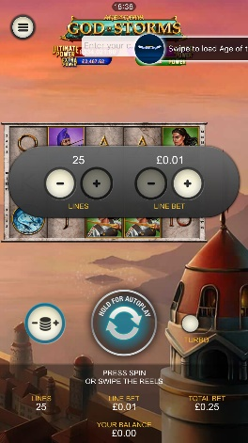
<game_code>_icon_10x10 | 540 x 540 | PNG | Main WL layout: game tiles icons in Lobby, on Game Advisor, Broken games etc. | 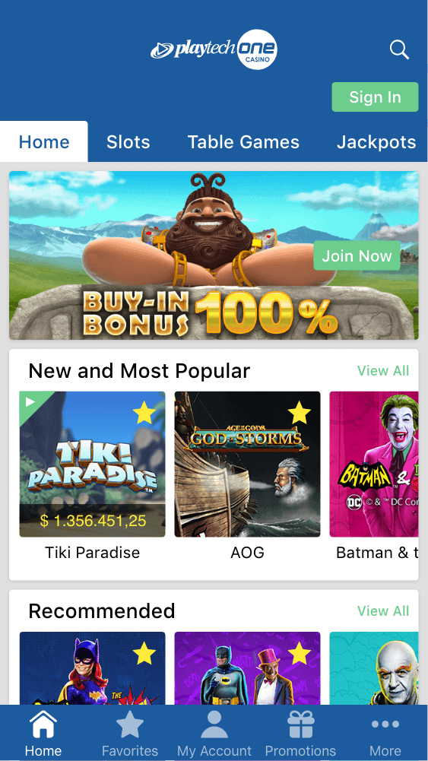  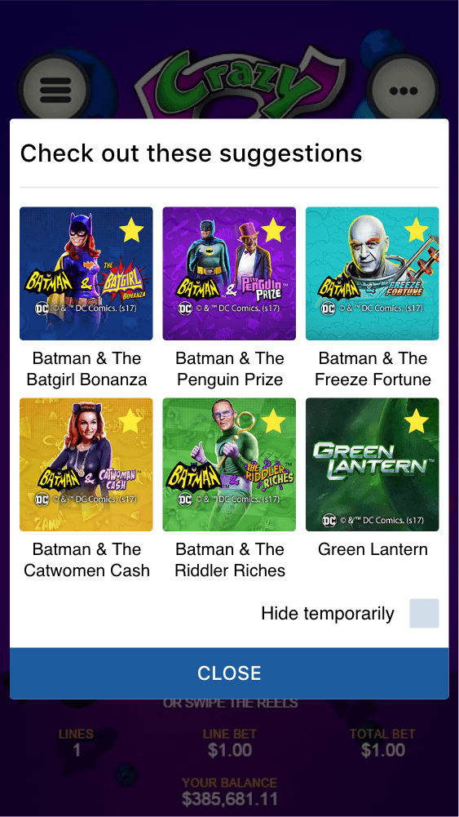
<game_code>_icon_30x5 | 1104 x 336 | PNG | Game Info screen header for tablets | 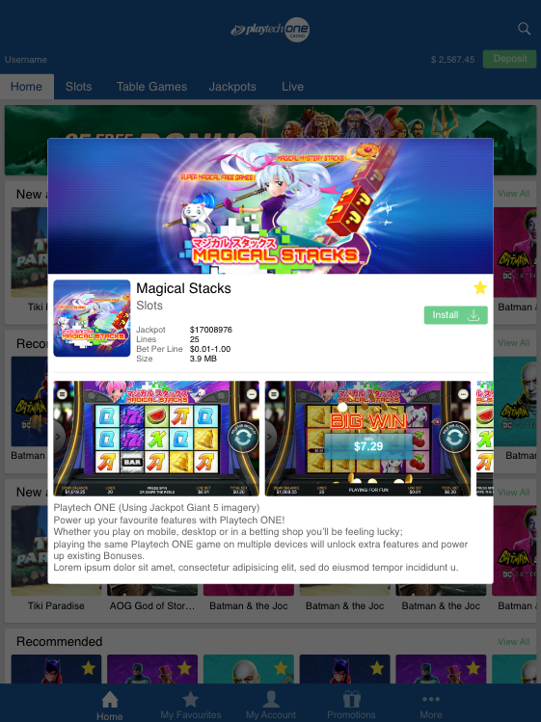
<game_code>_icon_30x10 | 1788 x 540 | PNG | My Favourites screen | 