Game Information for Native Casino App

Introduction
This document aims to capture game information and images for the Native Casino app. Please fill out all the yellow boxes.
This document is required for each game.

General information

Game name
What is the name of your game and the translation to Simplified Chinese? Include a trade mark if applicable.
English | Champions of Poseidon
Simplified Chinese | 波塞冬的勇士
Traditional Chinese | 波賽冬的衛士
Japanese | ポセイドンの王者
Korean | 포세이돈의 챔피언
Malay | Juara Poseidon
Spanish | Campeones de Poseidón

Game code
What is the game code?
pop_156162cf_eye

Winning lines or ways (slot games only)
How many winning lines or ways does your game have?
25 lines

Jackpot
Are jackpots supported in your game? If so, state the jackpot identifier.
Via another game code yes – but this game code is for the non jackpot version

Bet per lines
What is the default bet per line ranges? Please provide in different currencies if such information is available
GBP|EUR|USD [1, 2, 3, 4, 5, 6, 8, 10, 15, 20, 25, 30, 40, 50, 60, 80, 100, 200 ]

Game descriptions
Provide a description of your game in a few sentences for all the lobby languages:
Languages | Description
English (International) | Join the gods of the sea in Champions of Poseidon and spin for glory in this 5-reel, 3-row adventure through Atlantis, where you can win up to 800 x your bet.  Journey deep into the ocean to discover Poseidon's palace in the Free Games feature. Pay close attention to reel three, where a trident symbol may land to trigger the trident feature, which sees blasts from the trident shooting out across the reels to turn random symbols into Wilds.  This game is locked at 25 lines. The number of lines can not be changed.
Chinese Simplified | 在波塞冬的勇士中加入海神的行列，在这款5转轴、3行的亚特兰蒂斯冒险游戏中为荣耀而旋转，最高可赢得800x赌注的奖金。  在免费特色游戏中，深入海洋，探索波塞冬的宫殿。请密切关注转轴三，三叉戟符号可能会出现在这里，从而触发三叉戟特色游戏。三叉戟会在转轴上喷射出火焰，将随机符号变为百搭符号。  该游戏锁定为25条线。线数不可更改。
Chinese Traditional | 在這款5捲軸3行的亞特蘭蒂斯歷險遊戲中，加入海神的行列，成為波賽冬的衛士，旋轉贏得高達投注金額800倍的獎金。  潛入深海，在免費遊戲功能中找到波賽冬的宮殿。重點關注捲軸三，如果三叉戟符號落在捲軸上就可以觸發三叉戟功能，三叉戟的射線會射向捲軸，將隨機符號變成百搭符號。  該遊戲會鎖定使用25條線。線數無法改變。
Japanese | 海の神々と共に、ポセイドンの王者で栄光を求めて5リール、3列の冒険を進んで、アトランティスを訪れましょう。最大でベットの800倍を獲得することができます。  海の奥深くまで潜り、フリーゲームフィーチャーでポセイドンの宮殿を発見してください。トライデントシンボルが着地するとトライデントフィーチャーが発動し、リール全体に向けてトライデントからの爆風が飛び出してランダムなシンボルをワイルドに変えるリール3に注目しましょう。  このゲームは25ラインで固定されています。ラインの数は変更できません。
Korean | 포세이돈의 챔피언에서 바다의 신들과 함께 5릴, 3열로 구성된 아틀란티스 어드벤처에서 영광을 향해 스핀을 돌리고 베팅한 금액의 최대 800배를 획득하세요.  무료 게임 기능에서 깊은 바다 속을 여행하며 포세이돈의 궁전을 발견하세요. 3번째 릴에 삼지창 심볼이 나타나면 삼지창에서 발사되는 폭발이 릴을 가로질러 무작위 심볼을 와일드로 바꾸는 삼지창 기능이 작동될 수 있으므로 주의 깊게 살펴보시기 바랍니다.  이 게임은 25개의 라인으로 고정되어 있습니다. 라인 수는 변경할 수 없습니다.
Malay | Sertai Dewa dewi laut dalam Juara Poseidon dan berputar untuk kegemilangan dalam pengembaraan 5 kekili, 3 baris ini melalui Atlantis, di mana anda boleh memenangi sehingga 800 x pertaruhan anda.  Mengembara jauh ke dalam lautan untuk menemui istana Poseidon dalam ciri Permainan Percuma. Beri perhatian pada kekili tiga, di mana simbol trisula mungkin mendarat untuk mencetuskan ciri trisula, yang melihat letupan daripada trisula memanah keluar melintasi kekili untuk menukar simbol rawak menjadi Liar.  Permainan ini dikunci pada 25 baris. Bilangan baris tidak boleh diubah.
Spanish | Únase a los dioses del mar en Campeones de Poseidón y gire para alcanzar la gloria en esta aventura de 5 carretes y 3 filas por la Atlántida, donde podrá ganar hasta 800 veces su apuesta.  Viaje a lo más profundo del océano para descubrir el palacio de Poseidón en la función de Partidas Gratis. Preste atención al carrete tres, donde puede aparecer un símbolo de tridente para activar la función Tridente, que hará que el tridente lance descargas a los carretes para convertir símbolos aleatorios en Comodines.  Este juego se juega con 25 líneas, y el número de líneas no puede cambiarse.

Images
Note: the assets should be placed in the folders which have the following structure:
- icons with game names should be placed here: games\<game_code>\icons\icons_with_game_names\

Screenshots
The following screenshots are required on mobile in landscape. In case game is available in Portrait only, then screenshots in Portrait (461 x 819) should be provided.
Image type | Screenshot name | Dimensions | Format
Main game in English | screen_<game_code>_main | 819 x 461 | PNG
Significant win in English | screen_<game_code>_big_win | 819 x 461 | PNG
Bonus scene in English | screen_<game_code>_bonus | 819 x 461 | PNG

Game icons
The following game icons are required:
Image Name | Dimensions | Format | Where used in app | Screenshot
<game_code>_icon_5x5 | 240 x 240 | PNG | Quick Switch between games feature | 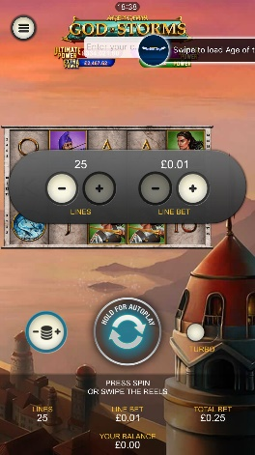
<game_code>_icon_10x10 | 540 x 540 | PNG | Main WL layout: game tiles icons in Lobby, on Game Advisor, Broken games etc. | 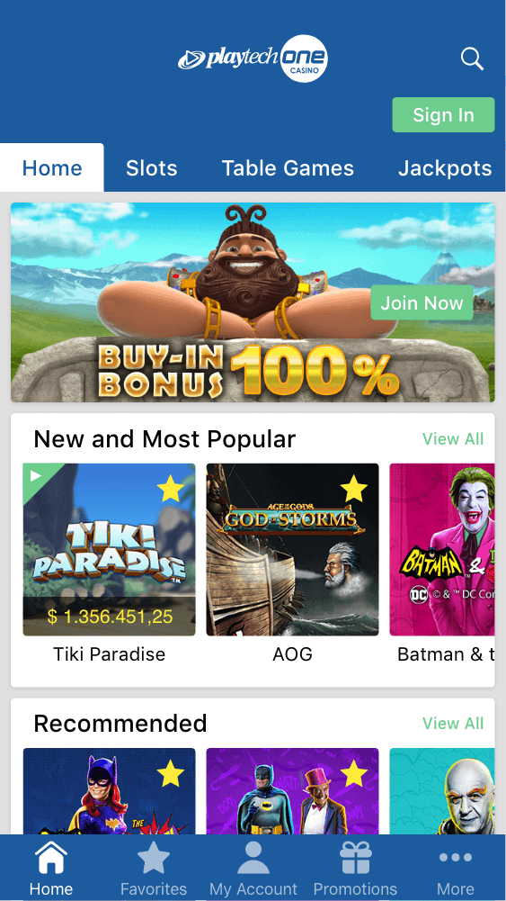  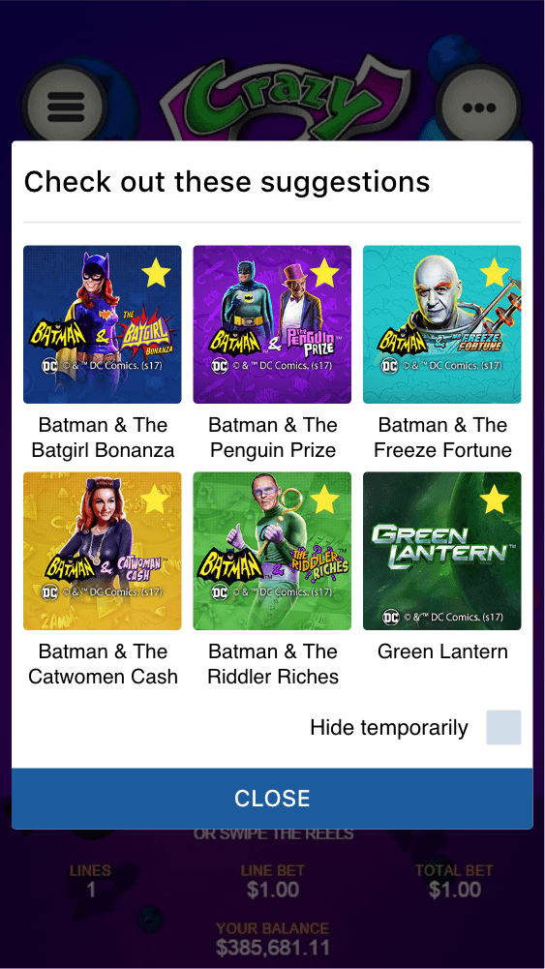
<game_code>_icon_30x5 | 1104 x 336 | PNG | Game Info screen header for tablets | 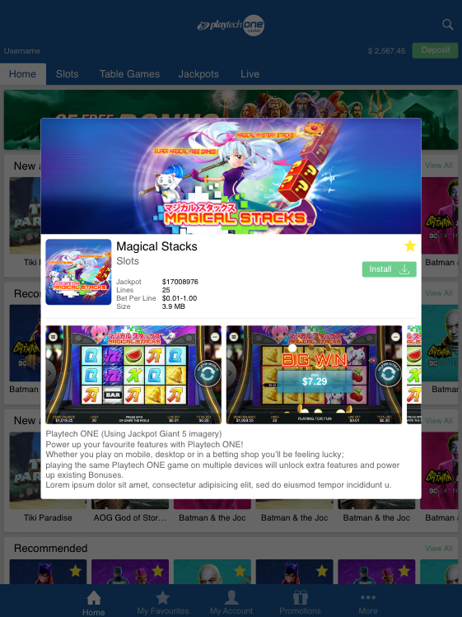
<game_code>_icon_30x10 | 1788 x 540 | PNG | My Favourites screen | 