CHENG GONG

Short Description

Travel the path of success in this new, feature-packed slot game, Cheng Gong! Win big as you advance your way through the Prize Pick levels and watch the alluring Princess reveal your fortunes! Golden Dragons lock-in even more roaring riches in the Dragon Respins feature! Red lanterns light up the path to prosperity as Free Games are bestowed upon you! Today is a good day for success!

Marketing Materials

The materials can be downloaded from [here](https://files.eyecon.com/index.php/s/YqWlRGzTeMsBKHM)

Screenshots

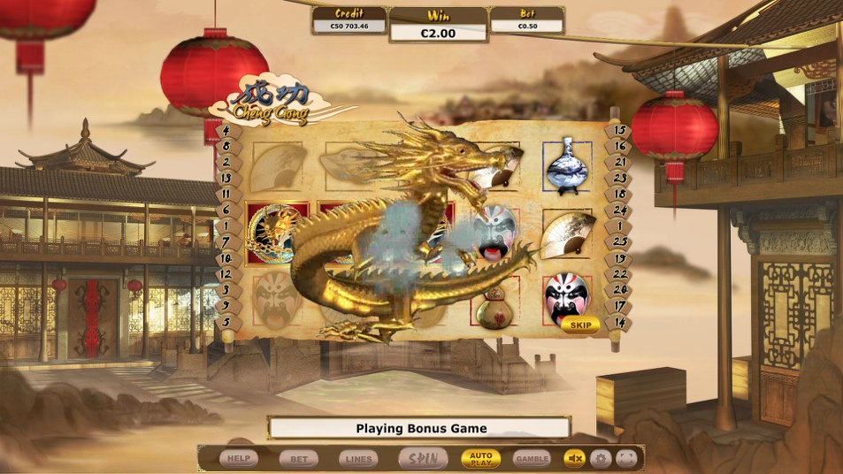--

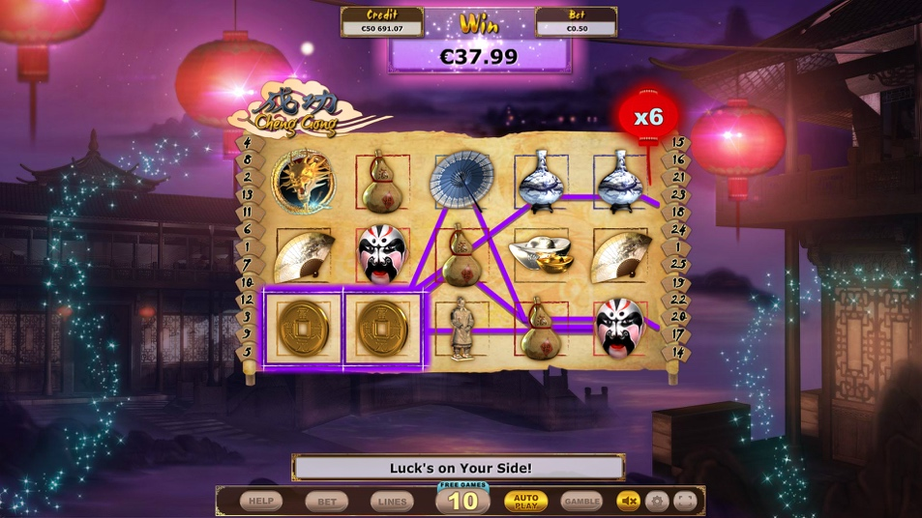Game Properties & Features

|  |  |
| --- | --- |
| **Properties** | |
| Versions | Standalone |
| RTP (%) | 95 |
| Number of Reels | 5 |
| Number of Lines | 25 |
| Min Bet | 1 credit |
| Max Bet | 50 credits |
| Game Play | Medium |
| Volatility | High |
| Hit Rate playing 1 line | 1 in 16.5 |
| Combined Feature Hit Rate | 1 in 102.5 |
| Default Bet | 1 credit per line |
| Supports Free Spins | Yes |
| Recommended Categories | * Adventure * Oriental * Fantasy * Big Wins/Volatile |
| **Features** | |
| Free Spins | Up to 25 |
| Substitute | Doubles Prizes |
| Prize Pick Feature | 30X or 100X total wager |