Game Information for Native Casino App

Introduction
This document aims to capture game information and images for the Native Casino app. Please fill out all the yellow boxes.
This document is required for each game.

General information

Game name
What is the name of your game and the translation to Simplified Chinese? Include a trade mark if applicable.
English | Crystal Furnace
Simplified Chinese | 水晶熔炉
Traditional Chinese | 水晶熔爐
Japanese | クリスタル ファーネス
Korean | 수정 용광로
Malay | Relau Kristal
Spanish | Horno de Cristal

Game code
What is the game code?
pop_af943ab4_eye

Winning lines or ways (slot games only)
How many winning lines or ways does your game have?
10 lines

Jackpot
Are jackpots supported in your game? If so, state the jackpot identifier.
Via another game code yes – but this game code is for the non jackpot version

Bet per lines
What is the default bet per line ranges? Please provide in different currencies if such information is available
GBP|EUR|USD [1, 2, 5, 10, 12, 15, 20, 25, 35, 50, 60, 75, 100, 200, 250, 500 ]

Game descriptions
Provide a description of your game in a few sentences for all the lobby languages:
Languages | Description
English (International) | Stoke your fire and get ready for Crystal Furnace. Experience the thrill and danger of swordsmithing. Land a hammer to watch as the molten steel pours down the reels to reveal expanding symbols and re-spins.Pays both ways to give you the biggest win. Test your steel in Crystal Furnace.
Chinese Simplified | 点燃炉火，为《水晶熔炉》准备预热。体验炼剑的刺激和重重风险。挥下铁锤，留意倾泻而下的钢水，它会落入卷轴揭开扩展符号和重新旋转。双管齐下，助你赢取最高奖金。在水晶熔炉检验钢铁。
Chinese Traditional | 點燃爐火，準備為《水晶熔爐》預熱。體驗鑄劍的驚險與刺激。揮舞鐵錘，注意奔流而下的鐵水，它會落入捲軸並揭開擴展符號和重新旋轉。雙管齊下，助你贏取最高獎金。在水晶熔爐試驗鋼鐵品質。
Japanese | 火をつけて、クリスタル ファーネスの準備をしましょう。刀鍛冶のスリルと危険を体験しましょう。ハンマーを当てると、溶けた鋼がリールに注がれ、拡大するシンボルとリスピンが表示されます。最大の勝利をもたらすために両方の方法で支払います。クリスタル ファーネスで鋼をテストしましょう。
Korean | 불을 지피고 수정 용광로를 준비하십시오. 검술의 스릴과 위험을 경험해 보십시오. 강철이 녹아 릴을 따라 흘러내리는 것을 보기 위해 망치를 내려놓으면 확장 심볼과 재스핀이 나타납니다. 두 가지 방법으로 모두 지불하면 가장 큰 승리를 거둘 수 있습니다. 수정 용광로에서 강철을 테스트하십시오.
Malay | Nyalakan api anda dan bersedia untuk Relau Kristal. Alami keseronokan dan bahaya penempaan pedang. Masukkan tukul untuk menyaksikan keluli cair mencurah ke dalam gelendong untuk mendedahkan simbol yang mengembang dan berputar semula. Membayar kedua-dua cara untuk memberi anda kemenangan terbesar. Uji keluli anda dalam Relau Kristal.
Spanish | Alimente su fuego interior y prepárese para el Horno de Cristal. Experimente la emoción y el peligro de la forja de espadas. Golpee con el martillo para ver cómo el acero fundido se derrama por los rodillos, revelando símbolos que se expanden y vuelven a girar. Premios en ambos sentidos, para obtener la mayor ganancia. Ponga a prueba su acero en el Horno de Cristal.

Images
Note: the assets should be placed in the folders which have the following structure:
- icons with game names should be placed here: games\<game_code>\icons\icons_with_game_names\

Screenshots
The following screenshots are required on mobile in landscape. In case game is available in Portrait only, then screenshots in Portrait (461 x 819) should be provided.
Image type | Screenshot name | Dimensions | Format
Main game in English | screen_<game_code>_main | 819 x 461 | PNG
Significant win in English | screen_<game_code>_big_win | 819 x 461 | PNG
Bonus scene in English | screen_<game_code>_bonus | 819 x 461 | PNG

Game icons
The following game icons are required:
Image Name | Dimensions | Format | Where used in app | Screenshot
<game_code>_icon_5x5 | 240 x 240 | PNG | Quick Switch between games feature | 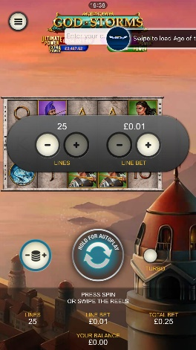
<game_code>_icon_10x10 | 540 x 540 | PNG | Main WL layout: game tiles icons in Lobby, on Game Advisor, Broken games etc. | 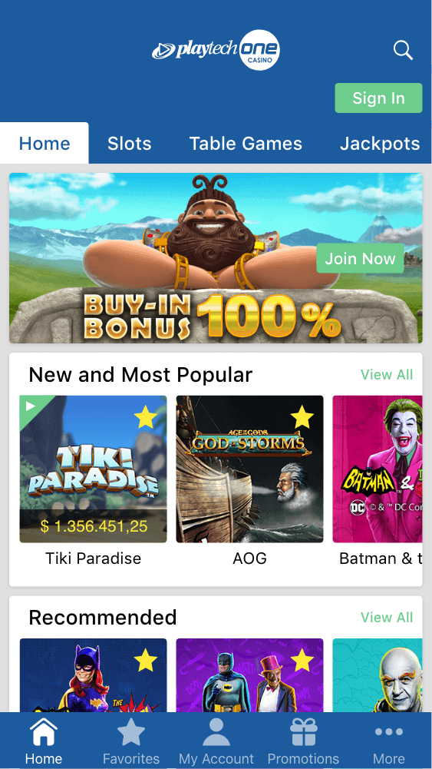  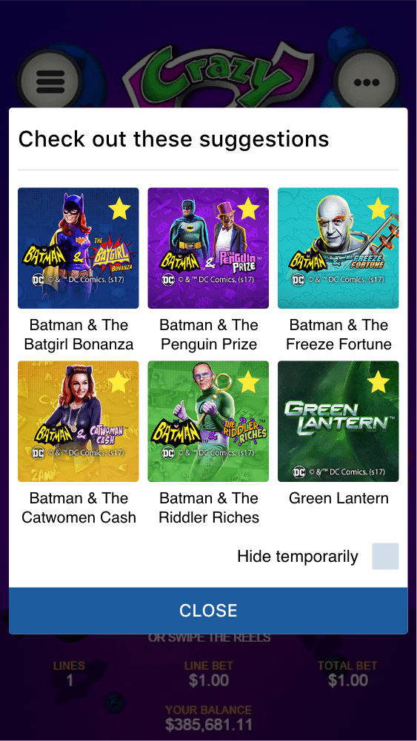
<game_code>_icon_30x5 | 1104 x 336 | PNG | Game Info screen header for tablets | 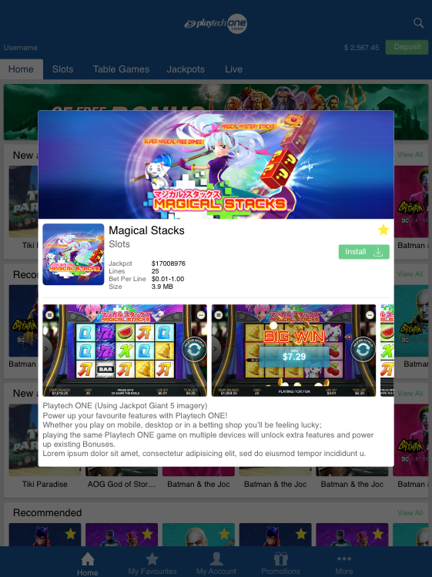
<game_code>_icon_30x10 | 1788 x 540 | PNG | My Favourites screen | 