CUP CARNAVAL

Short Description

Party in Brazil at the Cup Carnaval! Make a noise and celebrate your victories when you score up to 25 Free Games! Move your feet to the Samba beat as you triple your prizes when the Ball substitutes in a winning combination!

Marketing Materials

The materials can be downloaded from [here](https://files.eyecon.com/index.php/s/k6ZuTsAvL1ycKgj)

Screenshots

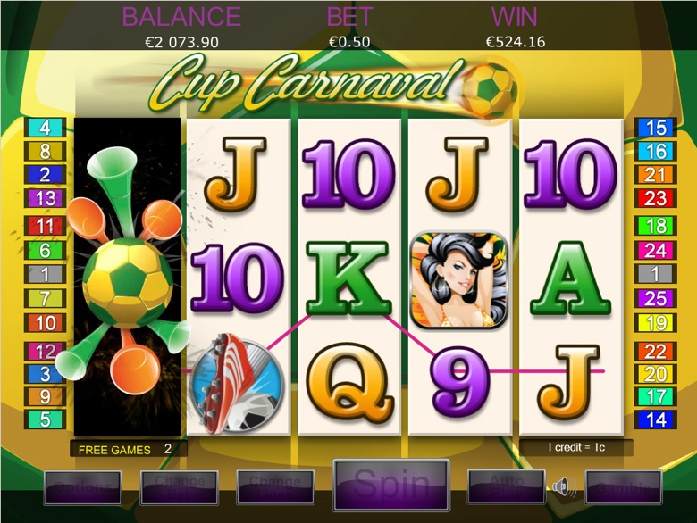

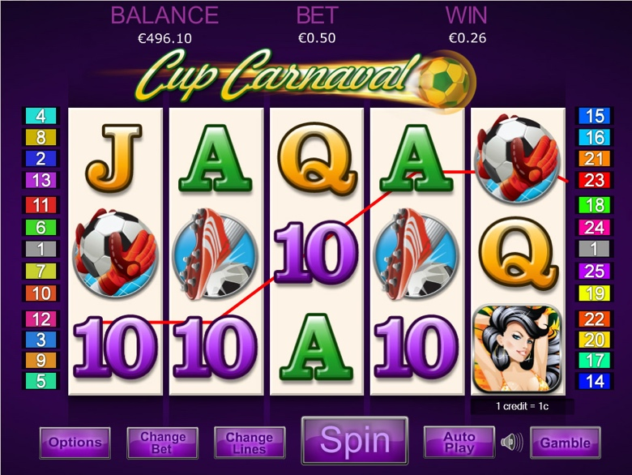

Game Properties & Features

|  |  |
| --- | --- |
| **Properties** | |
| Versions | Standalone, Mini, Mobile |
| RTP (%) | 95 |
| Number of Reels | 5 |
| Number of Lines | 25 |
| Min. Bet | 1 credit |
| Max Bet | 12 credits |
| Game Play | Medium |
| Volatility | High |
| Hit Rate playing 1 line | 1 in 8 |
| Combined Feature Hit Rate | 1 in 100 |
| Default Bet | 2p/line playing 25 lines |
| Supports Free Spins | Yes |
| Recommended Categories | * Festive/Seasonal – Football Cup Carnaval * Big Wins/Volatile |
| **Features** | |
| Free Spins | Up to 25 |
| Substitute | Football Symbol triples prizes |