CUPIDS ARROW

Short Description

Watch Cupid’s Arrow bring you love and fortune with 5 free games! Match the clouds and capture the flying hearts to reveal hidden riches in the exciting features! Cupid has all you need for love, fun and excitement in this action-packed game! How can you not love it?!

Marketing Materials

The materials can be downloaded from [here](https://files.eyecon.com/index.php/s/0MskoPF7Jfimcvk)

Screenshots

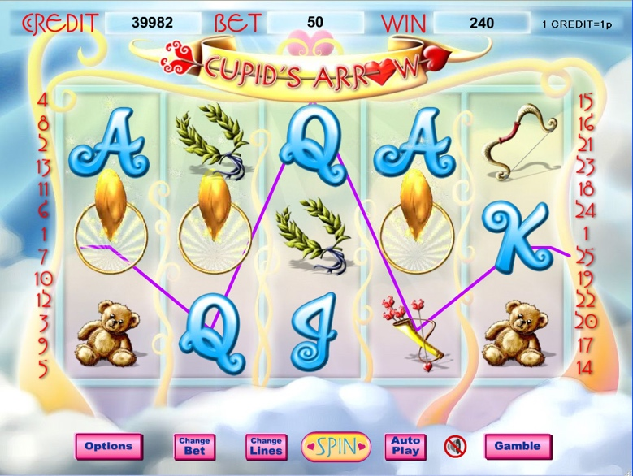



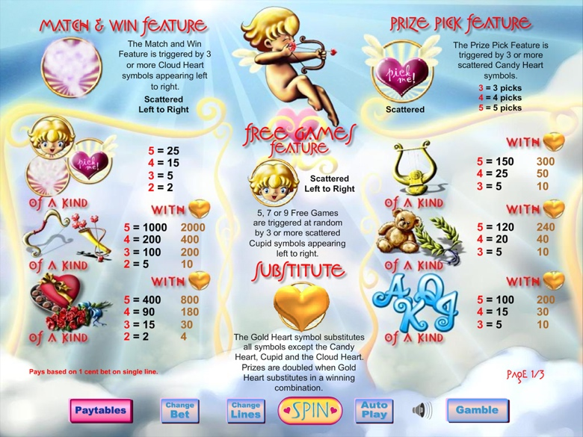

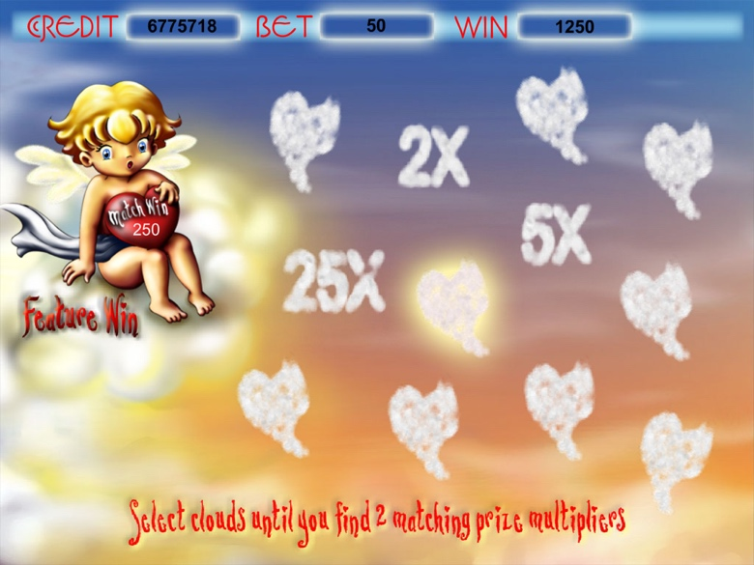

Game Properties & Features

|  |  |
| --- | --- |
| **Properties** | |
| Versions | Standalone |
| RTP (%) | 95 |
| Number of Reels | 5 |
| Number of Lines | 25 |
| Min. Bet | 1 credit |
| Max Bet | 1250 credits |
| Game Play | Medium |
| Volatility | Soft |
| Hit Rate playing 1 line | 1 in 8.6 |
| Combined Feature Hit Rate | 1 in 110 |
| Default Bet | 2 credits/line playing 25 lines |
| Supports Free Spins | Yes |
| Recommended Categories | * Festive/Seasonal – Valentine’s Day * Fantasy |
| **Features** | |
| Free Spins | Up to 9 |
| Substitute | Gold Heart Symbol |
| Prize Pick Feature | Triggered by 3 or more Candy Heart Symbols |
| Match & Win Feature | Triggered by 3 or more Cloud Hear Symbols |