DOTING DOGGIES

Short Description

Fun is your best friend in this delightful slot full of all your favourite canine pals! 25 lines of pampered pooches brings you fun and adventure over 5 massive reels. Doggie dollars are yours for the taking with triple prizes over 15 fun-filled Free Games!

Marketing Materials

The materials can be downloaded from [here](https://files.eyecon.com/index.php/s/K0FK1uKKxVcTl0L)

Screenshots

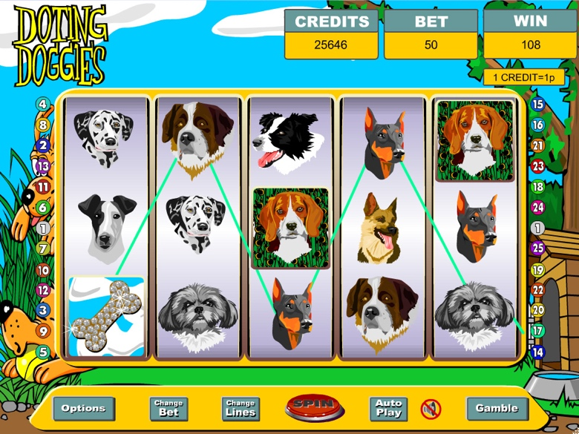

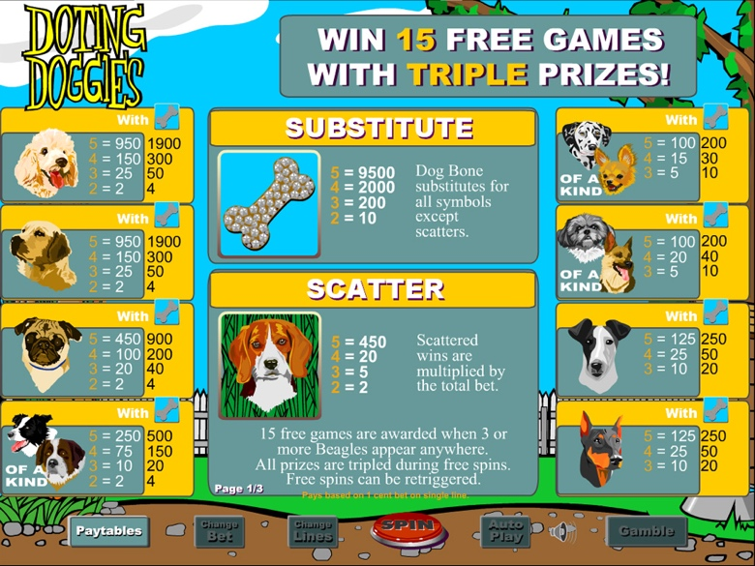

Game Properties & Features

|  |  |
| --- | --- |
| **Properties** | |
| Versions | Standalone |
| RTP (%) | 95 |
| Number of Reels | 5 |
| Number of Lines | 25 |
| Min. Bet | 1 credit |
| Max Bet | 1,250 credits |
| Game Play | Medium |
| Volatility | Medium |
| Hit Rate playing 1 line | 1 in 7.5 |
| Combined Feature Hit Rate | 1 in 113 |
| Default Bet | 2 credits/line playing 25 lines |
| Supports Free Spins | Yes |
| Recommended Categories | * Cute Animals |
| **Features** | |
| Free Spins | Up to 25 & Win up to 100X total bet during feature |
| Bonus Round | Triggered by 3 or more Beagles |
| Substitute | Bone Symbol |