DOUBLEUP DUCKS

Short Description

Roll up, roll up with Doubleup Ducks! Catch the circus side alley excitement of tripling your prizes with 15 free games! Don’t miss the cute prizes which can double and triple your wins.

Marketing Materials

The materials can be downloaded from [here](https://files.eyecon.com/index.php/s/Gh35a3UxASWVLtu)

Screenshots

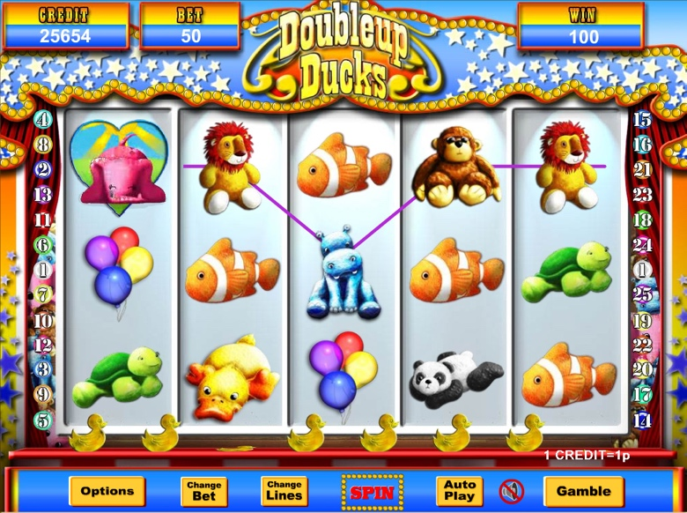

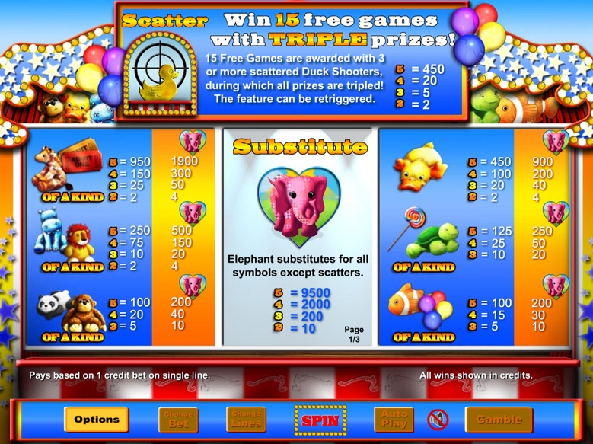

Game Properties & Features

|  |  |
| --- | --- |
| **Properties** | |
| Versions | Standalone, Mini, Mobile |
| RTP (%) | 95 |
| Number of Reels | 5 |
| Number of Lines | 25 |
| Min. Bet | 1 credit |
| Max Bet | 1,250 credits |
| Game Play | Medium |
| Volatility | Low |
| Hit Rate playing 1 line | 1 in 8 |
| Combined Feature Hit Rate | 1 in 116 |
| Default Bet | 1 credit per line |
| Supports Free Spins | Yes |
| Recommended Categories | * Popular * Progressive Jackpots |
| **Features** | |
| Free Spins | Up to 15 |
| Substitute | Elephant Symbol doubles prizes |