Game Information for Native Casino App

Introduction
This document aims to capture game information and images for the Native Casino app. Please fill out all the yellow boxes.
This document is required for each game.

General information

Game name
What is the name of your game and the translation to Simplified Chinese? Include a trade mark if applicable.
English | Dynamite Digger Eureka!
Simplified Chinese | 炸药掘金人之惊天大发现！
Traditional Chinese | 炸藥掘金人之驚天大發現！
Japanese | ダイナマイトディガーエウレカ！
Korean | 다이너마이트 디거 유레카!
Malay | Eureka Penggali Dinamit!
Spanish | Excavadora de Dinamita Eureka!

Game code
What is the game code?
pop_12e8e4c7_eye

Winning lines or ways (slot games only)
How many winning lines or ways does your game have?
20 lines

Jackpot
Are jackpots supported in your game? If so, state the jackpot identifier.
Via another game code yes – but this game code is for the non jackpot version

Bet per lines
What is the default bet per line ranges? Please provide in different currencies if such information is available
GBP|EUR|USD [1, 3, 5, 10, 20, 30, 40, 50, 60, 70, 80, 90, 100 ]

Game descriptions
Provide a description of your game in a few sentences for all the lobby languages:
Languages | Description
English (International) | Sharpen your pickaxe it's time to head down the tunnels because Dynamite Digger Eureka, the sequel to Playtech's Dynamite Digger, is giving you the chance to strike gold!  Land 3 or more of the Miners Scatter Symbol to choose one of our two bonus rounds, either crack open up to 25 Free Spins or explore the tunnels in our Mine Cart Bonus Feature. Choose your path through the mine and the higher you go the higher your prize will be with up to x 10,00 your wager to be won!
Chinese Simplified | 赶紧磨利十字镐，动身前往隧道吧，因为《炸药掘金人之惊天大发现》是 Playtech 的《炸药掘金人》续作，它将为你创造淘金机会！  出现 3 个或更多矿工分散符号时，即可选择一轮红利回合（共两轮），要么打开 25 次免费旋转，要么探索矿车红利游戏玩法中的隧道。在矿山中选择前行的路径，走得越高，奖金就越高，最多可赢得高达 10,00 倍投注额的彩金！
Chinese Traditional | 磨利你的十字鎬，趕緊動身前往隧道吧，因為《炸藥掘金人之驚天大發現》是 Playtech 的《炸藥掘金人》續作，它能為你創造淘金機會！  出現 3 個或更多礦工分散符號時，即可選擇一輪紅利回合（共兩輪），要麼開啟 25 次免費旋轉，要麼探索礦車紅利遊戲玩法中的隧道。在礦山中選擇你前進的路線，攀得越高，獎金就越高，最多可贏取高達 10,00 倍投注額的獎金！
Japanese | Playtech のダイナマイトディガーの続編であるダイナマイトディガーエウレカが金を打つチャンスを与えてくれるので、つるはしを研いでトンネルを下りましょう!  マイナースキャッターシンボルを 3 つ以上出現させると、2 つのボーナスラウンドのいずれかを選択できます。最大 25 回のフリースピンを利用するか、マインカートボーナス機能でトンネルを探索してください。鉱山を通る道を選び、上に行くほど賞金が高くなり、最大 10,00 倍の賭け金が獲得できます!
Korean | Playtech의 다이너마이트 디거 의 속편인 다이너마이트 디거 유레카 에서는 여러분에게 금을 캘 기회를 제공하기 때문에 곡괭이를 날카롭게 갈아서 터널을 내려가야 할 때입니다.  광부 스캐터 심볼이 3개 이상 내려오면 두 개의 보너스 라운드 중 하나를 선택하여 최대 25개의 프리 스핀을 열거나 광석 운반 보너스 기능에서 터널을 탐색하십시오. 광산으로 가는 길을 선택하고 더 높이 올라가면 갈수록 상금이 최대 1,000배만큼 높아집니다!
Malay | Tajamkan kapak anda sudah tiba masanya untuk menuruni terowong kerana Eureka Penggali Dinamit, sekuel Penggali Dinamit Playtech, memberi anda peluang untuk meraih emas!  Darat 3 atau lebih Simbol Serakan Pelombong untuk memilih salah satu daripada dua pusingan bonus kami, sama ada membuka sehingga 25 Putaran Percuma atau meneroka terowong dalam Ciri Bonus Troli Lombong kami. Pilih laluan anda melalui lombong dan semakin tinggi anda pergi semakin tinggi hadiah anda dengan sehingga x 10,00 taruhan anda untuk dimenangi!
Spanish | Afile su pico, es hora de bajar por los túneles porque Excavadora de Dinamita Eureka!, la secuela de Excavadora de Dinamita de Playtech, le da la oportunidad de encontrar oro.  Obtenga 3 o más símbolos Scatter de mineros para elegir una de nuestras dos fases de bonificación, gane hasta 25 giros gratis o explore los túneles en nuestra bonificación del carrito de mina. ¡Elija su camino su camino por mina, y cuanto más alto llegue, mayor será su premio, con ganancias de hasta 10,00x su apuesta!

Images
Note: the assets should be placed in the folders which have the following structure:
- icons with game names should be placed here: games\<game_code>\icons\icons_with_game_names\

Screenshots
The following screenshots are required on mobile in landscape. In case game is available in Portrait only, then screenshots in Portrait (461 x 819) should be provided.
Image type | Screenshot name | Dimensions | Format
Main game in English | screen_<game_code>_main | 819 x 461 | PNG
Significant win in English | screen_<game_code>_big_win | 819 x 461 | PNG
Bonus scene in English | screen_<game_code>_bonus | 819 x 461 | PNG

Game icons
The following game icons are required:
Image Name | Dimensions | Format | Where used in app | Screenshot
<game_code>_icon_5x5 | 240 x 240 | PNG | Quick Switch between games feature | 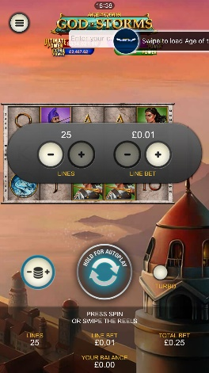
<game_code>_icon_10x10 | 540 x 540 | PNG | Main WL layout: game tiles icons in Lobby, on Game Advisor, Broken games etc. | 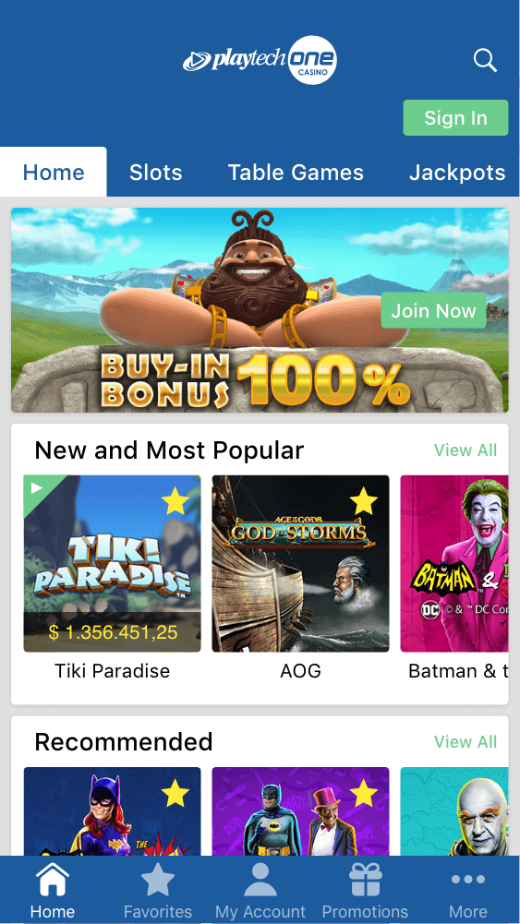  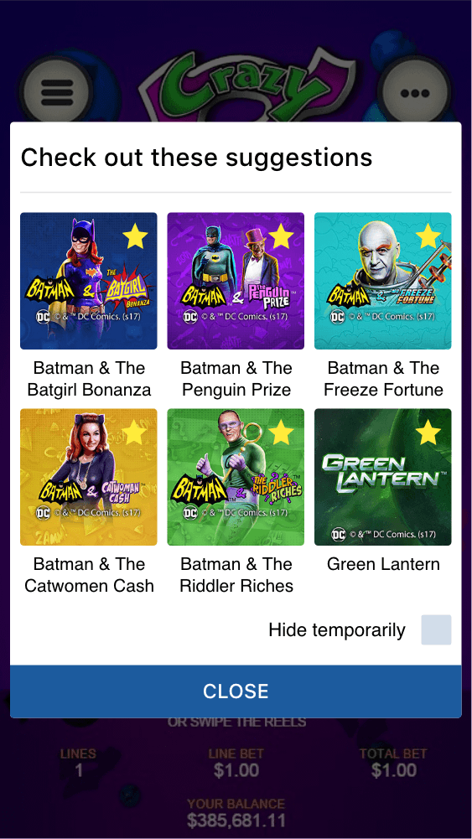
<game_code>_icon_30x5 | 1104 x 336 | PNG | Game Info screen header for tablets | 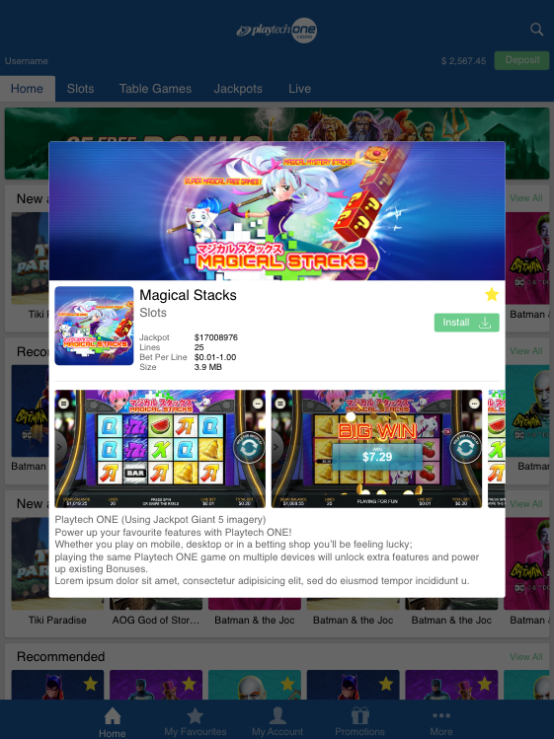
<game_code>_icon_30x10 | 1788 x 540 | PNG | My Favourites screen | 