EASTER ISLAND

Short Description

Welcome to the wilds of Easter Island where tribal bunnies reside, they pinch the colourful eggs of the fat little Easter birds turning excitement to eggcitement with this fun Easter Island ride. Let the dancing bunnies conjure up your fortune with 25 Free Games! Pick your rewards with the cheeky Easter birds! Eggcellent fun!

Marketing Materials

The materials can be downloaded from [here](https://files.eyecon.com/index.php/s/p5cHW2FLqVRyhM3)

Screenshots

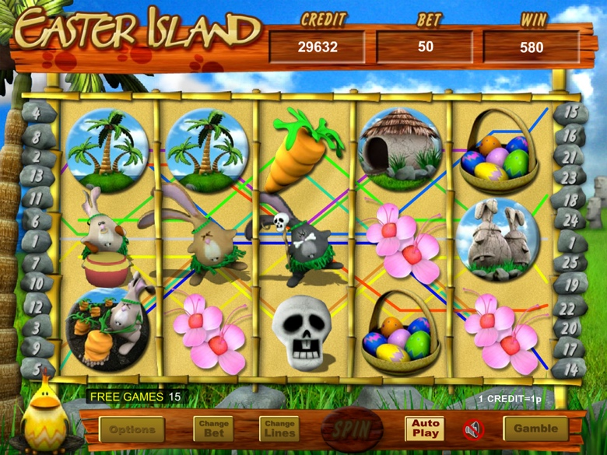

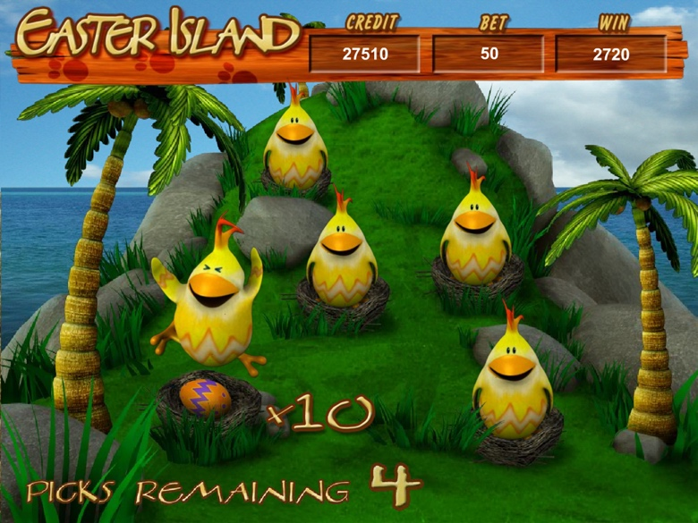

Game Properties & Features

|  |  |
| --- | --- |
| **Properties** | |
| Versions | Standalone |
| RTP (%) | 95 |
| Number of Reels | 5 |
| Number of Lines | 25 |
| Min. Bet | 1 credit |
| Max Bet | 1,250 credits |
| Game Play | Medium |
| Volatility | High |
| Hit Rate playing 1 line | 1 in 25 |
| Combined Feature Hit Rate | 1 in 134 |
| Default Bet | 2 credits/line playing 25 lines |
| Supports Free Spins | Yes |
| Recommended Categories | * Festive/Seasonal – Easter * Big Wins/Volatile * Cute Animals |
| **Features** | |
| Free Spins | Up to 5 |
| Substitute | Bunny Symbols |
| Prize Pick Feature | Triggered by 3 or more Easter Birds |