EMPEROR’S FORTUNE

Short Description

All hands on deck and prepare for victory in this 5 Reel, 25 Line slot, Emperor’s Fortune! Win big profits from the Little Corporal during Free Games! Blast your way to fortune in the riveting Ship Battle! Command and conquer the seven seas as you rise to power and glory! Free games triggered by 3 or more Napoleon symbols and prizes are tripled during Free Games. Prize Pick triggered by 3 or more Cannonballs and each pick can award a prize of up to 100X the total wager!

Marketing Materials

The materials can be downloaded from [here](https://files.eyecon.com/index.php/s/EaXAqxtMMn9ijcv)

Screenshots

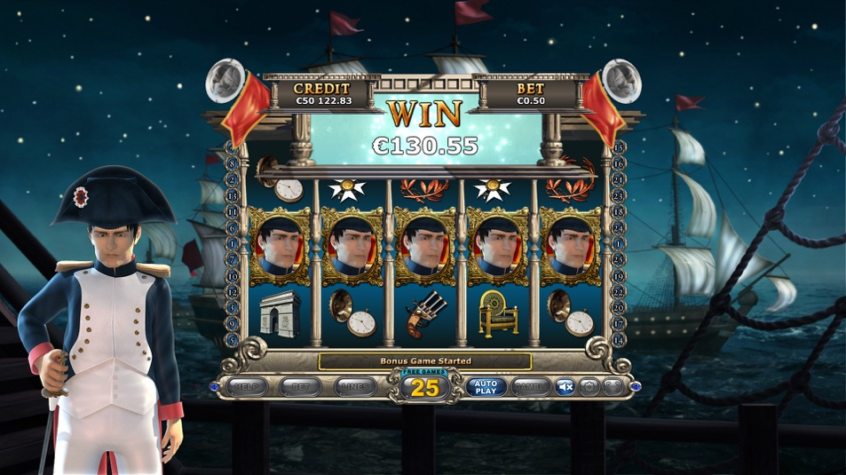

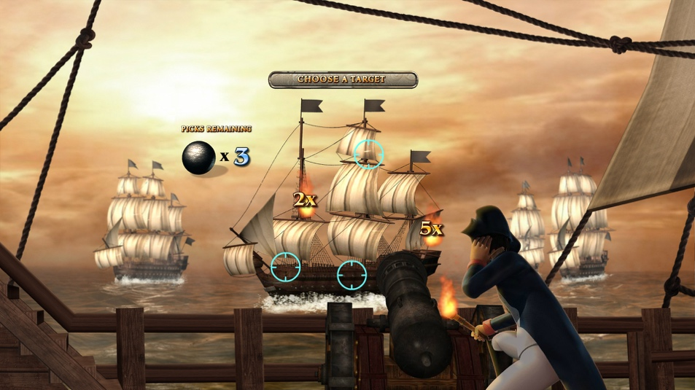

Game Properties & Features

|  |  |
| --- | --- |
| **Properties** | |
| Versions | Standalone |
| RTP (%) | 95 |
| Number of Reels | 5 |
| Number of Lines | 25 |
| Min. Bet | 1 credit |
| Max Bet | 50 credits |
| Game Play | Hard |
| Volatility | High |
| Hit Rate playing 1 line | 1 in 20.9 |
| Combined Feature Hit Rate | 1 in 134.7 |
| Default Bet | 1 credit per line |
| Supports Free Spins | Yes |
| Recommended Categories | * Action * Adventure * Fantasy |
| **Features** | |
| Free Spins | Up to 25 |
| Substitute | Prizes are doubled |
| Prize Pick Feature | Up to 100X total wager |