Game Information for Native Casino App

Introduction
This document aims to capture game information and images for the Native Casino app. Please fill out all the yellow boxes.
This document is required for each game.

General information

Game name
What is the name of your game and the translation to Simplified Chinese? Include a trade mark if applicable.
English | Enchanted Prince 2
Simplified Chinese | 魔法王子2
Traditional Chinese | 魅惑王子2
Japanese | エンチャンテッド・プリンス 2
Korean | 마법에 걸린 왕자 2
Malay | Putera Terpesona 2
Spanish | El Príncipe Encantado 2

Game code
What is the game code?
pop_e720bc12_eye

Winning lines or ways (slot games only)
How many winning lines or ways does your game have?
20 lines

Jackpot
Are jackpots supported in your game? If so, state the jackpot identifier.
Via another game code yes – but this game code is for the non jackpot version

Bet per lines
What is the default bet per line ranges? Please provide in different currencies if such information is available
GBP|EUR|USD [1, 2, 3, 4, 5, 6, 8, 10, 15, 20, 25, 30, 40, 50, 60, 80, 100, 200 ]

Game descriptions
Provide a description of your game in a few sentences for all the lobby languages:
Languages | Description
English (International) | The stunning sequel to one of our top games Enchanted Prince is here. Enchanted Prince 2 features an all new exciting ‘Hopping Wild’ feature which is triggered at random. Watch as the frog prince hops across the reels turning symbols into Wilds, the more he hops, the more multipliers are rewarded, but watch out for near misses! Also featuring Free Games will this ‘ribbiting’ game have you leaping with joy? Get ready to kiss a few frogs to find out!
Chinese Simplified | 我们的顶级游戏之一魔法王子的精彩续篇来了。魔法王子2具有令人兴奋的全新“跳跃百搭符号”特色游戏，该特色游戏随机触发。青蛙王子会在转轴上跳跃，将符号变成百搭符号，他跳得越多，奖赏的翻倍乘数就越多，但要小心险些失手！这款“呱呱叫”的游戏还具有免费特色游戏，您会高兴得一蹦三尺高吗？亲吻几只青蛙就知道了！
Chinese Traditional | 我們頂級遊戲魅惑王子推出續作。魅惑王子2中有可以隨機觸發的全新「跳動百搭符號」功能。青蛙王子會在捲軸上跳動，將符號變成百搭符號，跳得越多，獎勵的倍增指數就越多，不過要小心跳空！遊戲中還有免費遊戲，這款快樂遊戲能否讓您開心不已？準備好親吻幾隻青蛙，贏取大獎！
Japanese | 人気ゲームの1つ、エンチャンテッド・プリンスの見事な続編が登場です。エンチャンテッド・プリンス 2には、ランダムに発動される全く新しいエキサイティングな「ホッピングワイルド」フィーチャーが搭載されています。カエルの王子がリール上を飛び跳ね、シンボルをワイルドに変えていく様子を見守りましょう。彼が跳ねるほど、より多くのマルチプライヤーが報酬として与えられますが、ミスには気をつけてください！また、フリーゲームも搭載されており、はたしてこのゲームはあなたを喜びで飛び跳ねさせることはできるでしょうか？カエルの鳴き声と共に確かめてみましょう！
Korean | 최고의 인기 게임 중 하나인 마법에 걸린 왕자의 멋진 속편이 출시되었습니다. 마법에 걸린 왕자 2에는 무작위로 작동되는 완전히 새로운 흥미진진한 ‘호핑 와일드’ 기능이 추가되었습니다. 개구리 왕자가 릴을 뛰어넘어 심볼을 와일드로 바꾸고, 더 많이 뛰어넘을수록 더 많은 배수가 보상으로 주어지지만, 아슬아슬하게 놓칠 수 있으니 조심하세요! 또한 무료 게임으로 제공되는 이 ‘통통’ 튀는 게임이 여러분을 신나게 뛰게 할까요? 개구리 몇 마리와 키스할 준비를 하세요!
Malay | Susulan yang menakjubkan pada salah satu permainan popular Putera Terpesona kami ada di sini. Putera Terpesona 2 menampilkan ciri baru yang menarik 'Liar Melompat' yang dicetuskan secara rawak. Saksikan semasa putera katak melompat melintasi kekili menukar simbol kepada Liar, semakin banyak dia melompat, semakin banyak pengganda diberi ganjaran, tetapi berhati-hati untuk kejadian nyaris-nyaris terlepas! Juga menampilkan Permainan Percuma adakah permainan 'berdengkang' ini akan membuatkan anda melompat dengan gembira? Bersedia untuk mencium beberapa ekor katak untuk mengetahui!
Spanish | Ha llegado la impresionante secuela de uno de nuestros mejores juegos, El Príncipe Encantado. El Príncipe Encantado 2 cuenta con una nueva y emocionante función de "Comodín Saltarín" que se activa al azar. Vea cómo el príncipe rana salta por los carretes, convirtiendo símbolos en Comodines. Cuanto más salte, más multiplicadores activará, ¡pero no pierda de vista los fallos por poco! Con Partidas Gratis, ¿podrá este emocionante juego hacerle saltar de alegría? ¡Prepárese para besar unos cuantos sapos para descubrirlo!

Images
Note: the assets should be placed in the folders which have the following structure:
- icons with game names should be placed here: games\<game_code>\icons\icons_with_game_names\

Screenshots
The following screenshots are required on mobile in landscape. In case game is available in Portrait only, then screenshots in Portrait (461 x 819) should be provided.
Image type | Screenshot name | Dimensions | Format
Main game in English | screen_<game_code>_main | 819 x 461 | PNG
Significant win in English | screen_<game_code>_big_win | 819 x 461 | PNG
Bonus scene in English | screen_<game_code>_bonus | 819 x 461 | PNG

Game icons
The following game icons are required:
Image Name | Dimensions | Format | Where used in app | Screenshot
<game_code>_icon_5x5 | 240 x 240 | PNG | Quick Switch between games feature | 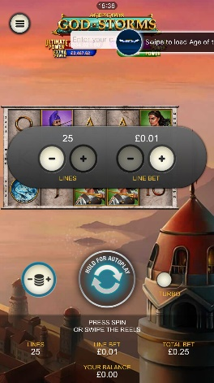
<game_code>_icon_10x10 | 540 x 540 | PNG | Main WL layout: game tiles icons in Lobby, on Game Advisor, Broken games etc. | 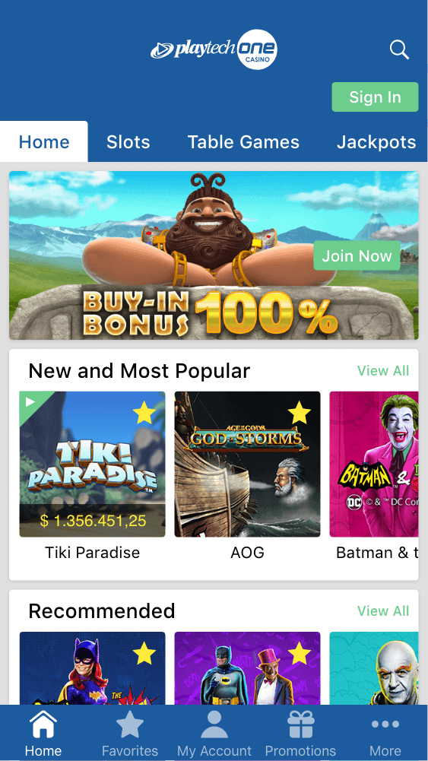  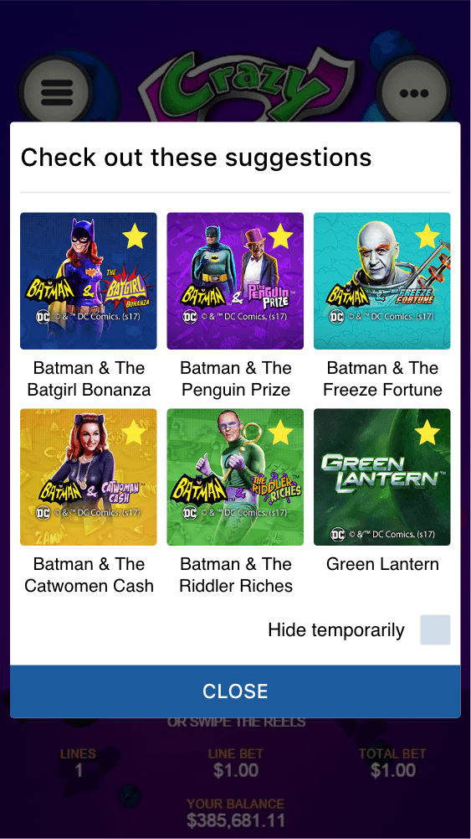
<game_code>_icon_30x5 | 1104 x 336 | PNG | Game Info screen header for tablets | 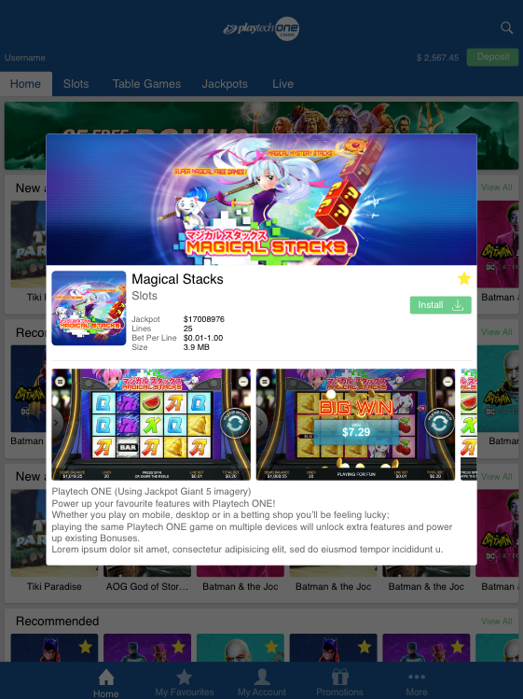
<game_code>_icon_30x10 | 1788 x 540 | PNG | My Favourites screen | 