ENCHANTED PRINCE

Short Description

Kiss the frog and find your handsome prince! Double your wins with the crown jewels and win a kiss to be rewarded with up to 25 free games! Free spins triggered by 3 or more scattered frog symbols. Up to 25 free games and the Crown symbol substitutes for all symbols except the Frog. Prizes doubles with Crowns too, will the charming Prince win your heart? Go on, take your chances and just give that frog a kiss!

Marketing Materials

The materials can be downloaded from [here](https://files.eyecon.com/index.php/s/9CHPQxCZioNKiOC)

Screenshots

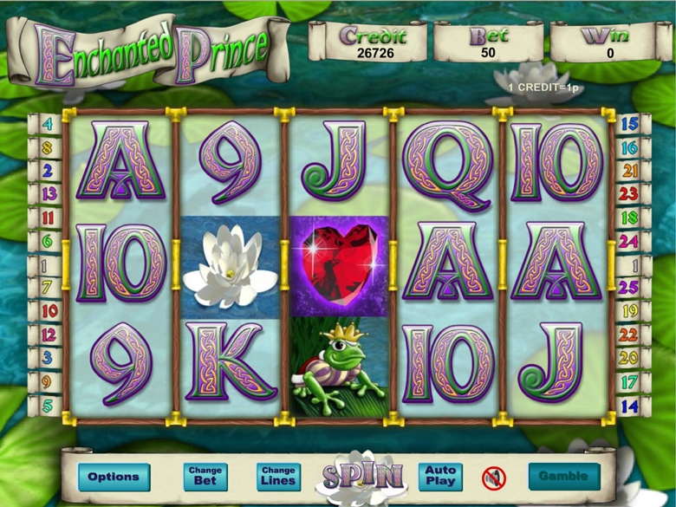

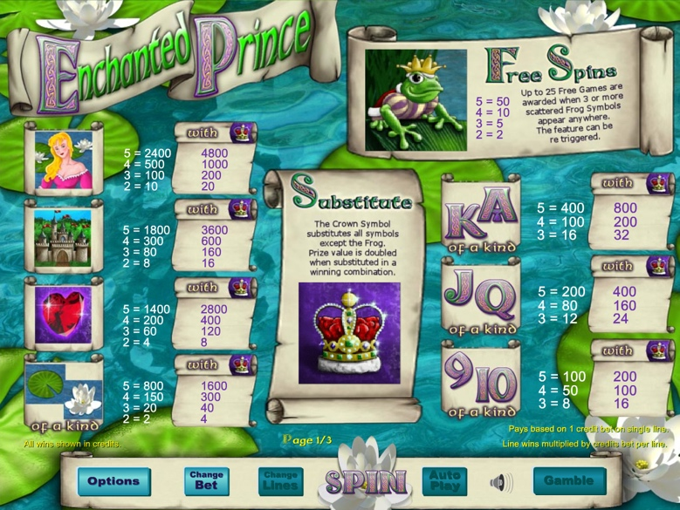

Game Properties & Features

|  |  |
| --- | --- |
| **Properties** | |
| Versions | Standalone |
| RTP (%) | 95 |
| Number of Reels | 5 |
| Number of Lines | 25 |
| Min. Bet | 1 credit |
| Max Bet | 50 credits |
| Game Play | Medium |
| Volatility | Low |
| Hit Rate playing 1 line | 1 in 8 |
| Combined Feature Hit Rate | 1 in 90 |
| Default Bet | 1 credit per line |
| Supports Free Spins | Yes |
| Recommended Categories | * Fantasy * Adventure |
| **Features** | |
| Free Spins | Up to 25 |
| Substitute | Prizes are doubled |