Noughts & Crosses

Short Description

Marketing Materials

The materials can be downloaded from [here](https://files.eyecon.com/index.php/s/AmRP3JAc5eyyaNq)

Screenshots

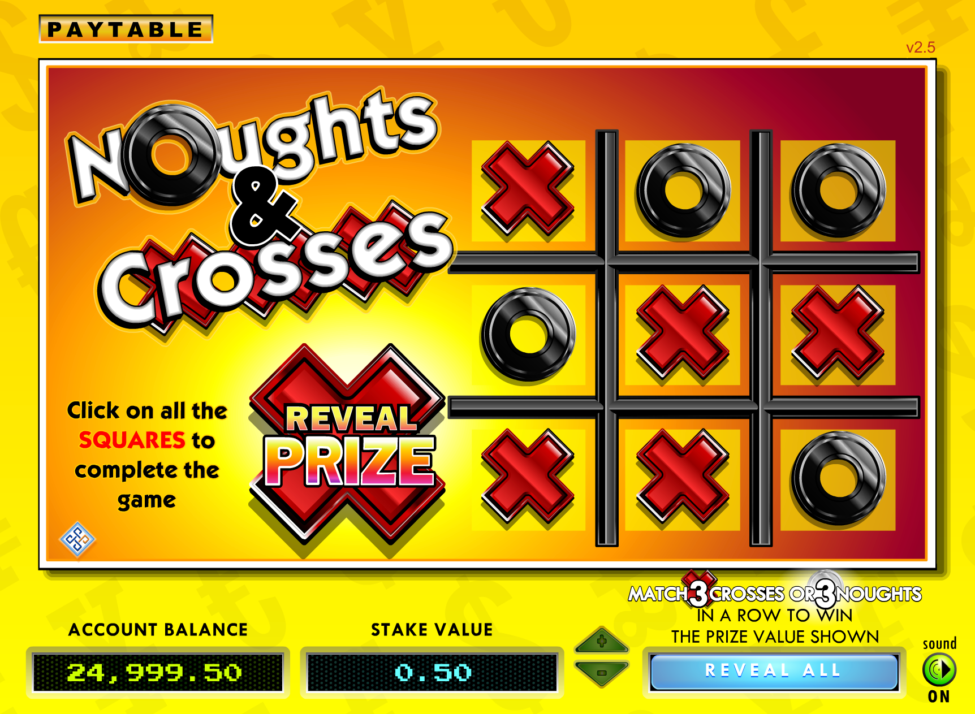

Game Properties & Features

|  |  |
| --- | --- |
| **Properties** | |
| Versions | Standalone, Mini |
| RTP (%) | 95.64% |
| Number of Reels | N/R |
| Number of Lines | N/R |
| Min. Bet | 1 credit |
| Max Bet | 1000 credits |
| Max Payout | £10,000 |
| Game Play | Easy |
| Volatility | Medium |
| Hit Rate playing 1 line |  |
| Combined Feature Hit Rate |  |
| Default Bet | 5 credits |
| Supports Free Spins | Yes |
| Recommended Categories | * Scratch Cards |
| **Features** | |
| Free Spins | N/R |
| Substitute | N/R |