Fae Legend Warrior

Short Description

**Summary**

Fae Legend Warrior Slots is full of magic, mystery, fairies and warriors – and also, loads of enchanting wins! Get ready to immerse yourself in the supernatural every time you spin, and in addition, you’ll enjoy FREE games, a Prize Pick Bonus and so much more! Fae Legend Warrior is sure to become one of your favourites, which is no problem, because you can play at home or on the go on all your mobile devices. Who knows where you’ll win next! Good luck!

**Formats**

* Stand Alone
* Embedded
* Mobile

**Recommended categories**

* Action
* Fantasy

Marketing Materials

The materials can be downloaded from [here](https://files.eyecon.com/index.php/s/OZwEhRtUaUIKbEK)

Screenshots

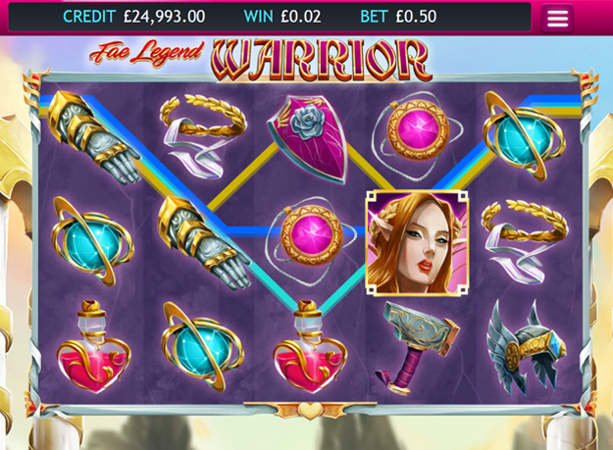

Game Properties & Features

|  |  |
| --- | --- |
| **Properties** | |
| Versions | Standalone, Mini, Mobile |
| RTP (%) | 95 |
| Number of Reels | 5 |
| Number of Lines | 25 |
| Min. Bet | 1 credit |
| Max Bet | 50 credits |
| Game Play | Hard |
| Volatility | High |
| Hit Rate playing 1 line | 1 in 24.8 |
| Combined Feature Hit Rate | 1 in 134.7 |
| Default Bet | 1 credit per line |
| Supports Free Spins | Yes |
| **Features** | |
| Free Spins | Up to 25 |
| Substitute | Prizes are doubled |
| Prize Pick Feature | Up to 100X your bet |