FIDDLE DEE DOUGH

Short Description

Feel the luck in this legendary slot game, Fiddle Dee Dough! Laugh your way through 8 magical free games with lucky leprechauns. Pots of gold grant your wishes of riches in the charming Prize Pick feature. Fortune awaits at the end of this rainbow!

Marketing Materials

The materials can be downloaded from [here](https://files.eyecon.com/index.php/s/Ry1TyiTtGofjwlb)

Screenshots

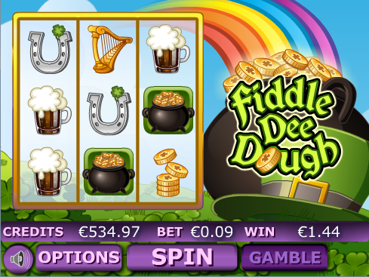

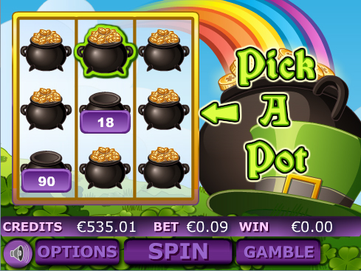

Game Properties & Features

|  |  |
| --- | --- |
| **Properties** | |
| Versions | Mini, Mobile |
| RTP (%) | 95 |
| Number of Reels | 5 |
| Number of Lines | 25 |
| Min. Bet | 1 credit |
| Max Bet | 900 credits |
| Game Play | Hard |
| Volatility | High |
| Hit Rate playing 1 line | 1 in 17 |
| Combined Feature Hit Rate | 1 in 77 |
| Default Bet | 1 credit per line |
| Supports Free Spins | Yes |
| Recommended Categories | * Big Wins/Volatile * Irish * Progressive Jackpots |
| **Features** | |
| Free Spins | Up to 8 |
| Substitute | Logo Symbol |