FIREWORKS FRENZY

Short Description
Blast off a fireworks frenzy in this action-packed exciting new slot game! 25 sparkling lines over 5 explosive reels shower you with luck and fortune. Launch yourself into a massive 25 free games and watch as the expanding reels take off in a flurry of colour and excitement. It’s celebration time, as you win big in this bonanza!

Marketing Materials
The materials can be downloaded from here
Screenshots
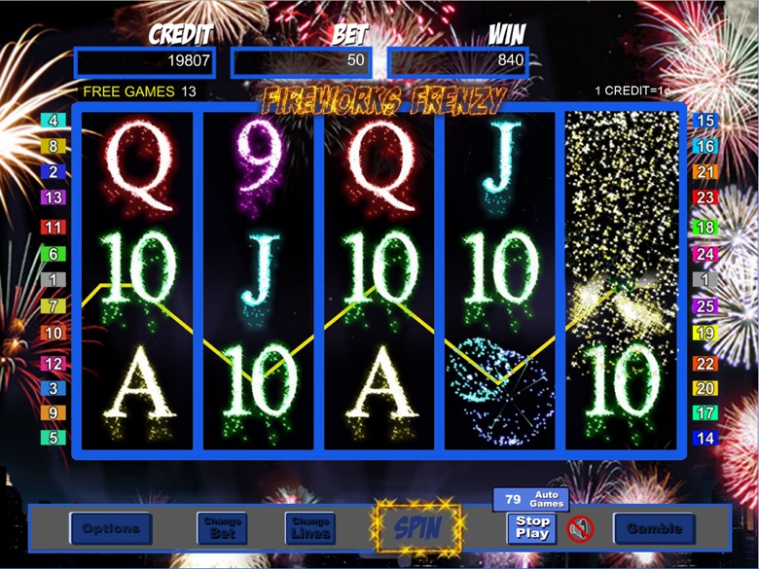
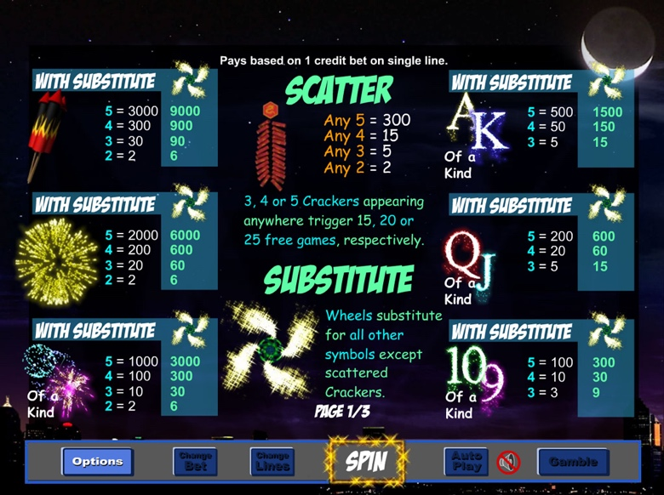

Game Properties & Features

Properties
Versions | Standalone, Mini, Mobile
RTP (%) | 95
Number of Reels | 5
Number of Lines | 25
Min. Bet | 1 credit
Max Bet | 1,250 credits
Game Play | Medium
Volatility | High
Hit Rate playing 1 line | 1 in 7.8
Combined Feature Hit Rate | 1 in 100
Default Bet | 1 credit per line
Supports Free Spins | Yes
Recommended Categories | - Big Wins/Volatile  - Seasonal/Festive
Features
Free Spins | Up to 25
Substitute | Firewheel Symbol triples prizes

