FIVE NINJAS

Short Description

Release your inner ninja in this explosive 5 reel, 25 line slot, Five Ninjas! Unearth the Golden Ninja in the Free Games feature and defeat your opponents to compete for even more free games! Hidden Ninjas grant you good fortunes in the Bonus Prize Pick feature – it’s bags of fun! Discover unknown passageways in the Secret Ninja Prize Pick feature and uncover the chance to win big behind each door!

Marketing Materials

The materials can be downloaded from TBC

Screenshots

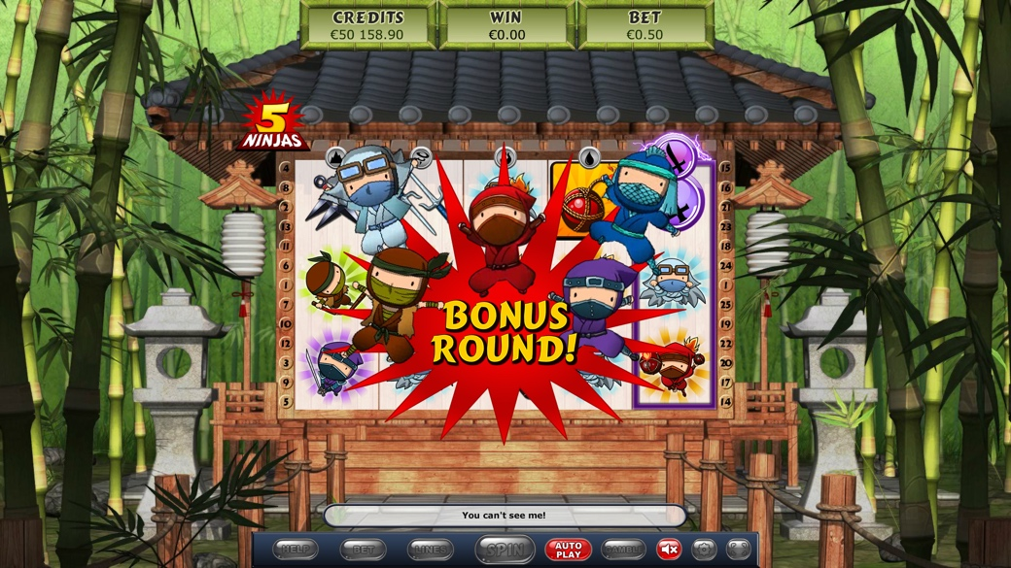



Game Properties & Features

|  |  |
| --- | --- |
| **Properties** | |
| Versions | Standalone |
| RTP (%) | 95 |
| Number of Reels | 5 |
| Number of Lines | 25 |
| Min. Bet | 1 credit |
| Max Bet | 50 credits |
| Game Play | Hard |
| Volatility | High |
| Hit Rate playing 1 line | 1 in 11 |
| Combined Feature Hit Rate | 1 in 124.9 |
| Default Bet | 1 credit per line |
| Supports Free Spins | Yes |
| Recommended Categories | * Adventure * Big Wins/Volatile * Oriental |
| **Features** | |
| Free Spins | Up to 10 |
| Substitute | Doubles prizes |
| Prize Pick Feature | Up to 100X total wager |