Game Information for Native Casino App

Introduction
This document aims to capture game information and images for the Native Casino app. Please fill out all the yellow boxes.
This document is required for each game.

General information

Game name
What is the name of your game and the translation to Simplified Chinese? Include a trade mark if applicable.
Fluffy Favourite MegawaysTM
毛绒爱宠大体验

Game code
What is the game code?
fluffy-favourites-megaways

Winning lines or ways (slot games only)
How many winning lines or ways does your game have?
Megaways (117,649 ways)

Jackpot
Are jackpots supported in your game? If so, state the jackpot identifier.
Via another game code yes – but this game code is for the non jackpot version

Bet per lines
What is the default bet per line ranges? Please provide in different currencies if such information is available
GBP|EUR|USD [20,40,60,80,100,200,300,400,500 ]

Game descriptions
Provide a description of your game in a few sentences for all the lobby languages:
Languages | Description
English (International) | Roll up, roll up, the Fluffy sensation is back and this time, its MEGA! Join Fluffy and friends in this Fluffy Favourites MEGAWAYS game. Enjoy all the fun of the Fluffy Fairground with all the excitement of a MEGAWAYS game. Featuring the iconic claw machine, free spins and cascading reels. Step right up and play today
Chinese Simplified | 滚呀滚，滚呀滚，毛绒绒的体验这次加倍袭来！在这款《毛绒爱宠大体验》中，与毛毛和朋友们一起嗨翻天吧。体验毛绒游乐场的所有乐趣，超级博彩游戏中激动人心的各个环节一样不少。玩法包括标志性的抓娃娃机、免费旋转和消除掉落式卷轴。赶快加入，即刻畅玩
Chinese Traditional | 滾呀滾，滾呀滾，毛絨絨的體驗這次加倍襲來！在這款《毛絨愛寵大體驗》中，與毛毛和朋友們一起嗨翻天吧。體驗毛絨遊樂場的所有樂趣，超級博彩遊戲中激動人心的各個環節一樣不少。玩法包括標誌性的抓娃娃機、免費旋轉和消除掉落式卷軸。積極加入，即刻暢玩
Japanese | クルクル、クルクル、ふわふわ感が戻ってきて、今回はメガです！このフラッフィーのお気に入りのメガウェイズのゲームでフラッフィーとその友達に参加してください。メガウェイズのゲームすべての興奮とともに、ふわふわフェアグラウンドのすべてをお楽しみください。象徴的なクローマシン、フリースピン、カスケードリールが特徴です。今すぐプレイしてください
Korean | 모이세요, 모이세요, 솜털같이 부드러운 감각이 돌아 왔습니다, 이번에는 메가입니다! 이 솜털같은 즐겨 찾기 메가웨이 게임에서 솜털같은 와 친구들과 함께 하십시오. 메가웨이 게임의 모든 흥분과 함께 솜털같은 박람회장의 모든 재미를 즐기십시오. 상징적인 클로 머신, 무료 스핀 및 캐스케이딩 릴이 특징입니다. 앞으로 나오셔서 오늘 플레이하십시오
Malay | Bersedia-sedialah, sensasi Fluffy telah kembali dan kali ini, ia MEGA! Sertai Fluffy dan rakan dalam permainan MEGAWAYS Kegemaran Gebu. Nikmati semua keseronokan Fairground Gebu dengan semua keterujaan permainan MEGAWAYS. Mengetengahkan mesin pencakar ikonik, putaran percuma dan gelendong melata. Sertai dan bermain permainan hari ini
Spanish | ¡Atención, el sensacional Fluffy está de vuelta, y esta vez es MEGA! Únase a Fluffy y sus amigos en este juego Fluffy Favourites MEGAWAYS. Fluffy Fairground viene cargado con toda la emoción de un juego MEGAWAYS. Con la icónica máquina del gancho, giros gratis y rodillos en cascada. ¡No lo dude, pruébelo hoy!

Images
Note: the assets should be placed in the folders which have the following structure:
- icons with game names should be placed here: games\<game_code>\icons\icons_with_game_names\

Screenshots
The following screenshots are required on mobile in landscape. In case game is available in Portrait only, then screenshots in Portrait (461 x 819) should be provided.
Image type | Screenshot name | Dimensions | Format
Main game in English | screen_<game_code>_main | 819 x 461 | PNG
Significant win in English | screen_<game_code>_big_win | 819 x 461 | PNG
Bonus scene in English | screen_<game_code>_bonus | 819 x 461 | PNG

Game icons
The following game icons are required:
Image Name | Dimensions | Format | Where used in app | Screenshot
<game_code>_icon_5x5 | 240 x 240 | PNG | Quick Switch between games feature | 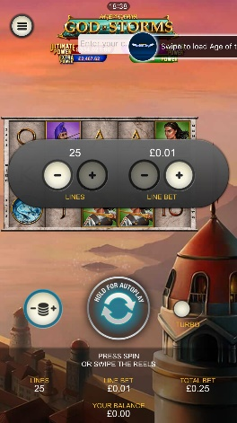
<game_code>_icon_10x10 | 540 x 540 | PNG | Main WL layout: game tiles icons in Lobby, on Game Advisor, Broken games etc. | 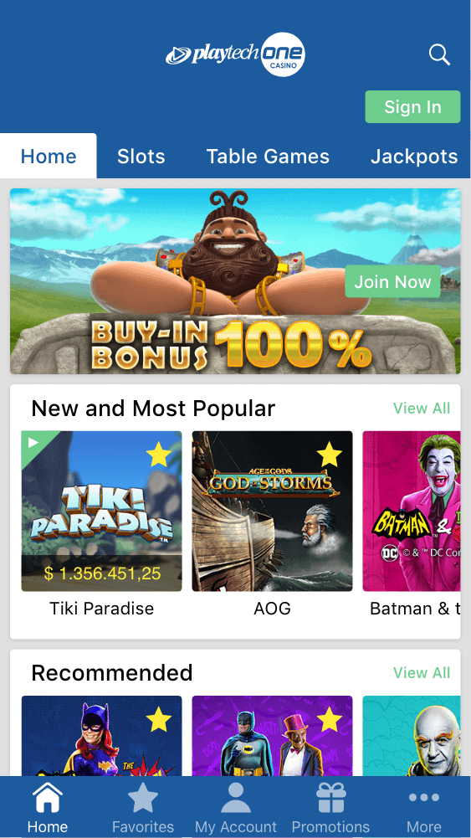  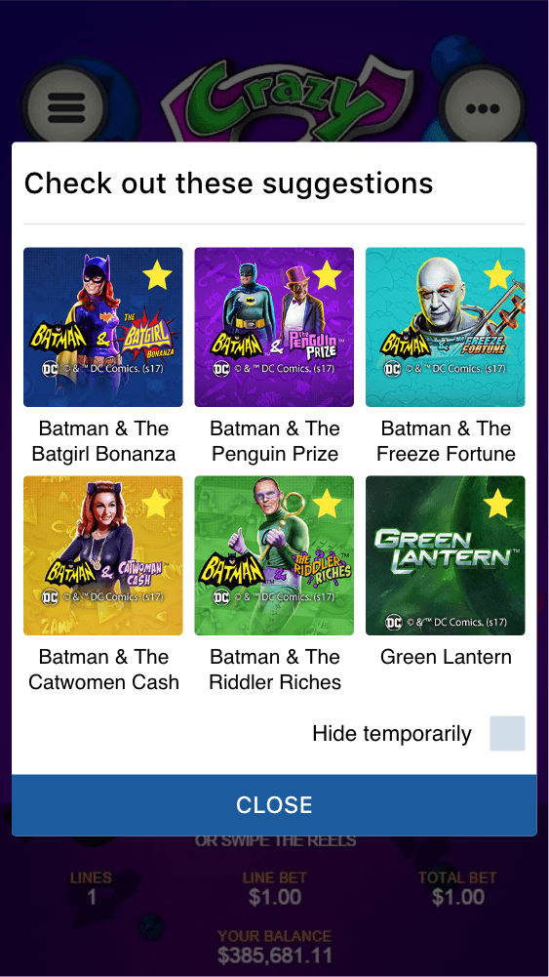
<game_code>_icon_30x5 | 1104 x 336 | PNG | Game Info screen header for tablets | 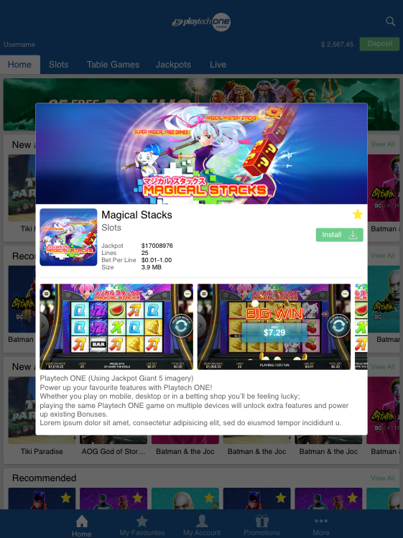
<game_code>_icon_30x10 | 1788 x 540 | PNG | My Favourites screen | 