Game Information for Native Casino App

Introduction
This document aims to capture game information and images for the Native Casino app. Please fill out all the yellow boxes.
This document is required for each game.

General information

Game name
What is the name of your game and the translation to Simplified Chinese? Include a trade mark if applicable.
English | Fluffy Favourites Mix n Win
Simplified Chinese | 毛绒萌宠混合赢奖
Traditional Chinese | 心愛毛絨玩具混合贏獎
Japanese | フラッフィー・フェイバリット・ミックス＆ウィン
Korean | 플러피 페이버릿 믹스 앤 윈
Malay | Kegemaran Fluffy Campur n Menang
Spanish | Mis peluches favoritos Mezcle y Gane

Game code
What is the game code?
pop_d6fd1a4e_eye

Winning lines or ways (slot games only)
How many winning lines or ways does your game have?
25 lines

Jackpot
Are jackpots supported in your game? If so, state the jackpot identifier.
Via another game code yes – but this game code is for the non jackpot version

Bet per lines
What is the default bet per line ranges? Please provide in different currencies if such information is available
GBP|EUR|USD [1, 2, 3, 4, 5, 6, 8, 10, 15, 20, 25, 30, 40, 50, 60, 80, 100, 200 ]

Game descriptions
Provide a description of your game in a few sentences for all the lobby languages:
Languages | Description
English (International) | For the first time ever, you can play Fluffy Favourites the way YOU want to with Free Games and up to 3 classic bonus games!  The fairground has never been more fun with your chance to win big when you choose from Free Games and a mix of one or ALL prize pick bonus features. These include crowd pleasing favourites "Grab-A-Fluffy", "Coin Pusher" and "Hook-A-Fluffy" for a chance to win 100x your bet!
Chinese Simplified | 有史以来第一次，您可以用自己喜欢的方式玩毛绒萌宠，免费游戏和多达3个经典奖励游戏供您畅玩！  从免费游戏中选择，组合一个或全部奖金挑选奖励特色游戏，就有机会赢得大奖，游乐场的乐趣从未如此丰富。其中包括大家最喜爱的“抓萌宠”、“推币机”和“金钩钓萌宠”，有机会赢取100x赌注的奖金！
Chinese Traditional | 史上首次，您可以隨心所欲地玩心愛毛絨玩具，享受免費遊戲和多達3種經典紅利遊戲！  您可以選擇免費遊戲以及一種或所有獎金挑選紅利功能的組合，遊戲從未如此精彩有趣。這些包括所有人都喜歡的「拿走一個毛絨玩具」、「推硬幣」和「娃娃機」，有機會贏得投注金額的100倍！
Japanese | フリーゲームと最大3つのクラシックボーナスゲームで、フラッフィー・フェイバリットを自分の希望通りにプレイできるようになりました！  フリーゲームと好きなプライズピックボーナスフィーチャー、あるいはそのすべてをミックスできるようになったことで、遊園地はより一層楽しくなりました。選択可能なフィーチャーにはみんなのお気に入り、「グラブ・フラッフィー」、「コインプッシャー」、そして「フック・フラッフィー」があり、ベット額の100倍を獲得するチャンスがあります！
Korean | 사상 처음으로 무료 게임과 최대 3개의 클래식 보너스 게임으로 원하는 방식으로 플러피 페이버릿을 플레이할 수 있습니다!  무료 게임과 한 가지 또는 모든 상품 선택 보너스 기능을 혼합하여 선택하면 큰 승리를 거둘 수 있는 기회가 이보다 더 재미있었던 적이 없습니다. 여기에는 군중을 즐겁게 하는 인기 게임인 "그랩 어 플러피", "코인 푸셔" 및 "후크 어 플러피"가 포함되어 있어 베팅의 100 배를 얻을 수있는 기회가 있습니다!
Malay | Buat pertama kalinya, anda boleh bermain Kegemaran Fluffy seperti yang ANDA mahu dengan Permainan Percuma dan sehingga 3 permainan bonus klasik!  The Tapak pameran tidak pernah lebih menyeronokkan dengan peluang anda untuk menang besar apabila anda memilih daripada Permainan Percuma dan gabungan satu atau SEMUA ciri bonus pilihan hadiah. Ini termasuk kegemaran ramai yang menggembirakan "Dapatkan Fluffy", "Penolak Syiling" dan "Cangkuk Fluffy" untuk peluang memenangi 100x taruhan anda!
Spanish | Por primera vez en la historia, ¡puede jugar a Mis peluches favoritos como USTED quiera con Partidas Gratis y hasta 3 juegos de bonus clásicos!  El juego nunca ha sido más divertido, dándole la oportunidad de ganar grandes premios cuando elija entre Partidas Gratis y una mezcla de una, o TODAS, las funciones de bonus de selección de premios. ¡Entre estas se incluyen las favoritas del público como "Elija-Un-Peluche", "Empujón de monedas" y "Enganche un Peluche" para tener la oportunidad de ganar 100x la apuesta!

Images
Note: the assets should be placed in the folders which have the following structure:
- icons with game names should be placed here: games\<game_code>\icons\icons_with_game_names\

Screenshots
The following screenshots are required on mobile in landscape. In case game is available in Portrait only, then screenshots in Portrait (461 x 819) should be provided.
Image type | Screenshot name | Dimensions | Format
Main game in English | screen_<game_code>_main | 819 x 461 | PNG
Significant win in English | screen_<game_code>_big_win | 819 x 461 | PNG
Bonus scene in English | screen_<game_code>_bonus | 819 x 461 | PNG

Game icons
The following game icons are required:
Image Name | Dimensions | Format | Where used in app | Screenshot
<game_code>_icon_5x5 | 240 x 240 | PNG | Quick Switch between games feature | 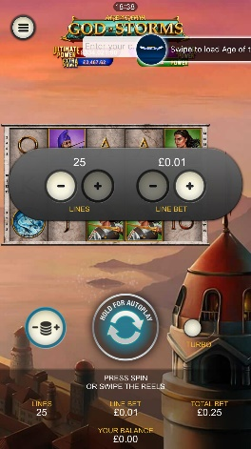
<game_code>_icon_10x10 | 540 x 540 | PNG | Main WL layout: game tiles icons in Lobby, on Game Advisor, Broken games etc. | 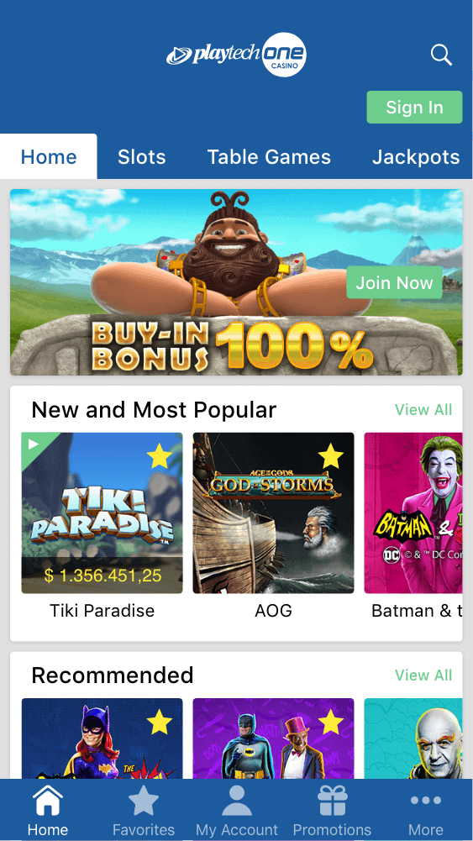  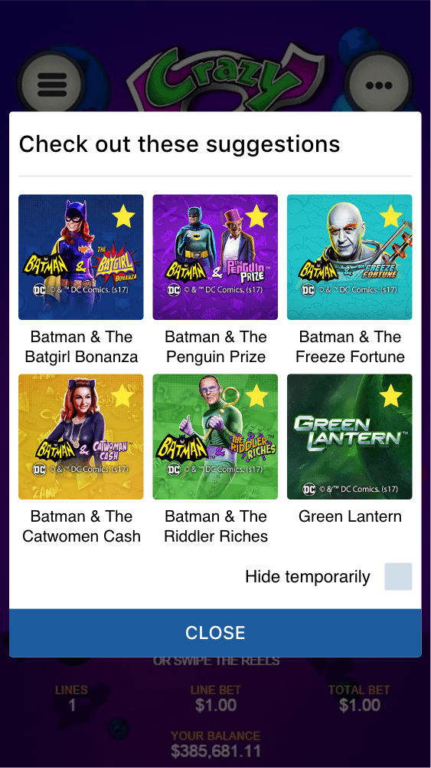
<game_code>_icon_30x5 | 1104 x 336 | PNG | Game Info screen header for tablets | 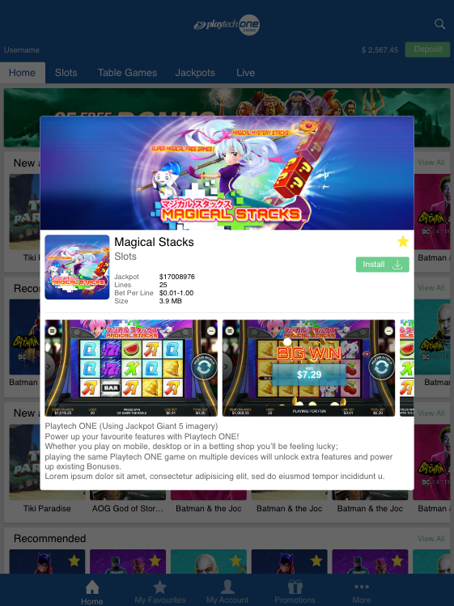
<game_code>_icon_30x10 | 1788 x 540 | PNG | My Favourites screen | 