Game Information for Native Casino App

Introduction
This document aims to capture game information and images for the Native Casino app. Please fill out all the yellow boxes.
This document is required for each game.

General information

Game name
What is the name of your game and the translation to Simplified Chinese? Include a trade mark if applicable.
English | Fluffy Favourites Remastered
Simplified Chinese | 毛绒萌宠重制版
Traditional Chinese | 心愛毛絨玩具重製版
Japanese | フラッフィー・フェイバリット・リマスター版
Korean | 플러피 페이버릿 리마스터
Malay | Kegemaran Fluffy Dikuasai Semula
Spanish | Mis peluches favoritos Remastered

Game code
What is the game code?
pop_48788d2a_eye

Winning lines or ways (slot games only)
How many winning lines or ways does your game have?
25 lines

Jackpot
Are jackpots supported in your game? If so, state the jackpot identifier.
Via another game code yes – but this game code is for the non jackpot version

Bet per lines
What is the default bet per line ranges? Please provide in different currencies if such information is available
GBP|EUR|USD [1, 2, 3, 4, 5, 6, 8, 10, 15, 20, 25, 30, 40, 50, 60, 80, 100, 200 ]

Game descriptions
Provide a description of your game in a few sentences for all the lobby languages:
Languages | Description
English (International) | Fluffy Favourites is one of the most popular slots around and has been a player favourite for years. Now, to celebrate 15 years of Fluffy, fans of the game can enjoy all the fun and character of the original Fluffy Favourites but with all new upgraded artwork in Fluffy Favourites Remastered! Experience the original phenomenon Fluffy Favourites like you have never seen it before.
Chinese Simplified | 毛绒萌宠是最受欢迎的老虎机之一，多年来一直深受玩家喜爱。现在，为了庆祝毛绒萌宠诞生15周年，游戏迷们可以在毛绒萌宠重制版中享受到原版毛绒萌宠的所有乐趣和特色，同时还能欣赏到全新升级的画面！体验前所未有的毛绒萌宠原版风味。
Chinese Traditional | 心愛毛絨玩家是史上最受歡迎的老虎機之一，多年來都是玩家最喜歡的遊戲。現在，為了慶祝心愛毛絨玩具誕生15週年，熱愛這款遊戲的粉絲們不僅可以享受原始遊戲的樂趣和人物，還可以在心愛毛絨玩具重製版中感受所有最新升級的藝術設計！暢玩現象級的心愛毛絨玩具，感受前所未有的體驗。
Japanese | フラッフィー・フェイバリットは最も人気のあるスロットゲームの一つであり、何年もにわたりプレイヤーたちに愛されてきました。そして今、15周年を祝して、ゲームのファンは元祖フラッフィー・フェイバリットの楽しさとキャラクターをすべて新しくアップグレードされたアートワークで楽しむことができるようになりました。フラッフィー・フェイバリット・リマスター版では、かつてない形で元祖フラッフィー・フェイバリットの巻き起こした現象を体験してください。
Korean | 플러피 페이버릿은 가장 인기 있는 슬롯 중 하나이며 수년 동안 플레이어들의 사랑을 받아왔습니다. 이제 플러피의 15주년을 기념하여 오리지널 플러피 페이버릿의 모든 재미와 개성은 그대로 살리면서 업그레이드된 새로운 아트워크와 함께 플러피 페이버릿 리마스터에서 즐길 수 있습니다! 이제껏 본 적 없는 플러피 페이버릿의 오리지널 모습을 경험해 보세요.
Malay | Kegemaran Fluffy ialah salah satu slot paling popular dan telah menjadi kegemaran pemain selama bertahun-tahun. Kini, untuk meraikan 15 tahun Fluffy, peminat permainan ini boleh menikmati semua keseronokan dan watak Kegemaran Fluffy yang asal tetapi dengan semua karya seni yang dinaik taraf baharu dalam Kegemaran Fluffy Dikuasai Semula! Alami fenomena asal Kegemaran Fluffy seperti yang anda tidak pernah lihat sebelum ini.
Spanish | Mis peluches favoritos es una de nuestras tragaperras más populares y lleva años siendo la favorita de nuestros jugadores. Ahora, para celebrar 15 años de "Peluches", ¡los jugadores pueden disfrutar de toda la diversión y el carácter del juego original Mis peluches favoritos con gráficos mejorados en Mis peluches favoritos Remastered! Viva el fenómeno original de Mis peluches favoritos como nunca lo había visto antes.

Images
Note: the assets should be placed in the folders which have the following structure:
- icons with game names should be placed here: games\<game_code>\icons\icons_with_game_names\

Screenshots
The following screenshots are required on mobile in landscape. In case game is available in Portrait only, then screenshots in Portrait (461 x 819) should be provided.
Image type | Screenshot name | Dimensions | Format
Main game in English | screen_<game_code>_main | 819 x 461 | PNG
Significant win in English | screen_<game_code>_big_win | 819 x 461 | PNG
Bonus scene in English | screen_<game_code>_bonus | 819 x 461 | PNG

Game icons
The following game icons are required:
Image Name | Dimensions | Format | Where used in app | Screenshot
<game_code>_icon_5x5 | 240 x 240 | PNG | Quick Switch between games feature | 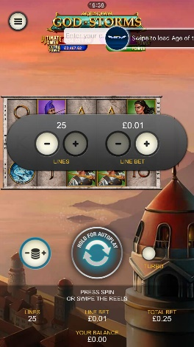
<game_code>_icon_10x10 | 540 x 540 | PNG | Main WL layout: game tiles icons in Lobby, on Game Advisor, Broken games etc. | 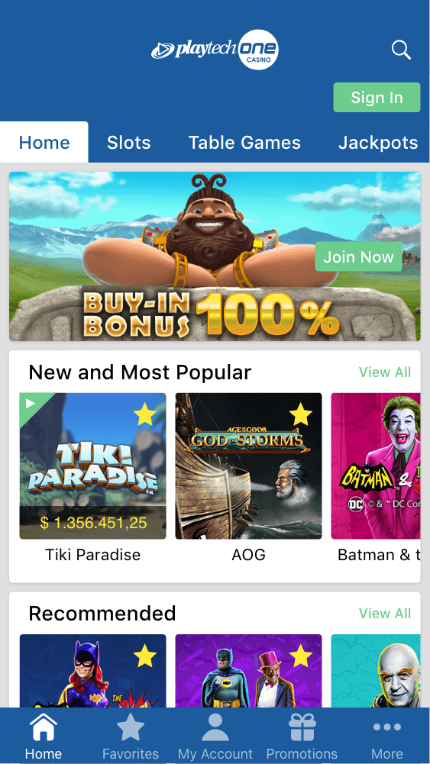  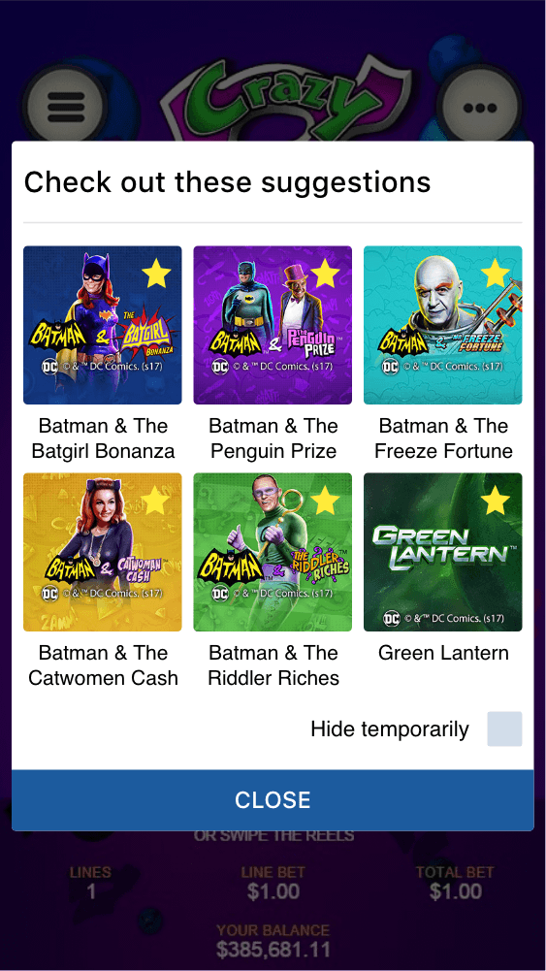
<game_code>_icon_30x5 | 1104 x 336 | PNG | Game Info screen header for tablets | 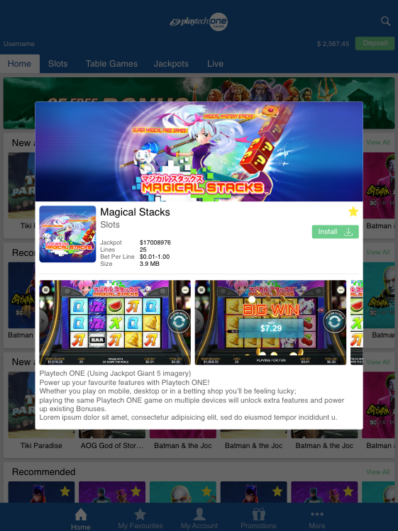
<game_code>_icon_30x10 | 1788 x 540 | PNG | My Favourites screen | 