STAMPEDE

Short Description

Loads of wild animals and loads of wins in Stampede Slots – Spin it to win it today! This exotic online slot game follows the African Big 5, with some incredible 3D graphics and a beautiful sunset in the background to accompany your play. There are FREE spins, multipliers and more, giving you extra chances for some enormous wins. Go on a one-of-a-kind safari adventure and have a great time online when you play Stampede Slots. Good luck!

**Formats**

* Stand Alone
* Embedded
* Mobile

**Why your players would love this game?**

* Hard core casino slot built for serious gamblers
* High-quality graphics with 3D rendered and animated Elephant raging towards the camera
* Player selectable volatility, which means you can choose 20 free spins with a 2x multiplier (low volatility), up to 5 free spins with a 10x multiplier (high volatility)
* 243 Ways symbol wins and the elephant symbol feature trigger scattering anywhere will suit the most sophisticated player
* Will appeal to players who liked Raging Rhino (WMS), Lions and other African animal themed games from competitors

Marketing Materials

The materials can be downloaded from [here](https://files.eyecon.com/index.php/s/ctFkFYbihThQAN5)

Screenshots

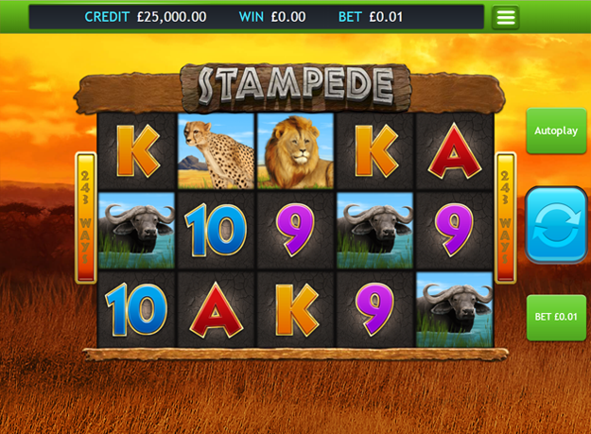

Game Properties & Features

|  |  |
| --- | --- |
| **Properties** | |
| Versions | Standalone, Mini, Mobile |
| RTP (%) | 95.2 |
| Number of Reels | 5 |
| Number of Lines | 243 |
| Min. Bet | 25 credits |
| Game Play | Hard |
| Volatility | High |
| Hit Rate playing 243 lines | 1 in 2.796 |
| Combined Feature Hit Rate | 1 in 141.03 |
| Default Bet | 100 credits |
| Supports Free Spins | Yes |
| Recommended Categories | * Action * Adventure * Animal Games * Huge Wins |
| **Features** | |
| Free Spins | Up to 20 |
| Substitute | Sun Symbol |