FLUFFY FAVOURITES

Short Description

25 Fluffy, fun-filled lines will have you dancing for joy over 5 massive reels of excitement! Test your skill against the exciting crane game to win big! Each toy awards up to 100X the feature triggering bet! Dance up a storm with pink elephants awarding you with bonus wins and free games! It’s a great day to take home a Fluffy Favourite!

Marketing Materials

The materials can be downloaded from [here](https://files.eyecon.com/index.php/s/Uk2ZWE4yhy3XwWq)

Screenshots

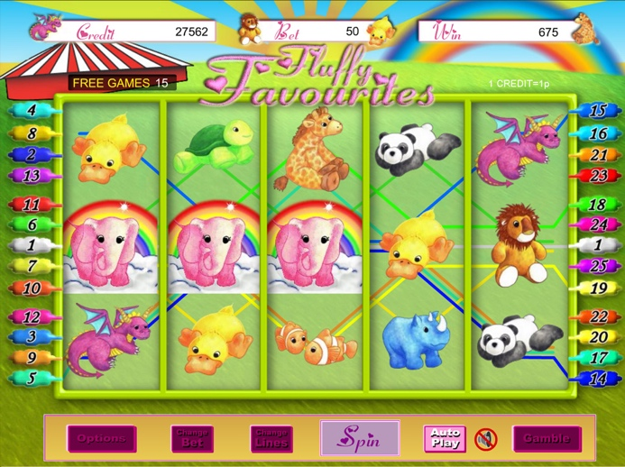

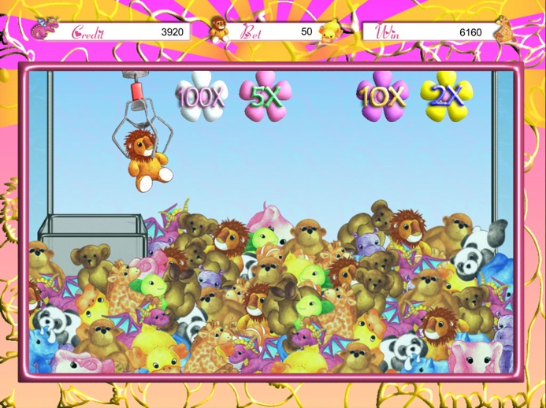

Game Properties & Features

|  |  |
| --- | --- |
| **Properties** | |
| Versions | Standalone |
| RTP (%) | 95 |
| Number of Reels | 5 |
| Number of Lines | 25 |
| Min. Bet | 1 credit |
| Max Bet | 50 credits |
| Game Play | Hard |
| Volatility | High |
| Hit Rate playing 1 line | 1 in 24.8 |
| Combined Feature Hit Rate | 1 in 134.7 |
| Default Bet | 1 credit per line |
| Supports Free Spins | Yes |
| Recommended Categories | * Popular * Cute Animals |
| **Features** | |
| Free Spins | Up to 25 |
| Substitute | Prizes are doubled |
| Prize Pick Feature | Up to 100X the feature triggering bet |