FLUFFY TOO

Short Description

Cute just got even cuter in the all new Fluffy Too! Fluffy returns with all your favourite in this exciting 5 reel, 25-line slot game. Dance your way through 25 Free Games and collect your fortunes in the classic arcade Coin-Pusher Feature! Double your prizes with Fluffy substituting for all symbols except Coin symbols. Play today and see what all the fluff is about!

Marketing Materials

The materials can be downloaded from [here](https://files.eyecon.com/index.php/s/yswUwD6hxASPqYz)

Screenshots

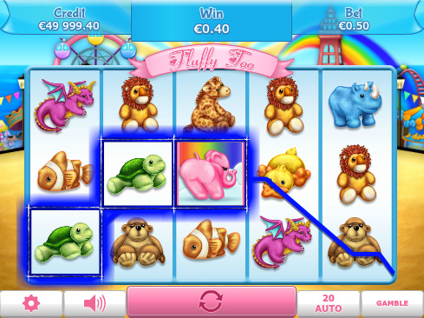

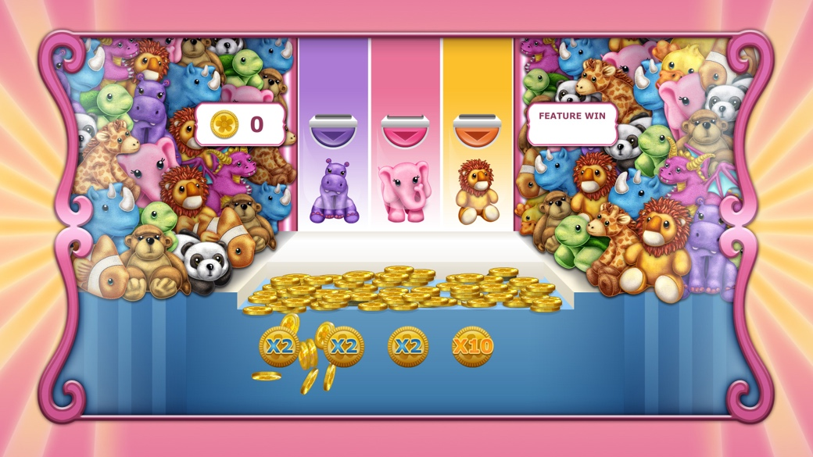

Game Properties & Features

|  |  |
| --- | --- |
| **Properties** | |
| Versions | Standalone, Mini, Mobile |
| RTP (%) | 95 |
| Number of Reels | 5 |
| Number of Lines | 25 |
| Min. Bet | 1 credit |
| Max Bet | 50 credits |
| Game Play | Hard |
| Volatility | High |
| Hit Rate playing 1 line | 1 in 24.8 |
| Combined Feature Hit Rate | 1 in 134.7 |
| Default Bet | 1 credit per line |
| Supports Free Spins | Yes |
| Recommended Categories | * Popular * Cute Animals |
| **Features** | |
| Free Spins | Up to 25 |
| Substitute | Prizes are doubled |
| Prize Pick Feature | Up to 100X your bet |