# Happy Birthday

**Summary**

Celebrate your birthday in style every time you play Happy Birthday Slots! Remember, age is just a number, so no matter your age, you can enjoy FREE spins, exciting bonuses, and great music, including a cool version of the ever popular ‘Happy Birthday’ that will have you singing and dancing in your seat. Happy Birthday is based on the popular Secret Garden Slots, so if you like that game, then don’t miss another minute playing Happy Birthday!

**How to Play**

All you have to do to get the party started and begin playing Happy Birthday Slots is choose your initial wager and number of pay lines you want to play with. You can also select the game’s AutoPlay Feature for a more hands-off approach, and select up to 25 games to play in a row. Be sure to look out for the Streamers Symbol, which acts as your Substitute – it can replace any symbol, except the Scatter, to complete a winning combination, and when it does, your prize will DOUBLE!

**Bonus Features**

**Free** **Games**

You can’t have a birthday party without a birthday cake, right?! In Happy Birthday Slots, the delicious cake with candles is your Scatter, and when it appears across the reels 3 or more times, you’ll be rewarded with up to 15FREE Games! During the FREE Games Bonus, all prizes will be TRIPLED, and this exciting feature can be retriggered up to 15 times! Quick – make a wish!

**Why Players will Love Happy Birthday Slots**

-      Everyone loves a good birthday celebration!

-      Great promotional tools to bring in players of any age

-      FREE spins bonus is available on both desktop and mobile versions

-      Great music, including a cool guitar style version of ‘Happy Birthday’ to get players tapping their foot and dancing along in their seats

-      Insider information: Happy Birthday is based on the top performing game Secret Garden, with similar mathematics, including its generous triple payouts during the Free Spins Bonus

Screenshots

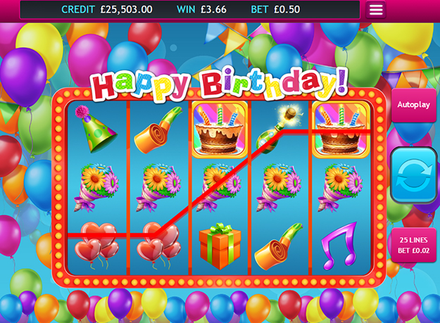

Game Properties & Features

|  |  |
| --- | --- |
| **Properties** | |
| Versions | Standalone, Mini, Mobile |
| RTP (%) | 95 |
| Number of Reels | 5 |
| Number of Lines | 25 |
| Min. Bet | 1 credit |
| Max Bet | 1250 credits |
| Game Play | Medium |
| Volatility | Medium |
| Hit Rate playing 1 line | 1 in 7.5 |
| Combined Feature Hit Rate | 1 in 113 |
| Default Bet | 1 credit per line |
| Supports Free Spins | Yes |
| Recommended Categories | * Big Wins/Volatile |
| **Features** | |
| Free Spins | Up to 15 |
| Substitute | Cake |