HAPPY MUSHROOM

Short Description

Be whisked away on a magical adventure of 25 lines across 5 fun-filled reels! Win big as you dance amongst the wishing willows where rainbow mushrooms bounce with delight and the wise owls reward you with Free Games. Feel the magic and adventure as you spin your way to fortune in this enchanted slot game!

Marketing Materials

The materials can be downloaded from [here](https://files.eyecon.com/index.php/s/Cl210pBZ9gPmRc9)

Screenshots

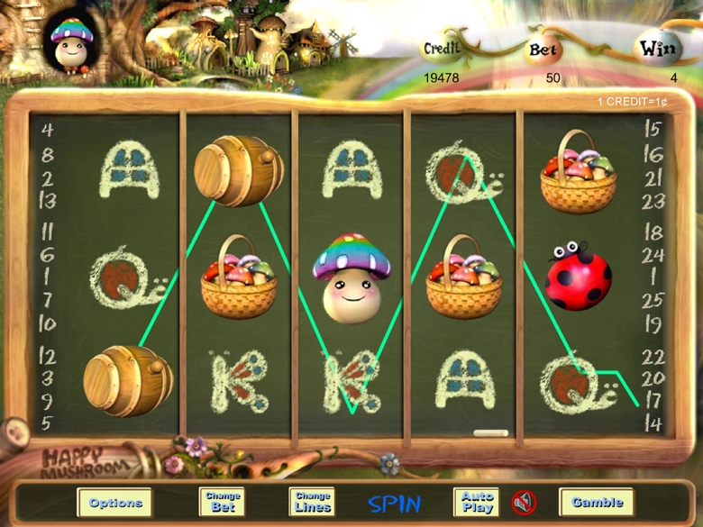

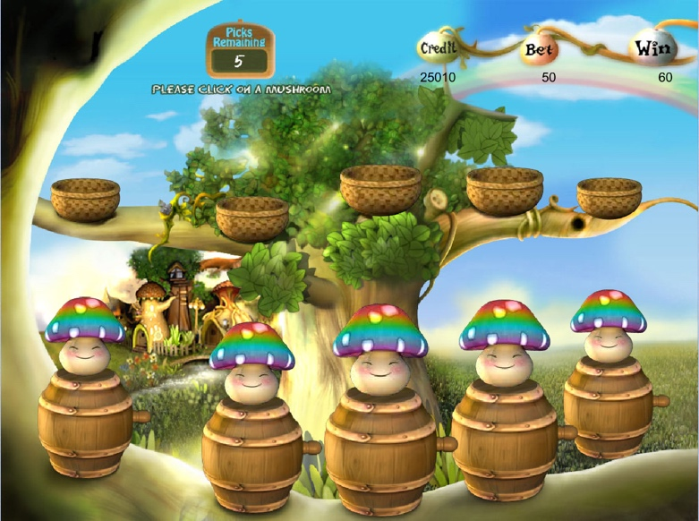

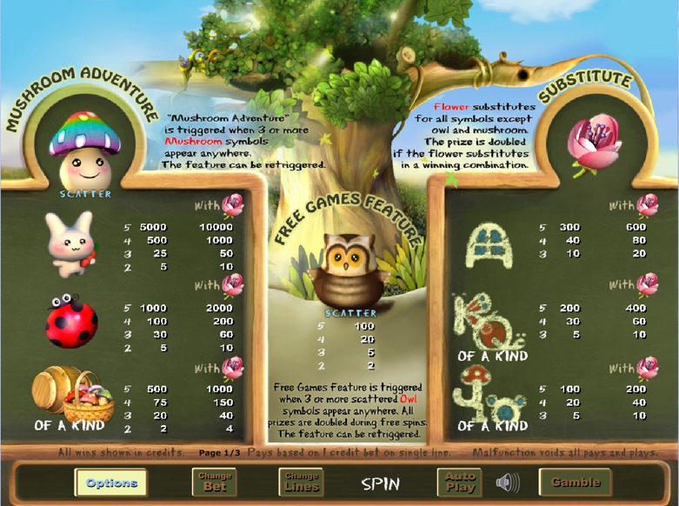

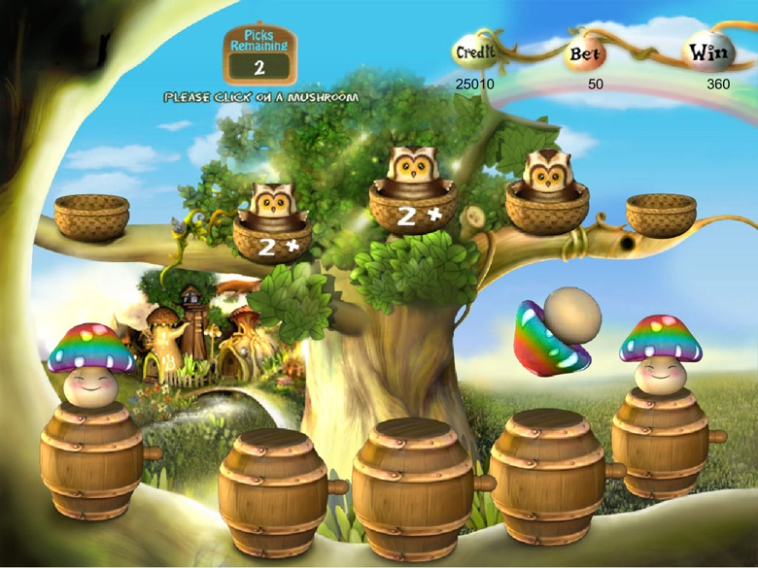

Game Properties & Features

|  |  |
| --- | --- |
| **Properties** | |
| Versions | Standalone |
| RTP (%) | 95 |
| Number of Reels | 5 |
| Number of Lines | 25 |
| Min. Bet | 1 credit |
| Max Bet | 1,250 credits |
| Game Play | Medium |
| Volatility | Medium |
| Hit Rate playing 1 line | 1 in 8.5 |
| Combined Feature Hit Rate | 1 in 80 |
| Default Bet | 2 credits/line playing 25 lines |
| Supports Free Spins | Yes |
| Recommended Categories | * Festive/Seasonal – Spring * Cute Animals |
| **Features** | |
| Free Spins | Up to 25 |
| Substitute | Flower Symbols |
| Bonus Rounds | Triggered by 3 or more Mushrooms/Owls |