Game Information for Native Casino App

Introduction
This document aims to capture game information and images for the Native Casino app. Please fill out all the yellow boxes.
This document is required for each game.

General information

Game name
What is the name of your game and the translation to Simplified Chinese? Include a trade mark if applicable.
English | Hot off the Press
Simplified Chinese | 新闻热点
Traditional Chinese | 重磅頭條
Japanese | 最新ニュースラッシュ
Korean | 핫 오프 더 프레스
Malay | Panas dari Akhbar
Spanish | Recién llegado de la prensa

Game code
What is the game code?
pop_416a4674_eye

Winning lines or ways (slot games only)
How many winning lines or ways does your game have?
25 lines

Jackpot
Are jackpots supported in your game? If so, state the jackpot identifier.
Via another game code yes – but this game code is for the non jackpot version

Bet per lines
What is the default bet per line ranges? Please provide in different currencies if such information is available
GBP|EUR|USD [1, 2, 3, 4, 5, 6, 8, 10, 15, 20, 25, 30, 40, 50, 60, 80, 100, 200 ]

Game descriptions
Provide a description of your game in a few sentences for all the lobby languages:
Languages | Description
English (International) | Extra! Extra! Read all about it!  Hot off the Press hits headlines with an exciting Prize Pick feature plus Free Games! 3 or more scattered 'Hot off the Press' symbols appearing anywhere will trigger the prize Pick feature, with a prize of up to 5000x the total wager available!  This game will really give our players something to gossip about!
Chinese Simplified | 号外！号外！仔细读读吧！  新闻热点以令人兴奋的奖金挑选特色游戏和免费游戏成为头条新闻！3个或更多散布的“新闻热点”符号出现在任意位置时，将会触发奖金挑选特色游戏，奖金最高可达5000x总赌注！  这款游戏将给我们的玩家带来真正的劲爆新闻！
Chinese Traditional | 號外！號外！不要錯過重磅新聞！  在重磅頭條中，精彩的獎金挑選功能和免費遊戲等著您！3個或更多散佈出現的「重磅頭條」符號出現在任何位置上會觸發獎金挑選功能，可能在其中最多贏得總投注金額的5000倍！  該遊戲帶來無限討論話題！
Japanese | 号外！号外！詳しくはコチラ！  最新ニュースラッシュが、エキサイティングなプライズピックフィーチャーとフリーゲームでヘッドラインを賑わせます！ どこにでも現れる3つ以上の「最新ニュースラッシュ」シンボルで、最大5000倍のトータルベットが可能なプライズピックフィーチャーがトリガーされます！  このゲームは、本当にプレイヤーにおしゃべりのネタを提供することでしょう！
Korean | 보세요! 추가입니다! 자세히 읽어보세요!  핫 오프 더 프레스는 흥미진진한 상금 선택 기능과 무료 게임으로 헤드라인을 장식합니다! 흩어져 있는 '핫 오프 더 프레스' 심볼이 3개 이상 나타나면 총 베팅 금액의 최대 5000배에 달하는 상금을 받을 수 있는 상금 선택 기능이 작동합니다!  이 게임은 플레이어들에게 가십거리를 제공할 것입니다!
Malay | Ekstra! Ekstra! Baca semua tentangnya!  Panas dari Akhbar menjadi tajuk utama dengan ciri Pilihan Hadiah yang menarik serta Permainan Percuma! 3 atau lebih simbol 'Panas dari Akhbar' bertaburan di mana-mana sahaja akan mencetuskan ciri Pilih hadiah, dengan hadiah sehingga 5000x jumlah pertaruhan yang tersedia!  Permainan ini benar-benar akan memberikan pemain kami sesuatu untuk digosipkan!
Spanish | ¡Extra, extra! ¡Aquí puede leerlo todo!  Recién llegado de la prensa aparece en primera plana con una emocionante función de Selección de Premios, ¡además de Partidas Gratis! 3 o más símbolos dispersos "Recién llegado de la prensa" en cualquier parte activarán la función Selección de Premios, ¡con un premio de hasta 5000x la apuesta total!  ¡Este juego sin duda dará a nuestros jugadores algo que comentar durante mucho tiempo!

Images
Note: the assets should be placed in the folders which have the following structure:
- icons with game names should be placed here: games\<game_code>\icons\icons_with_game_names\

Screenshots
The following screenshots are required on mobile in landscape. In case game is available in Portrait only, then screenshots in Portrait (461 x 819) should be provided.
Image type | Screenshot name | Dimensions | Format
Main game in English | screen_<game_code>_main | 819 x 461 | PNG
Significant win in English | screen_<game_code>_big_win | 819 x 461 | PNG
Bonus scene in English | screen_<game_code>_bonus | 819 x 461 | PNG

Game icons
The following game icons are required:
Image Name | Dimensions | Format | Where used in app | Screenshot
<game_code>_icon_5x5 | 240 x 240 | PNG | Quick Switch between games feature | 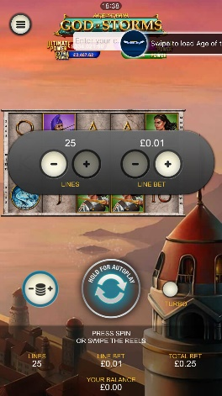
<game_code>_icon_10x10 | 540 x 540 | PNG | Main WL layout: game tiles icons in Lobby, on Game Advisor, Broken games etc. | 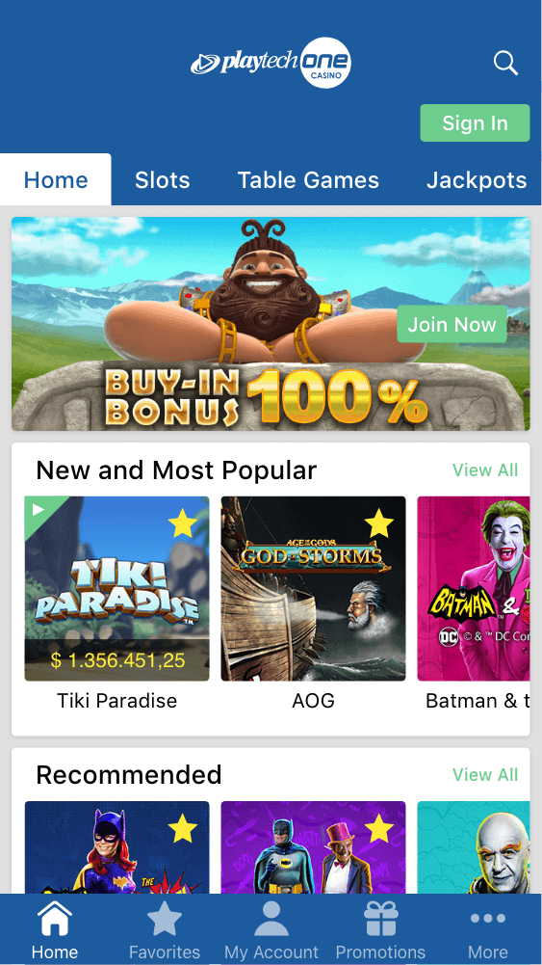  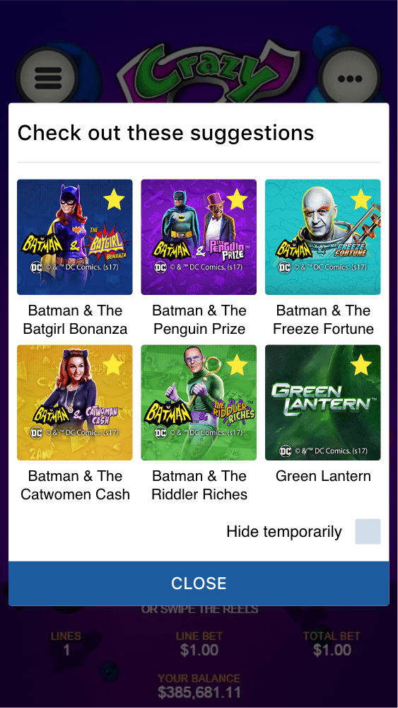
<game_code>_icon_30x5 | 1104 x 336 | PNG | Game Info screen header for tablets | 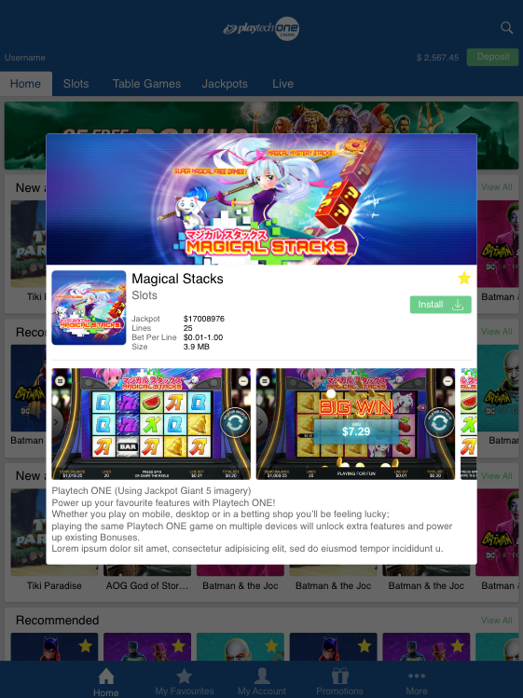
<game_code>_icon_30x10 | 1788 x 540 | PNG | My Favourites screen | 