Imperial Destiny

Short Description

Live the excitement and conquer your fortune in this new slot game, Imperial Destiny! Experience the wonder of expanding reels in the exciting FREE games feature. Bring the terracotta warriors to life and win up to 100X your bet! It’s your destiny to win big!

Marketing Materials

The materials can be downloaded from [here](https://files.eyecon.com/index.php/s/sUXOzVGv1WgmmHX)

Screenshots

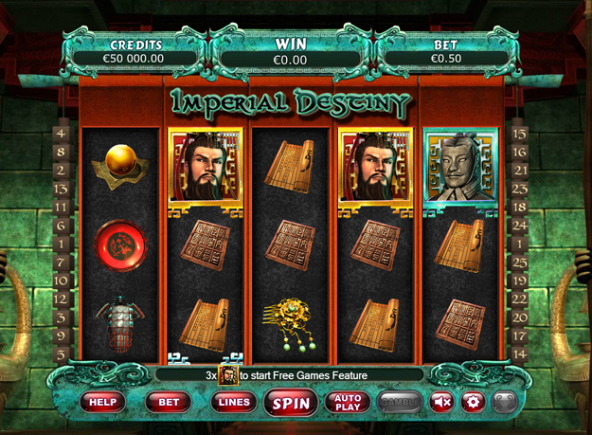

Game Properties & Features

|  |  |
| --- | --- |
| **Properties** | |
| Versions | Standalone, Mobile |
| RTP (%) | 95 |
| Number of Reels | 5 |
| Number of Lines | 25 |
| Min. Bet | 1 credit |
| Max Bet | 50 credits |
| Game Play | Medium |
| Volatility | Medium |
| Hit Rate playing 1 line | 1 in 27.8 |
| Combined Feature Hit Rate | 1 in 112.2 |
| Default Bet | 1 credit per line |
| Supports Free Spins | Yes |
| Recommended Categories | * Action * Adventure * Fantasy * Oriental games |
| **Features** | |
| Free Spins | Up to 25 |
| Substitute | Prizes are doubled |
| Prize Pick Feature | Up to 100X your bet |