IRISH LUCK

Short Description

Embrace your inner lucky leprechaun when you play Irish Luck Slots. It’s one of the best online slot games around, and once you start spinning, it’ll be clear why! It’s a fun and light-hearted Irish themed game, filled with all things lucky – Four Leaf Clovers, Leprechauns, Fairies, Frothy Beer and more! It’s an easy game to play, and you’re guaranteed to have the best time whilst winning big! Green never looked so good! Don’t miss another minute of luck – spin to win Irish Luck Slots today!

Marketing Materials

The materials can be downloaded from [here](https://files.eyecon.com/index.php/s/LGG7HY5Cx0pSFYw)

Screenshots

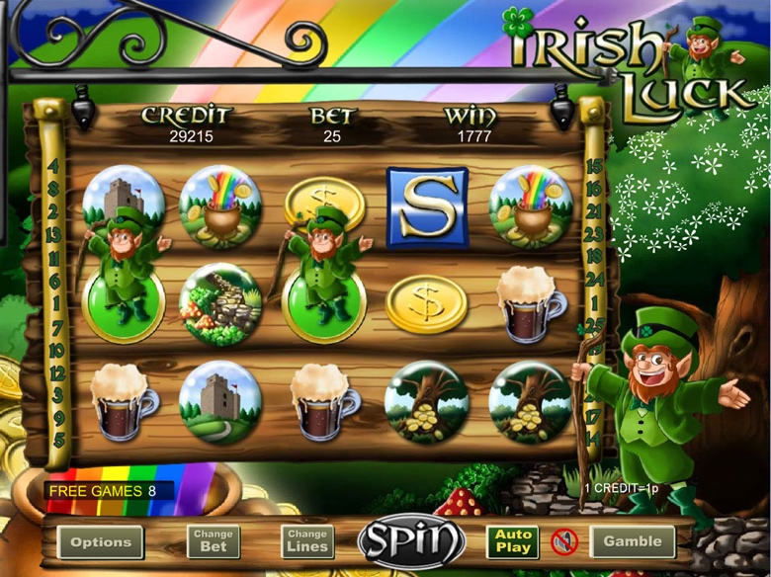

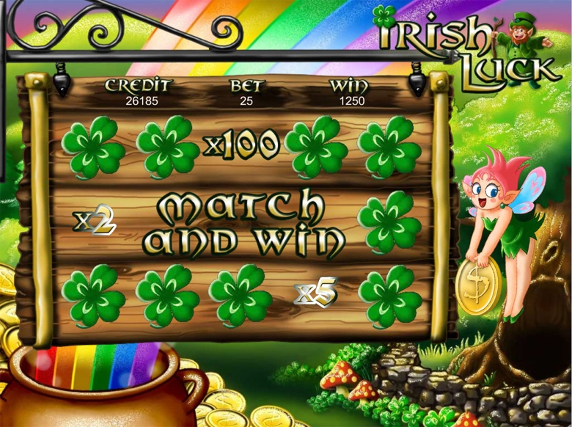

Game Properties & Features

|  |  |
| --- | --- |
| **Properties** | |
| Versions | Standalone, Mini, Mobile |
| RTP (%) | 95 |
| Number of Reels | 5 |
| Number of Lines | 25 |
| Min. Bet | 1 credit |
| Max Bet | 1,250 credits |
| Game Play | Medium |
| Volatility | Medium |
| Hit Rate playing 1 line | 1 in 5 |
| Combined Feature Hit Rate | 1 in 75 |
| Default Bet | 1 credit per line |
| Supports Free Spins | Yes |
| Recommended Categories | * Irish Slots * Fantasy |
| **Features** | |
| Free Spins | Up to 10 |
| Substitute | Prizes are doubled |
| Prize Pick Feature | Up to 100X the feature triggering bet |