JEWEL JOURNEY

Short Description

Don’t miss the excitement of the Jewel Journey! Reveal hidden treasure with the purple gems. Escape the tiger and be rewarded with up to 12 Free Games and random multipliers. Locate the missing gems with the map to win the treasure! Let the adventure begin over 25 paylines and 5 reels!

Marketing Materials

The materials can be downloaded from [here](https://files.eyecon.com/index.php/s/6WwsdpvTj1unXBZ)

Screenshots

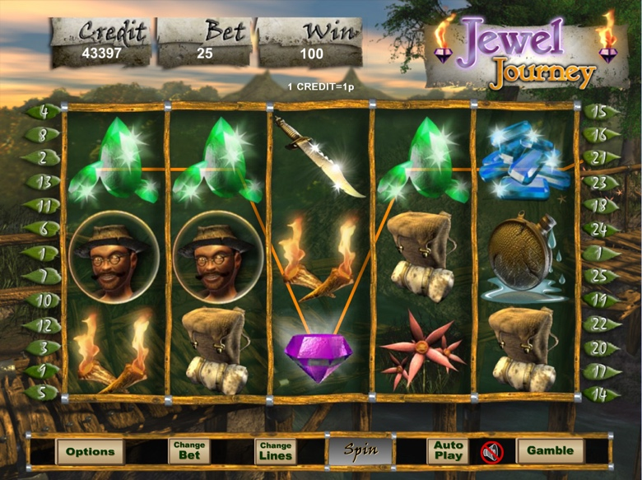

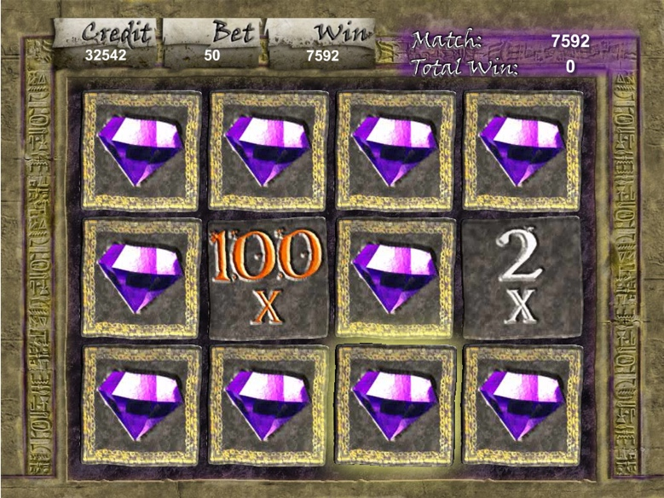

Game Properties & Features

|  |  |
| --- | --- |
| **Properties** | |
| Versions | Standalone, Mini |
| RTP (%) | 95 |
| Number of Reels | 5 |
| Number of Lines | 25 |
| Min. Bet | 1 credit |
| Max Bet | 1250 credits |
| Game Play | Medium |
| Volatility | Low |
| Hit Rate playing 1 line | 1 in 6.3 |
| Combined Feature Hit Rate | 1 in 105 |
| Default Bet | 1 credit per line |
| Supports Free Spins | Yes |
| Recommended Categories | * Adventure * Treasure |
| **Features** | |
| Free Spins | Up to 12 |
| Substitute | Purple Gem Doubles Prizes |
| Prize Pick Feature | Up to 100X triggering bet |