JURASSIC JUNIORS

Short Description

Jurassic Juniors takes cute to the Eggs-treme! Enjoy the fun with 12 adorable baby dinos in this 25-lines slot. Hatch your fortunes in the Egg and run away with free games and triple prizes while the volcano is erupting. These prehistoric pets require constant attention. Find the Big Momma to double your winnings. Get cracking and play now!

Marketing Materials

The materials can be downloaded from [here](https://files.eyecon.com/index.php/s/HRzbbxpeyQTv9v6)

Screenshots

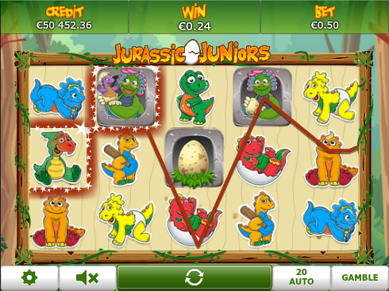

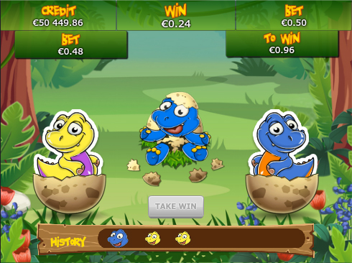

Game Properties & Features

|  |  |
| --- | --- |
| **Properties** | |
| Versions | Standalone, Mini, Mobile |
| RTP (%) | 95 |
| Number of Reels | 5 |
| Number of Lines | 25 |
| Min. Bet | 1 credit |
| Max Bet | 50 credits |
| Game Play | Medium |
| Volatility | Medium |
| Hit Rate playing 1 line | 1 in 7.5 |
| Combined Feature Hit Rate | 1 in 113 |
| Default Bet | 1 credit per line |
| Supports Free Spins | Yes |
| Recommended Categories | * Adventure * Cute Animals |
| **Features** | |
| Free Spins | Up to 15 |
| Substitute | Big Momma Symbol |