KINGDOM OF CASH

Short Description
Hear ye! Hear ye! Let the fun and adventure begin in this exciting new 25-line slot, Kingdom of Cash! Battle your way to fortune and glory in the thrilling Combat Feature. Tremble with excitement as the Princess bestows up to 25 free games with triple prizes! Play now as the Kingdom of Cash awaits!

Marketing Materials
The materials can be downloaded from here
Screenshots
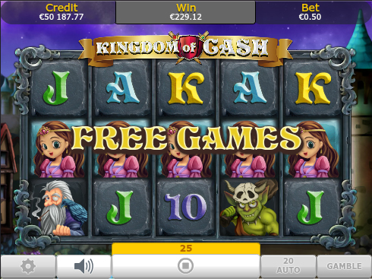
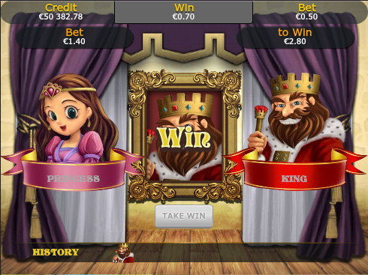

Game Properties & Features

Properties
Versions | Standalone, Mini, Mobile
RTP (%) | 95
Number of Reels | 5
Number of Lines | 25
Min. Bet | 1 credit
Max Bet | 50 credits
Game Play | Hard
Volatility | High
Hit Rate playing 1 line | 1 in 24.8
Combined Feature Hit Rate | 1 in 134.7
Default Bet | 1 credit per line
Supports Free Spins | Yes
Recommended Categories | - Big Wins/Volatile  - Adventure  - Progressive Jackpots
Features
Free Spins | Up to 25
Substitute | Princess Symbol doubles prizes

