Game Information for Native Casino App

Introduction
This document aims to capture game information and images for the Native Casino app. Please fill out all the yellow boxes.
This document is required for each game.

General information

Game name
What is the name of your game and the translation to Simplified Chinese? Include a trade mark if applicable.
English | Kiss Me Clover
Simplified Chinese | 吻我吧，三叶草妖精
Traditional Chinese | 四葉草之吻
Japanese | キスミークローバー
Korean | 키스 미 클로버
Malay | Kucup Saya Clover
Spanish | Bésame Trébol

Game code
What is the game code?
pop_kissmeclover_eye

Winning lines or ways (slot games only)
How many winning lines or ways does your game have?
25 Line

Jackpot
Are jackpots supported in your game? If so, state the jackpot identifier.
Via another game code yes – but this game code is for the non jackpot version

Bet per lines
What is the default bet per line ranges? Please provide in different currencies if such information is available
GBP|EUR|USD [ 1, 2, 3, 4, 5, 6, 8, 10, 15, 20, 25, 30, 40, 50, 60, 80, 100, 200 ]

Game descriptions
Provide a description of your game in a few sentences for all the lobby languages:
Languages | Description
English (International) | Do you have the Luck of the Irish? Why not find out today with this exciting new 5 reel, 25 line slot game! A little bit of Irish blarney may be what you need to win, are you full of that Irish charm? Maybe if you win up to 25 free games you will know that luck is on your side! And if Lady Luck really smiles on you, you will be playing the wonderful Lucky Wheel feature allowing you to win prizes 100X your bet. Is today your lucky day, will YOU be winning your fortune with Kiss Me Clover.
Chinese Simplified | 您有爱尔兰人的运气吗？何不在今天立即体验这款设有 5 个卷轴 25 条赔付线的全新老虎机游戏！也许需要一些爱尔兰式的赞许才能中奖，您浑身散发着爱尔兰式的魅力吗？倘若赢得 25 次免费游戏，您一定会发现自己运气来了！要是再得到幸运女神的眷顾，还将有机会体验奇妙的幸运轮盘玩法，赢取相当于 100 倍投注额的彩金。今天是您的幸运日吗？您会在《吻我吧，三叶草妖精》游戏中赢取丰厚彩金吗。
Chinese Traditional | 你擁有愛爾蘭人的好運嗎？來這款全新的 5 捲軸 25 條獲勝線的遊戲上一試身手吧！一點點愛爾蘭的花言巧語可能就是助你獲勝的關鍵，你是否擁有這種愛爾蘭好運魔力呢？或許在贏下最多 25 次免費遊戲後，你會知道幸運女神是在你這邊的！要是幸運女神真的在對你微笑，你還將有機會轉動奇妙的幸運轉盤，讓你的獎金額翻上 100X 倍。今天會是你的幸運日嗎，你會在《四葉草之吻》中抱得大獎歸嗎。
Japanese | アイリッシュの幸運を持っていますか？新しい5リール、25ラインスロットゲームで確かめてみてはどうでしょうか？アイリッシュブラーニが少しあれば勝てるかもしれません。あなたはそのアイリッシュチャームで溢れていますか？最大25のフリーゲームを獲得したら幸運があなたに味方をしているかわかるかもしれません！本当に幸運の女神があなたに微笑むのであれば、ベットの100倍の賞金を獲得することが可能な素晴らしいラッキーホイールフィーチャーをプレイできるかもしれません。今日はあなたのラッキーデイでしょうか？キスミークローバーで大金を獲得できるでしょうか？
Korean | 아이리쉬의 행운을 가지고 있습니까? 이 흥미로운 새로운 5 릴, 25 라인 슬롯 게임을 오늘 알아보세요! 아이리쉬 블래니가 당신이 승리하기 위해 필요한 것일 지도 모릅니다, 그 아일랜드의 매력으로 가득 차 있습니까? 아마 최대 25 회의 무료 게임에서 이긴다면 운이 내 편이라는 것을 알게 될 것입니다! 그리고 레이디 럭이 정말로 당신에게 미소를 짓는다면, 멋진 행운의 휠 기능을 플레이하여 당신의 베팅에서 100 배의 상금을 받을 수 있습니다. 오늘은 당신의 행운의 날이니, 키스 미 클로버로 당신의 행운을 빕니다.
Malay | Adakah anda memiliki Tuah Irish? Mengapa tidak ketahuinya hari ini dengan permainan slot 25 baris, 5 gelendong baharu yang mengujakan ini! Sedikit tentang kemulukan Irish mungkin merupakan perkara yang anda perlukan untuk menang, adakah anda penuh dengan peribadi Irish yang menawan? Mungkin jika anda menang sehingga 25 permainan percuma anda akan tahu tuah berada di pihak anda! Dan jika Tuah benar-benar tersenyum kepada anda, anda akan bermain ciri Roda Tuah hebat yang membolehkan anda untuk memenangi hadiah 100X taruhan anda. Adakah hari ini hari bertuah anda, adakah ANDA akan memenangi kekayaan anda dengan Kiss Me Clover.
Spanish | ¿Tienes la suerte de los irlandeses? ¡Por qué no descubrirlo hoy con esta nueva y emocionante tragaperras de 5 rodillos y 25 líneas! Un trébol de cuatro hojas puede ser lo que necesitas para ganar. ¿Alguna vez has encontrado alguno? ¡Si ganas el tope 25 giros gratis sabrás que la suerte está de tu lado! Y si la Diosa Fortuna realmente te sonríe, alcanzarás la maravillosa Ruleta de la Suerte, que te permite ganar premios 100 veces tu apuesta. ¿Es hoy tu día de suerte? ¿Te cubrirás de billetes gracias a Kiss Me Clover?

Images
Note: the assets should be placed in the folders which have the following structure:
- icons with game names should be placed here: games\<game_code>\icons\icons_with_game_names\

Screenshots
The following screenshots are required on mobile in landscape. In case game is available in Portrait only, then screenshots in Portrait (461 x 819) should be provided.
Image type | Screenshot name | Dimensions | Format
Main game in English | screen_<game_code>_main | 819 x 461 | PNG
Significant win in English | screen_<game_code>_big_win | 819 x 461 | PNG
Bonus scene in English | screen_<game_code>_bonus | 819 x 461 | PNG

Game icons
The following game icons are required:
Image Name | Dimensions | Format | Where used in app | Screenshot
<game_code>_icon_5x5 | 240 x 240 | PNG | Quick Switch between games feature | 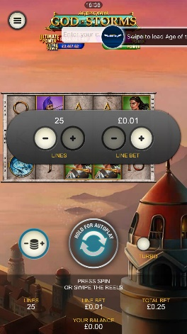
<game_code>_icon_10x10 | 540 x 540 | PNG | Main WL layout: game tiles icons in Lobby, on Game Advisor, Broken games etc. | 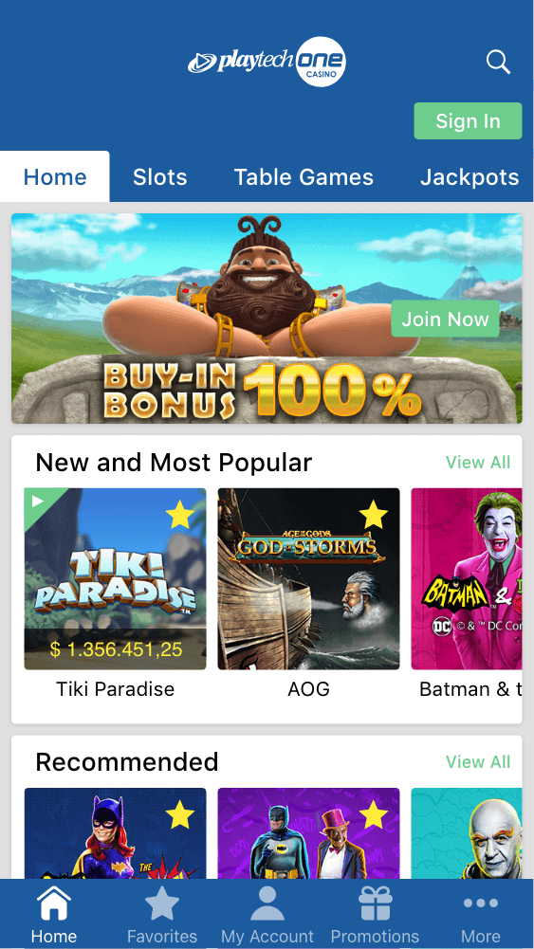  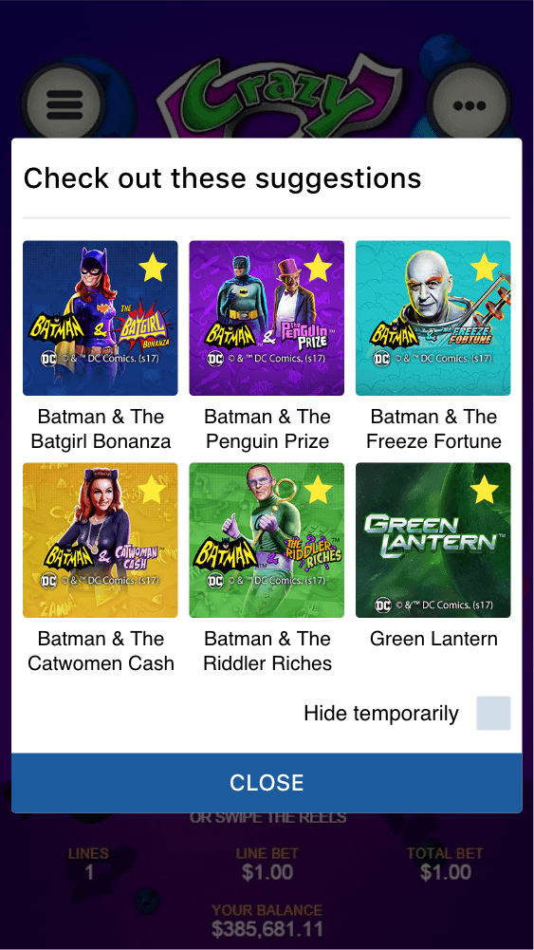
<game_code>_icon_30x5 | 1104 x 336 | PNG | Game Info screen header for tablets | 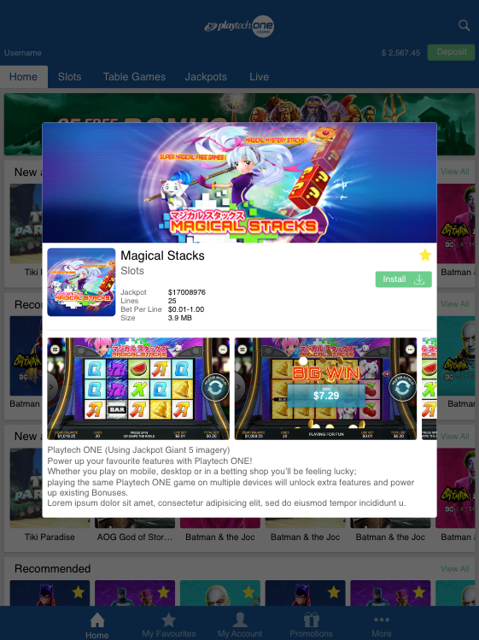
<game_code>_icon_30x10 | 1788 x 540 | PNG | My Favourites screen | 