Game Information for Native Casino App

Introduction
This document aims to capture game information and images for the Native Casino app. Please fill out all the yellow boxes.
This document is required for each game.

General information

Game name
What is the name of your game and the translation to Simplified Chinese? Include a trade mark if applicable.
English | Kitty Payout
Simplified Chinese | 猫咪派彩
Traditional Chinese | 猫咪派彩
Japanese | キティペイアウト
Korean | 키티 페이아웃
Malay | Pembayaran Kitty
Spanish | Gatito Ganador

Game code
What is the game code?
pop_kittypayout_eye

Winning lines or ways (slot games only)
How many winning lines or ways does your game have?
25 Line

Jackpot
Are jackpots supported in your game? If so, state the jackpot identifier.
Via another game code yes – but this game code is for the non jackpot version

Bet per lines
What is the default bet per line ranges? Please provide in different currencies if such information is available
GBP|EUR|USD [ 1, 2, 3, 4, 5, 6, 8, 10, 15, 20, 25, 30, 40, 50, 100, 200 ]

Game descriptions
Provide a description of your game in a few sentences for all the lobby languages:
Languages | Description
English (International) | Let’s pounce and play this all new 25 line, 5-reel slot – Kitty Payout. Win up to 25 Furry Free games and feed Kitty her bowl of milk to double your prize. Simply the purrrfect way to start 2018, this game really is a bouncing ball of fun.
Chinese Simplified | 立即尝鲜这款设有 25 条赔付线的 5 卷轴全新老虎机游戏——《猫咪派彩》。最高可赢得 25 次毛绒动物免费游戏，喂猫咪喝牛奶，让您的奖励加倍。此游戏堪称 2018 年的最佳开启方式，体验充满乐趣的弹力球。
Chinese Traditional | 立即嘗鮮這款設有 25 條線的 5 軸全新老虎機游戲–《猫咪派彩》。最高可贏得 25 次毛絨動物免費游戲，喂猫咪喝牛奶，讓你的獎勵加倍。此游戲堪稱開啟 2018 年完美方式，盡情體驗樂趣橫生的彈力球。
Japanese | このまったく新しい25ライン、5リールスロット– キティーペイアウトを急いでプレイしましょう。最大25のファーリーフリーゲームに勝ち、キティにミルクのボウルを与え賞金を2倍にしましょう。2018年の完璧な始まりであるこのゲームは、本物の楽しさそのものです。
Korean | 이 새로운 25 라인, 5 릴 슬롯인, 키티 페이아웃을 즉시 플레이 해 봅시다. 최대 25 개의 퍼리 프리 게임에서 승리하고 키티에게 우유 한 그릇을 먹이면 귀하의 상금이 두 배가 됩니다. 2018 년을 시작하는 간단한 완벽한 방법인, 이 게임은 정말 재미있는 바운싱 볼입니다.
Malay | Mari cuba dan main slot 25 baris, 5 gelendong serba baharu ini – Pembayaran Kitty. Menangi hingga 25 permainan Bebas Bulu dan beri makan Kitty dengan semangkuk susunya untuk menggandakan hadiah anda. Sememangnya cara yang sempurna untuk memulakan tahun 2018, permainan ini benar-benar bola lantun keseronokan.
Spanish | Disfrutemos como gatitos en esta nueva tragaperras de 5 carretes y 25 líneas: Gatito Ganador. Gane hasta 25 partidas gratis Peludos, y dele al Gatito su tazón de leche para duplicar el premio. ¡Una experiencia auténticamente felina, más divertida que un ovillo de lana!

Images
Note: the assets should be placed in the folders which have the following structure:
- icons with game names should be placed here: games\<game_code>\icons\icons_with_game_names\

Screenshots
The following screenshots are required on mobile in landscape. In case game is available in Portrait only, then screenshots in Portrait (461 x 819) should be provided.
Image type | Screenshot name | Dimensions | Format
Main game in English | screen_<game_code>_main | 819 x 461 | PNG
Significant win in English | screen_<game_code>_big_win | 819 x 461 | PNG
Bonus scene in English | screen_<game_code>_bonus | 819 x 461 | PNG

Game icons
The following game icons are required:
Image Name | Dimensions | Format | Where used in app | Screenshot
<game_code>_icon_5x5 | 240 x 240 | PNG | Quick Switch between games feature | 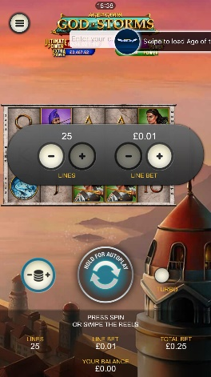
<game_code>_icon_10x10 | 540 x 540 | PNG | Main WL layout: game tiles icons in Lobby, on Game Advisor, Broken games etc. | 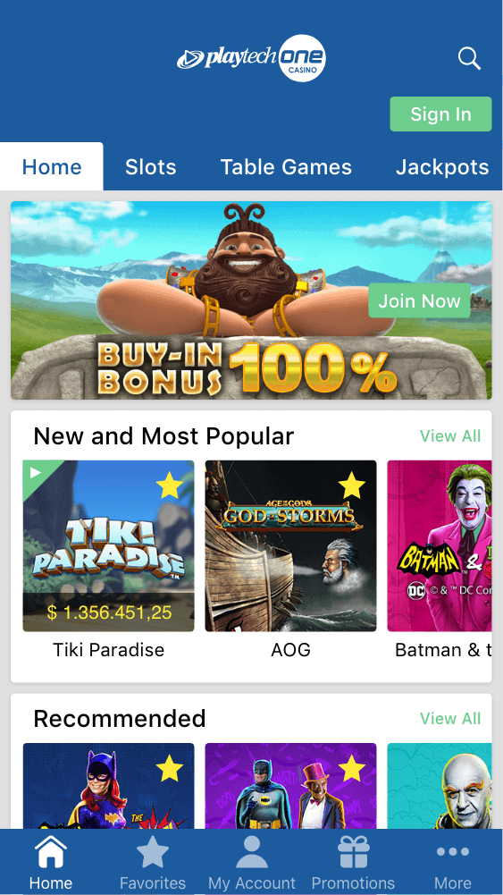  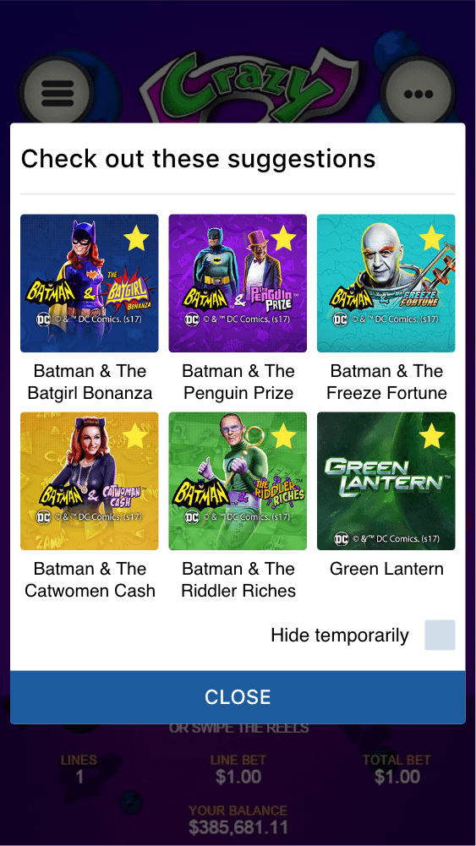
<game_code>_icon_30x5 | 1104 x 336 | PNG | Game Info screen header for tablets | 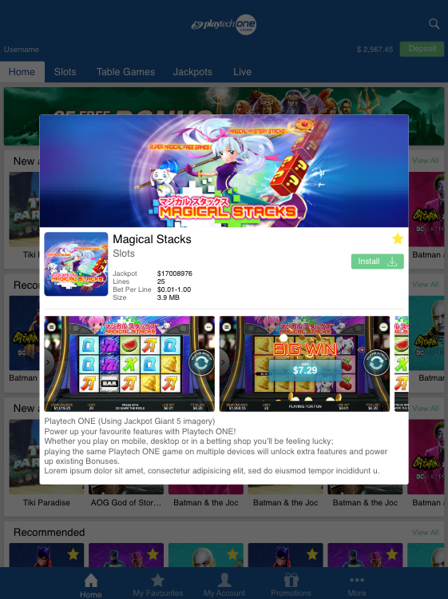
<game_code>_icon_30x10 | 1788 x 540 | PNG | My Favourites screen | 