LION DANCE

Short Description

The Lion Dance brings you good luck and fortune, so you can win big in this slot with 3 awesome features! Prizes are doubled with Lettuce substitutes. Red Envelopes reward you in the new multi-level prize pick feature, see the Lion Dance in Free Games and enjoy the excitement of the Fireworks Festival!

Marketing Materials

The materials can be downloaded from [here](https://files.eyecon.com/index.php/s/DXPvOvM047AZxWT)

Screenshots

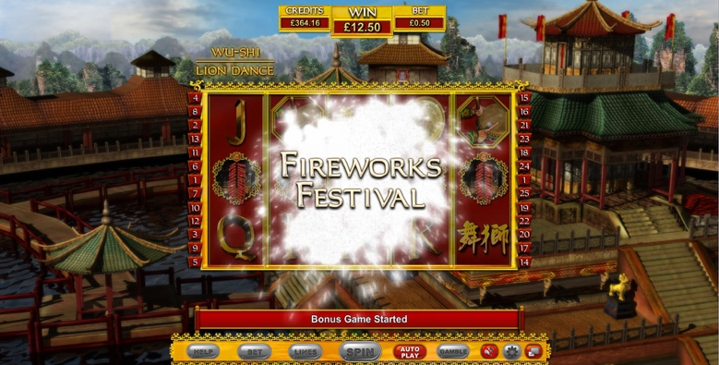

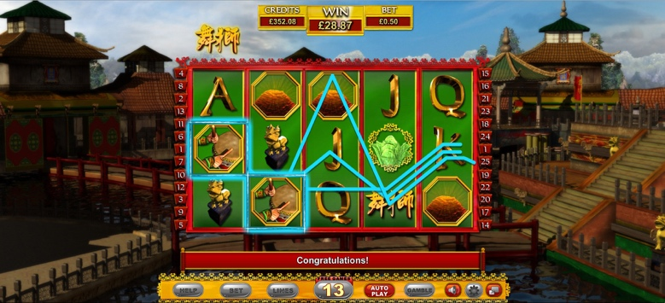

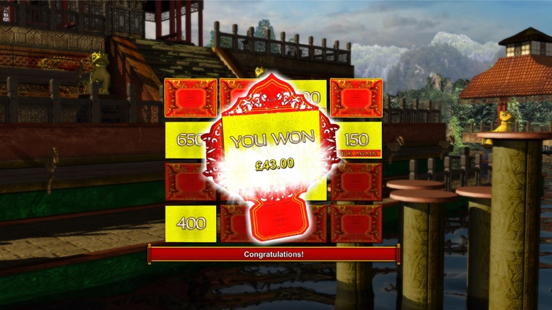

Game Properties & Features

|  |  |
| --- | --- |
| **Properties** | |
| Versions | Standalone |
| RTP (%) | 95 |
| Number of Reels | 5 |
| Number of Lines | 25 |
| Min. Bet | 1 credit |
| Max Bet | 1250 credits |
| Game Play | Medium |
| Volatility | Medium |
| Hit Rate playing 1 line | 1 in 15.5 |
| Combined Feature Hit Rate | 1 in 92 |
| Default Bet | 2 credits/line playing 25 lines |
| Supports Free Spins | Yes |
| Recommended Categories | * Oriental * Festive/Seasonal – Chinese New Year |
| **Features** | |
| Free Spins | Up to 25 |
| Substitute | Lettuce Symbol |
| Bonus Round | Triggered by 3 or more Envelopes |