LOST ISLAND

Short Description

Discover a Lost Island of treasures in this magical 25-line, 5-reel slot game full of adventure! Dance with the local tribesmen to win free games while massive volcanic eruptions substitute in the winning combinations. You’ll be the king of the jungle sitting on a throne of Island Treasures!

Marketing Materials

The materials can be downloaded from [here](https://files.eyecon.com/index.php/s/ctFkFYbihThQAN5)

Screenshots

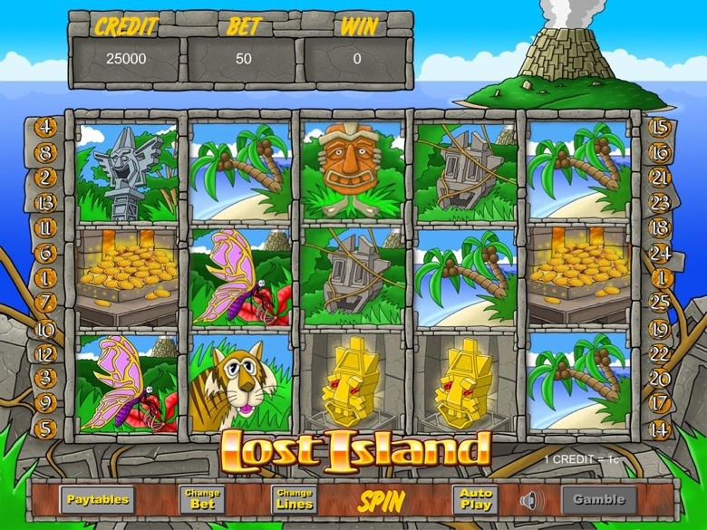

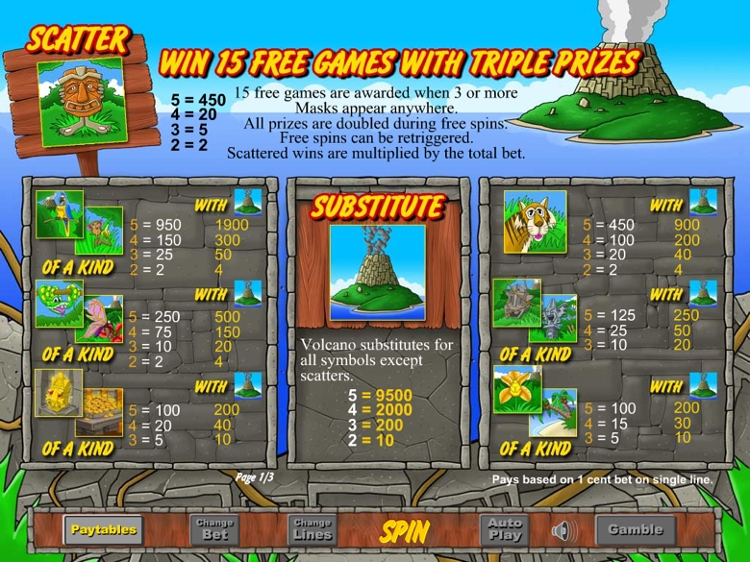

Game Properties & Features

|  |  |
| --- | --- |
| **Properties** | |
| Versions | Standalone, Mini, Mobile |
| RTP (%) | 95 |
| Number of Reels | 5 |
| Number of Lines | 25 |
| Min. Bet | 1 credit |
| Max Bet | 1,250 credits |
| Game Play | Medium |
| Volatility | Soft |
| Hit Rate playing 1 line | 1 in 6.7 |
| Combined Feature Hit Rate | 1 in 86 |
| Default Bet | 1 credit per line |
| Supports Free Spins | Yes |
| Recommended Categories | * Big Wins/Volatile * Adventure * Progressive Jackpots |
| **Features** | |
| Free Spins | Up to 100 |
| Substitute | Volcano Symbol doubles prizes |