Game Information for Native Casino App

Introduction
This document aims to capture game information and images for the Native Casino app. Please fill out all the yellow boxes.
This document is required for each game.

General information

Game name
What is the name of your game and the translation to Simplified Chinese? Include a trade mark if applicable.
English | Lost Island
Simplified Chinese | 失落的岛屿
Traditional Chinese | 迷失的島嶼
Japanese | ローストアイランド
Korean | 로스트 아일랜드
Malay | Pulau yang Hilang
Spanish | Isla Perdida

Game code
What is the game code?
pop_lostisland_eye

Winning lines or ways (slot games only)
How many winning lines or ways does your game have?
25 Line

Jackpot
Are jackpots supported in your game? If so, state the jackpot identifier.
Via another game code yes – but this game code is for the non jackpot version

Bet per lines
What is the default bet per line ranges? Please provide in different currencies if such information is available
GBP|EUR|USD [ 1, 2, 3, 4, 5, 6, 8, 10, 15, 20, 25, 30, 40, 50, 100, 200 ]

Game descriptions
Provide a description of your game in a few sentences for all the lobby languages:
Languages | Description
English (International) | Let me set the scene – you’ve just discovered a lost island, which hasn’t been touched in centuries! There are also loads of exotic animals like parrots and tigers, Mayan ruins, and incredible treasures waiting for you. The graphics in Lost Island Slots are simple and beautiful, with a volcano in the background and the sun shining down on the beautiful coconut trees. So, are you ready to start exploring? It’s one of the top online slot games you’ll play, so start spinning!
Chinese Simplified | 不妨勾勒出这样一个场景——刚刚发现一座数百年来从未有人涉足的失落岛屿！那里有鹦鹉和老虎等珍禽异兽，还有玛雅遗址和令人难以置信的宝藏等您去探索。《失落的岛屿》老虎机游戏画面简约美观，以火山为背景，阳光照耀着美丽的椰树林。准备开始探索之旅了吗？这是一款值得体验的顶级老虎机游戏。立即开始旋转吧！
Chinese Traditional | 讓我來幫你設想一個場景吧——你剛剛發現了一座迷失的小島，這裡已經有幾個世紀無人涉足了！島上到處是諸如鸚鵡老虎之類的奇珍異獸和瑪雅遺跡，當然還有令人驚嘆的寶藏在等著你。《迷失的島嶼》遊戲畫面出色：簡約而又富有美感，其以一座火山、落日和美麗的椰子樹為背景。那麼，你準備好探險了嗎？你將玩到的是最一流的線上老虎機遊戲之一，馬上開始吧！
Japanese | 状況を説明します - 今まさにローストアイランドを発見しました。何世紀にも渡って人の目にさらされることがなかった島です！オウムやトラなどのエキゾチックな動物、マヤ遺跡、お宝など、あらゆるものがあなたの参加を待っています。ローストアイランドスロットのグラフィックはシンプルで美しく、バックグラウンドには火山が使われてココナッツの木に太陽の光がさんさんと振り込んでいます。探検する準備はできていますか？最高のオンラインスロットゲームの1つですので、さっそくスピンしてみてください！
Korean | 몇 세기 동안 손대지 않은 잃어버린 섬을 당신이 발견했다는 장면을 설정합시다! 앵무새와 호랑이, 마야 유적지, 당신을 기다리는 놀라운 보물과 같은 이국적인 동물들이 또한 많이 있습니다. 로스트 아일랜드 슬롯의 그래픽들은 간단하고 아름답습니다. 화산이 배경에 있고 태양은 아름다운 코코넛 나무들 아래로 빛나고 있습니다. 이제, 탐험을 시작할 준비가 되셨습니까? 이것은 최고의 온라인 슬롯 게임들 중 하나이므로, 자 스핀을 시작해 보세요!
Malay | Biarkan saya tetapkan suasananya – anda baru sahaja menemui pulau yang hilang, yang belum disentuh selama berkurun! Terdapat juga banyak haiwan eksotik seperti burung kakak tua dan harimau, puing puak Mayan, dan harta karun menakjubkan yang sedang menantikan anda. Grfik dalam Slot Lost Island adalah mudah dan cantik, dengan gunung berapi di latar belakang dan matahari yang menyinari pokok-pokok kelapa yang indah. Jadi, adakah anda sudah bersedia untuk mula meneroka? Permainan ini ialah salah satu permainan slot dalam talian paling popular yang pernah anda main, jadi mula memutarkan!
Spanish | Esta es la emocionante premisa del juego: ¡acabas de descubrir una isla perdida que nadie ha pisado durante siglos! Está llena de animales exóticos, antiguas ruinas e increíbles tesoros esperando que alguien los recoja. Los gráficos de Lost Island Slots son bonitos y sencillos, con un volcán en el fondo y el sol brillando sobre los hermosos cocoteros. ¿Te atreves a empezar la exploración? Lost Island es una de las mejores tragaperras del momento, ¡descubre por qué!

Images
Note: the assets should be placed in the folders which have the following structure:
- icons with game names should be placed here: games\<game_code>\icons\icons_with_game_names\

Screenshots
The following screenshots are required on mobile in landscape. In case game is available in Portrait only, then screenshots in Portrait (461 x 819) should be provided.
Image type | Screenshot name | Dimensions | Format
Main game in English | screen_<game_code>_main | 819 x 461 | PNG
Significant win in English | screen_<game_code>_big_win | 819 x 461 | PNG
Bonus scene in English | screen_<game_code>_bonus | 819 x 461 | PNG

Game icons
The following game icons are required:
Image Name | Dimensions | Format | Where used in app | Screenshot
<game_code>_icon_5x5 | 240 x 240 | PNG | Quick Switch between games feature | 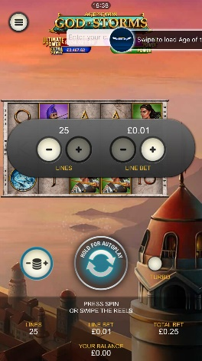
<game_code>_icon_10x10 | 540 x 540 | PNG | Main WL layout: game tiles icons in Lobby, on Game Advisor, Broken games etc. | 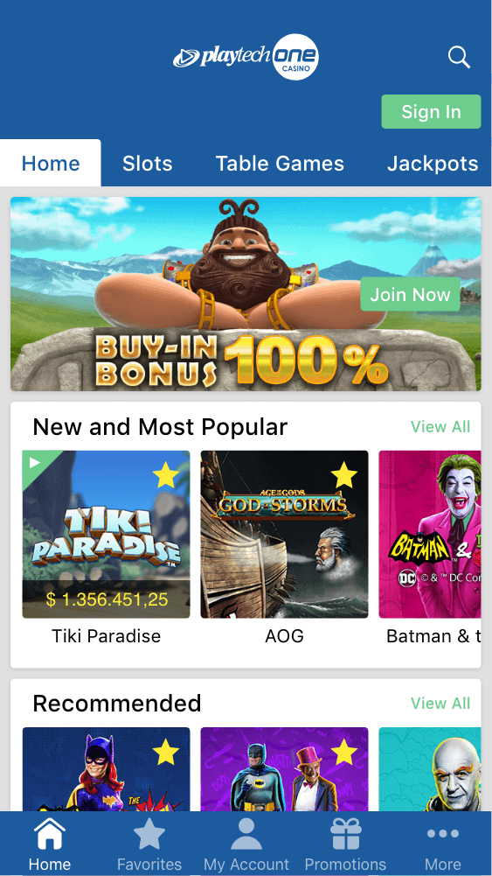  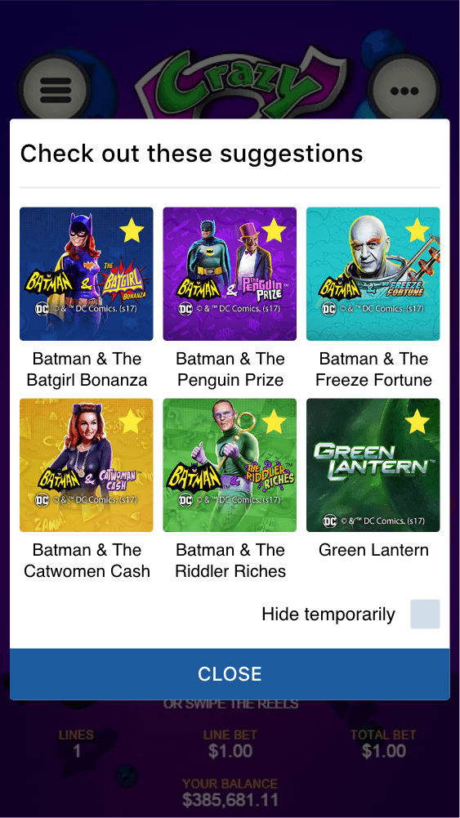
<game_code>_icon_30x5 | 1104 x 336 | PNG | Game Info screen header for tablets | 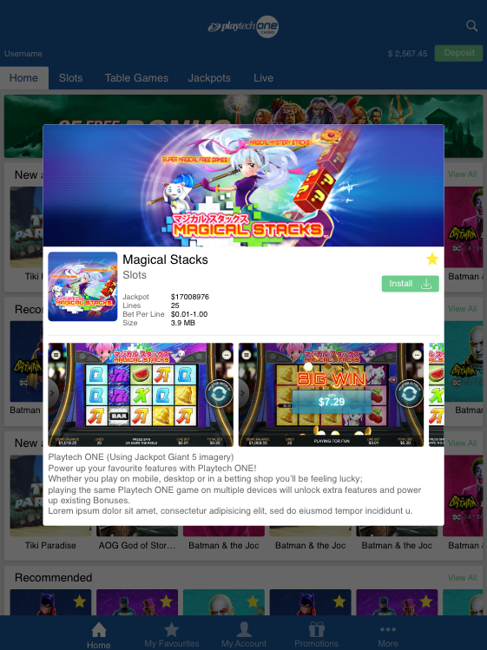
<game_code>_icon_30x10 | 1788 x 540 | PNG | My Favourites screen | 