MAKEOVER MAGIC

Short Description

If you’re wanting a new look then Makeover Magic is the game for you! With up to 25 Free Games to be won and prizes of up to 100X your feature bet, let the girlfriends bring the magical feeling of a makeover to you! Makeover your life by winning big in this exciting new game!

Marketing Materials

The materials can be downloaded from [here](https://files.eyecon.com/index.php/s/H47ElIZ5qas8KUC)

Screenshots

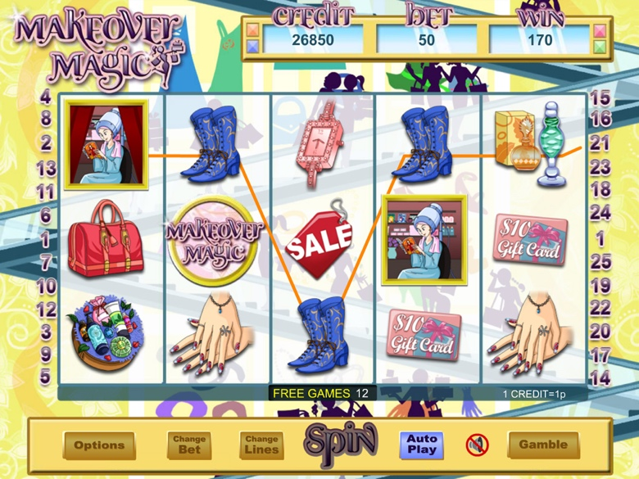

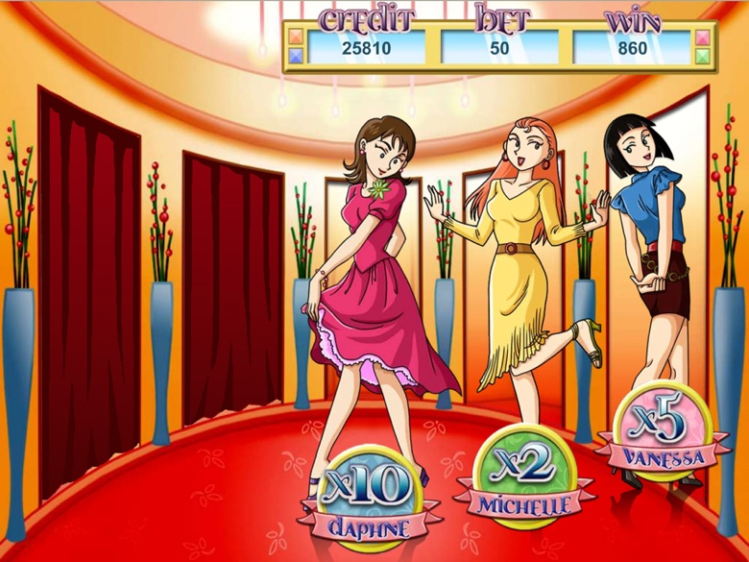

Game Properties & Features

|  |  |
| --- | --- |
| **Properties** | |
| Versions | Standalone, Mini |
| RTP (%) | 95 |
| Number of Reels | 5 |
| Number of Lines | 25 |
| Min. Bet | 1 credit |
| Max Bet | 1,250 credits |
| Game Play | Hard |
| Volatility | Medium |
| Hit Rate playing 1 line | 1 in 21 |
| Combined Feature Hit Rate | 1 in 36.7 |
| Default Bet | 2 credits/line playing 25 lines |
| Supports Free Spins | Yes |
| Recommended Categories | * Ladies |
| **Features** | |
| Free Spins | Up to 25 |
| Substitute | Makeover Symbol |
| Prize Pick Feature | Triggered by 3 or more Girlfriend Symbols |