MONEY BUNNY

Short Description

Indulge yourself this Easter in the egg-citing new mini slot, Money Bunny! Get cracking to reveal egg-cellent fortunes in the delightful Prize Pick Feature and fill up your Easter basket with an enormous 8 Free Games! It’s a 9-line egg-stravaganza over 3 exciting reels. Money Bunny is sure to leave you bouncing for joy!

Marketing Materials

The materials can be downloaded from [here](https://files.eyecon.com/index.php/s/jOgPQZogSxt21Z4)

Screenshots

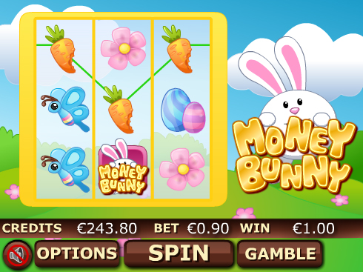

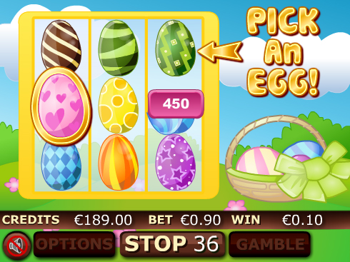

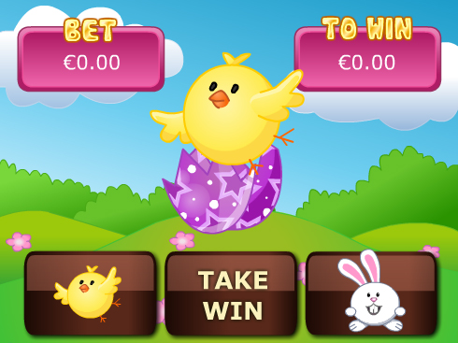

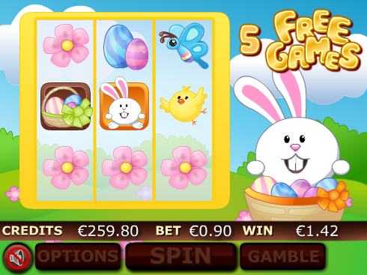

Game Properties & Features

|  |  |
| --- | --- |
| **Properties** | |
| Versions | Standalone |
| RTP (%) | 95 |
| Number of Reels | 3 |
| Number of Lines | 9 |
| Min. Bet | 1 credit |
| Max Bet | 900 credits |
| Game Play | Hard |
| Volatility | High |
| Hit Rate playing 1 line | 1 in 16 |
| Combined Feature Hit Rate | 1 in 79 |
| Default Bet | 10 credits/line playing 9 lines |
| Supports Free Spins | Yes |
| Recommended Categories | * Festive/Seasonal – Easter * Cute Animals |
| **Features** | |
| Free Spins | Up to 8 |
| Substitute | Money Bunny Logo |
| Prize Pick Feature | Triggered by 3 Basket Symbols |