Hi Zvi,

How are you?  Hope you didn't have a typical British summer, although I have to admit I'm miss the weather over there☺

We have been promoting a lot of the Eyecon games in July and August and I wanted to update you with some of our activities.

**1.**    **Robin's summer postal**

**Postal** – sent to over 95,000 players

**Players were credited with 20 Free Spins on deposit for 99time**

**Cross:**Players given 100 Free Spins (credited in 5 batches) to play top slot games.

**Churn High:** 100 free spins credited in 5 batches

**Churn Low:** 20 Free Spins which can be credited twice upon deposit.

            Dates: 28.06 – 15.07.17

Free Spins were given for Fluffy, Unicorn Bliss, Enchanted Prince and Stampede.

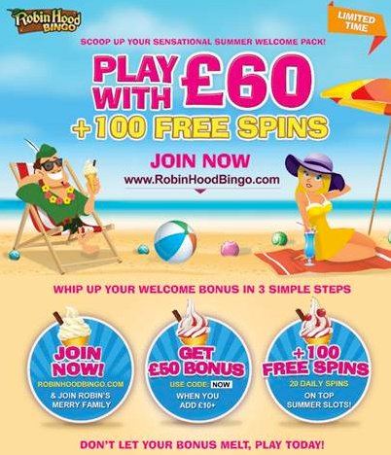

**2.**    **Robin chat parties**

We ran 2 weeks of chat parties for the postal, promoting 99time by giving Free Spins to 1tg & 2tg winners.

**3.**    **Prominent position in the lobby**.

We created a Summer Slots category across all our brands featuring 99time in first place.

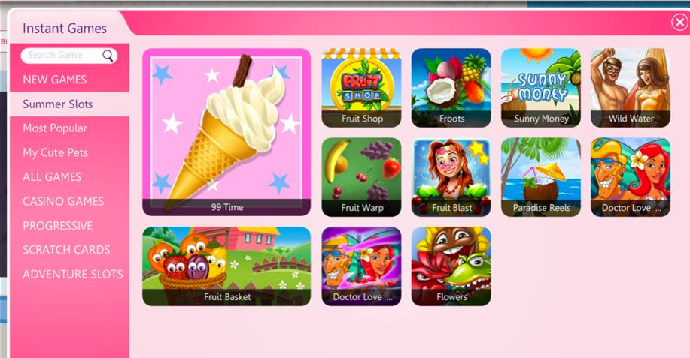

**4.**    **Email**

Email and sms were sent to around 150,000 players promoting the game.

**5.**    **Slots competition.**

Aviv and Asaf ran an IG competition. For every £50 wagered on 99time and another game they got a ticket to the draw.

This competition played the first week the game launched.

                Dates: 15.6 – 21.6.17

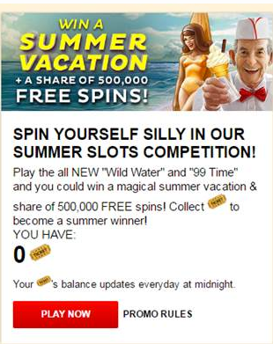

**6.**    **FB.**

Noa gave away free spins on FB to the game.

As you can see it reached over 4,500 people and it got a lot of engagement with our fans.

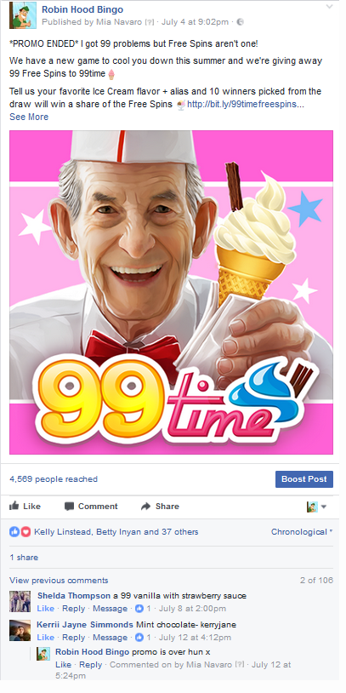

**7.**    **Happy Birthday IG**

We celebrated Moon's 9th birthday!

Happy Birthday is the first game given to players on deposit

Postal  - over 79,000 players

Dates: [27.07-12.08.17](callto:27.07-12.08.17)

Players are given Free Spins to all Eyecon games☺

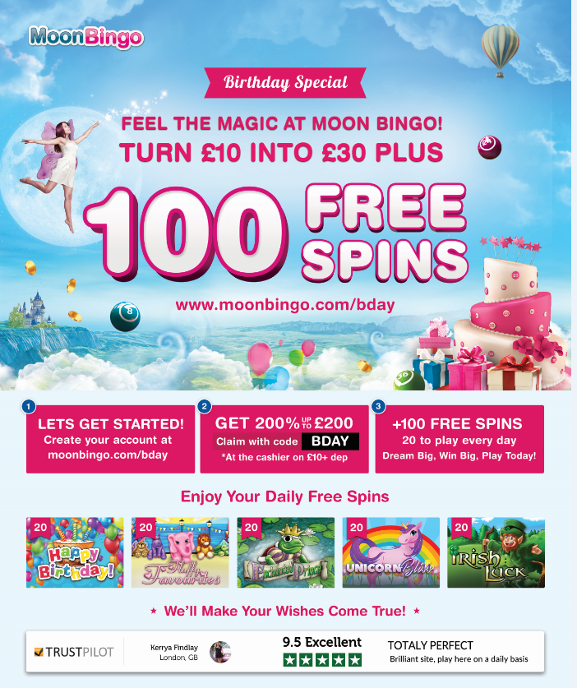

**8.**    **Moon – Chat party activities**.

            Special birthday chat parties giving away Free Spins to Happy Birthday

Keep making great games!

Thanks,

Abi

|  |  |  |  |  |  |  |  |  |  |  |  |  |  |  |  |  |  |  |  |  |  |  |  |  |  |
| --- | --- | --- | --- | --- | --- | --- | --- | --- | --- | --- | --- | --- | --- | --- | --- | --- | --- | --- | --- | --- | --- | --- | --- | --- | --- |
| |  |  |  |  |  | | --- | --- | --- | --- | --- | | **Abigail  Obludzyner** | |  | | | | Branding Team | | | [+972-3-7402952](callto:+972-3-7402952) |  | | [+972547929343](callto:+972547929343) |  | | Abi[@netboostmedia.com](mailto:roman.n@netboostmedia.com) |  | | [www.netboostmedia.com](mailto:roman.n@netboostmedia.com) |  | | This email and its attached content (if any) are private and confidential. | | |  |  | | <http://www.netboostmedia.com/disclaimer/> | | |  |  | |