CARAVAN TO CAIRO

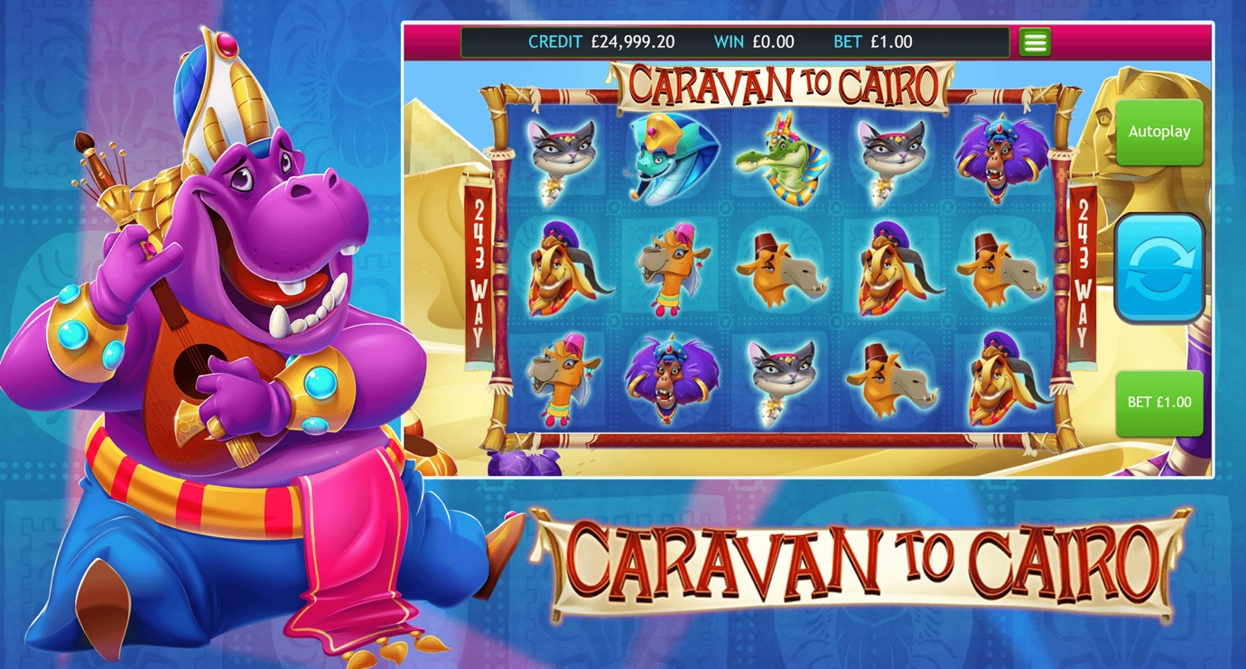

Short Description

Join our band of Merry Men, as they caravan to Cairo, side swayed by adventures along the way. It’s a journey of fun and excitement with treasures of prizes to discover. Jump on board the Caravan to Cairo and enjoy the high-speed 243-way slot where players can not only win big but can also choose the volatility of their free spins (a feature pioneered on Stampede which has become a true success story). The caravan is about to leave so mount your camel and let the adventure begin!

**Formats**

* Stand Alone
* Embedded
* Mobile

Game Properties & Features

|  |  |
| --- | --- |
| **Properties** | |
| Versions | Standalone, Mini, Mobile |
| RTP (%) | 95.2 |
| Number of Reels | 5 |
| Number of Lines | 243 |
| Min. Bet | 25 credits |
| Game Play | Hard |
| Volatility | High |
| Hit Rate playing 243 lines | 1 in 2.796 |
| Combined Feature Hit Rate | 1 in 141.03 |
| Default Bet | 100 credits |
| Supports Free Spins | Yes |
| Recommended Categories | * Action * Adventure * Egyptian Slots * Huge Wins |
| **Features** | |
| Free Spins | Up to 20 |
| Substitute | Pyramid Symbol |