Game Information for Native Casino App

Introduction
This document aims to capture game information and images for the Native Casino app. Please fill out all the yellow boxes.
This document is required for each game.

General information

Game name
What is the name of your game and the translation to Simplified Chinese? Include a trade mark if applicable.
English | Past the Post
Simplified Chinese | 《冲破终点》
Traditional Chinese | 《衝破終點》
Japanese | ポストを過ぎて
Korean | 패스트 더 포스트
Malay | Lepasi Pos
Spanish | Caballo Ganador

Game code
What is the game code?
pop_pastthepost_eye

Winning lines or ways (slot games only)
How many winning lines or ways does your game have?
253 Ways

Jackpot
Are jackpots supported in your game? If so, state the jackpot identifier.
Via another game code yes – but this game code is for the non jackpot version

Bet per lines
What is the default bet per line ranges? Please provide in different currencies if such information is available
GBP|EUR|USD [25, 50, 72, 100, 200, 500, 1000, 1500, 2000, 2500, 5000 ]

Game descriptions
Provide a description of your game in a few sentences for all the lobby languages:
Languages | Description
English (International) | Following our super successful games Stampede and Beat the Bobbies, we’re happy to bring you our latest 243-way slot game, which will fit perfectly into your Cheltenham, Grand National and other horse racing promotions.  “Past The Post” features beautiful imagery and a fast-paced action, giving you the ability to choose the volatility of your free spins. Who do you fancy? Choose your horse, jockey and the odds (volatility) and you could be first past the post on a race day and maximize your winnings!
Chinese Simplified | - 继《狂潮》和《鏖战英警》等游戏大获成功后，我们很高兴为大家送上最新的 243 条赔付线老虎机游戏。此游戏可完美融入英国切尔滕纳姆、全国越野障碍赛马和其他赛马推广活动。  《冲破终点》游戏画面精美，节奏明快，开放免费旋转波动率选项。你最看好谁？选择马匹、骑师和赔率（波动率），成为比赛当日第一个冲破终点的人，赢得最高奖金！
Chinese Traditional | - 繼《狂潮》和《鏖戰英警》等游戲大獲成功後，我們很高興爲大家推出最新的 243 條線老虎機游戲。此游戲完美融入英國切爾滕納姆、全國越野障礙賽馬和其他賽馬推廣活動。  「衝破終點」游戲畫面精美，節奏明快，開放免費旋轉波動率選項。你最看好誰？選擇馬匹、騎師和賠率（波動率），成爲比賽當日第一個衝破終點的人，贏得最高獎金！
Japanese | ボビー倒しに続いて、チェルトナム、グランドナショナル、その他の競馬プロモーションに完全に適合する最新の243ウェイスロットゲームをお届けします。「ポストを過ぎて」は、美しい画像と速いペースのアクションを特徴としており、フリースピンの揮発度を選択することができます。誰に憧れますか？馬、騎手、オッズ（揮発率）を選択すると、レース当日に最初にポストを通過して、賞金を最大化できます！
Korean | - 당사의 매우 성공적인 게임 스탬피드 및 바비를 이겨라에 이어, 첼튼햄, 그랜드 내셔널 및 기타 경마 프로모션에 완벽하게 맞는 최신 243 방법 슬롯 게임을 제공하게 되어 기쁩니다.  "패스트 더 포스트"는 아름다운 이미지와 빠르게 진행되는 액션을 특징으로 하며, 무료 스핀의 변동성을 선택할 수 있는 기능을 제공합니다. 누구를 좋아합니까? 말, 기수 및 확률(변동성)을 선택하면 레이스 당일 깃발을 먼저 지나고 상금을 최대화할 수 있습니다!
Malay | - Ikuti permainan super berjaya kami Rempuhan dan Tewaskan Bobbies, kami dengan gembiranya membawakan permainan slot 243 jalan terkini kami kepada anda, yang dapat disesuaikan dengan baik ke dalam Cheltenham, Grand National dan promosi lumba kuda lain.  “Lepasi Pos” mengetengahkan imejan indah dan aksi pantas, membolehkan anda untuk memilih kemeruapan putaran percuma anda. Siapakah yang anda gemarkan? Pilih kuda, joki dan nasib (kemeruapan) anda dan anda boleh menjadi orang yang pertama melepasi pos pada hari perlumbaan dan memaksimumkan kemenangan anda!
Spanish | - Después de nuestros exitosos juegos Stampede y Vence a los Bobbies, nos complace presentarles nuestra última tragaperras, una máquina con 243 vías de premio que encajará perfectamente con la temporada de carreras hípicas, tales como Cheltenham, el Grand National y otras.  "Caballo Ganador" ofrece hermosos gráficos y un ritmo trepidante, brindando la posibilidad de elegir la volatilidad de sus giros gratis. ¿Cuáles son sus preferidos? ¡Elija su caballo, jinete y cuotas (volatilidad), y podría cruzar la meta en primer lugar el día de la carrera, embolsándose excelentes ganancias!

Images
Note: the assets should be placed in the folders which have the following structure:
- icons with game names should be placed here: games\<game_code>\icons\icons_with_game_names\

Screenshots
The following screenshots are required on mobile in landscape. In case game is available in Portrait only, then screenshots in Portrait (461 x 819) should be provided.
Image type | Screenshot name | Dimensions | Format
Main game in English | screen_<game_code>_main | 819 x 461 | PNG
Significant win in English | screen_<game_code>_big_win | 819 x 461 | PNG
Bonus scene in English | screen_<game_code>_bonus | 819 x 461 | PNG

Game icons
The following game icons are required:
Image Name | Dimensions | Format | Where used in app | Screenshot
<game_code>_icon_5x5 | 240 x 240 | PNG | Quick Switch between games feature | 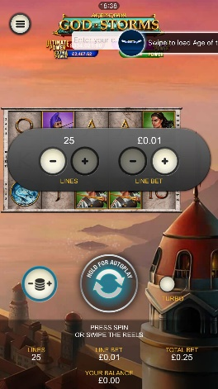
<game_code>_icon_10x10 | 540 x 540 | PNG | Main WL layout: game tiles icons in Lobby, on Game Advisor, Broken games etc. | 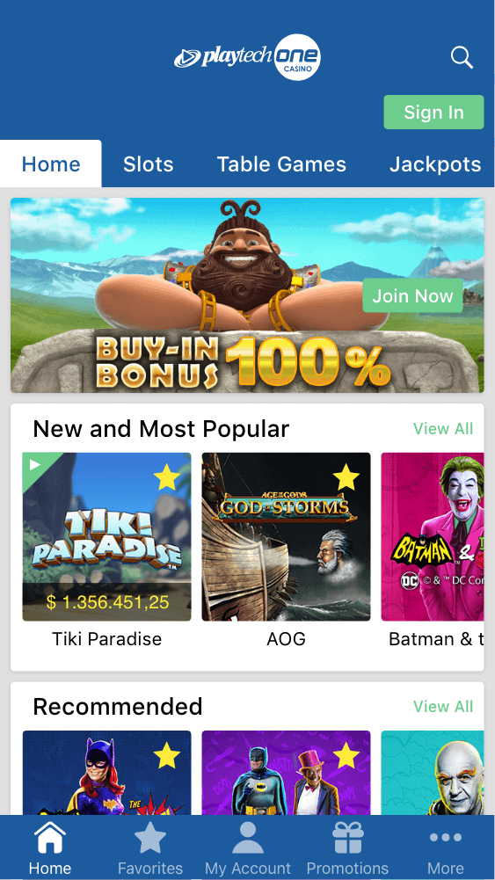  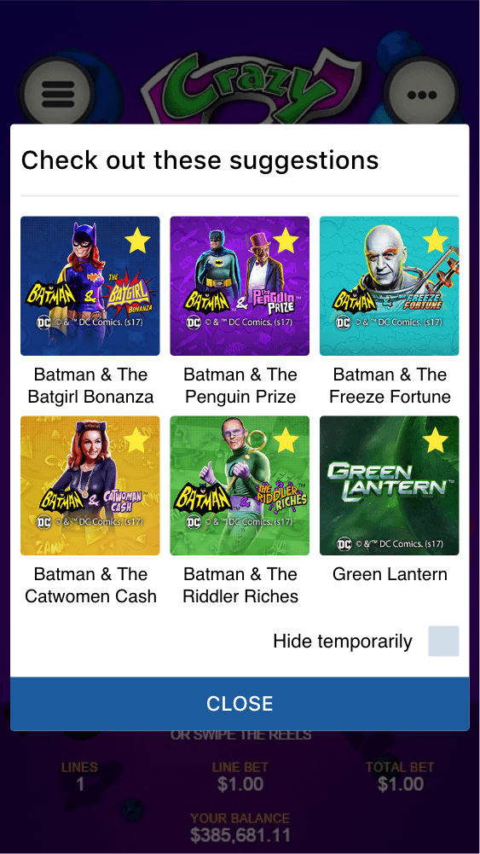
<game_code>_icon_30x5 | 1104 x 336 | PNG | Game Info screen header for tablets | 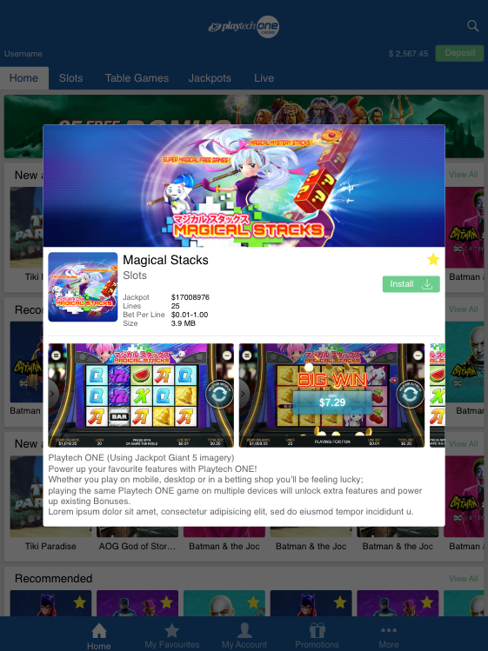
<game_code>_icon_30x10 | 1788 x 540 | PNG | My Favourites screen | 