Game Information for Native Casino App

Introduction
This document aims to capture game information and images for the Native Casino app. Please fill out all the yellow boxes.
This document is required for each game.

General information

Game name
What is the name of your game and the translation to Simplified Chinese? Include a trade mark if applicable.
English | Piggy Payout
Simplified Chinese | 小猪派彩
Traditional Chinese | 小豬派彩
Japanese | ピギーペイアウト
Korean | 피기 페이아웃
Malay | Pembayaran Piggy
Spanish | Pago Chanchito

Game code
What is the game code?
pop_piggypayout_eye

Winning lines or ways (slot games only)
How many winning lines or ways does your game have?
25 Line

Jackpot
Are jackpots supported in your game? If so, state the jackpot identifier.
Via another game code yes – but this game code is for the non jackpot version

Bet per lines
What is the default bet per line ranges? Please provide in different currencies if such information is available
GBP|EUR|USD [ 1, 2, 3, 4, 5, 6, 8, 10, 15, 20, 25, 30, 40, 50, 100, 200 ]

Game descriptions
Provide a description of your game in a few sentences for all the lobby languages:
Languages | Description
English (International) | Piggy Payout Slots is one of the most popular online slot games – spin today and find out why! You’ll be knee deep in bonuses, jackpots, FREE spins and more! The graphics are fun, colourful and cartoony, with reels filled with cute farm animals, sweet corn and sunflowers. Come on; it’s ok to get a little dirty – the wins are worth it!
Chinese Simplified | 《小猪派彩》是最受欢迎的在线老虎机游戏之一——立即旋转，一探究竟！让自己完全沉浸在赢取奖励、大奖、免费旋转机会和其他福利的乐趣当中！游戏卡通画面多彩有趣，卷轴上将出现各种可爱的农场动物、甜玉米和向日葵。速来游戏，稍稍弄脏衣服也无妨——因为丰厚彩金值得您这么做！
Chinese Traditional | 《小豬派彩》是最受歡迎的線上老虎機遊戲之一——立即體驗，一探此遊戲最受歡迎的原因！各種獎勵、大獎、免費旋轉玩法定會讓你應接不暇！風趣、可愛、顏色豐富的畫面，與充滿各種農場可愛動物、玉米和向日葵的捲軸圖案相得益彰。來吧；沾上一點點泥巴有什麼關係——畢竟有大獎在等著你呢！
Japanese | ピギーペイアウトスロットは、最も人気なオンラインスロットゲームの1つです。今すぐスピンしてその理由を知ってください！ボーナスやジャックポット、フリースピンで膝まで埋まってしまうことでしょう！グラフィックも楽しく、カラフルで、アニメチックです。リールはかわいい農場動物やトウモロコシ、ひまわりで溢れています。何をしてるんですか？少しくらい汚れても大丈夫です。勝つ方が大事です！
Korean | 피기 페이아웃 슬롯은 가장 인기있는 온라인 슬롯 게임들 중 하나입니다. 오늘 스핀하여 그 이유를 알아보세요! 보너스, 잭팟, 무료 스핀 등에 열중할 수 있습니다! 그래픽들은 재미있고, 화려하며 만화적이고, 귀여운 농장 동물, 달콤한 옥수수 및 해바라기들로 가득 찬 릴들이 있습니다. 자; 조금 더러워도 괜찮습니다 – 승리는 그만한 가치가 있습니다!
Malay | Slot Piggy Payout ialah salah satu permainan slot dalam talian yang paling popular – putarkan hari ini dan ketahui sebabnya! Anda akan tenggelam dalam bonus, cepumas, putaran PERCUMA dan banyak lagi! Grafiknya menyeronokkan, berwarna-warni dan penuh kartun dengan gelendong yang penuh dengan haiwan ladang yang comel, jagung manis dan bunga matahari. Jom; tidak apa jika kotor sedikit – kemenanganya menjadikannya sangat berbaloi!
Spanish | Piggy Payout Slots es una de las tragaperras en línea más populares. ¡Pruébala y descubre por qué! ¡Pronto te verás empapado de botes, bonificaciones giros GRATIS y más! Los gráficos son muy divertidos y coloridos, de dibujos animados. Los rodillos rebosan de bonitos animales de granja, maíz y girasoles. Está bien ensuciarse un poco: ¡estos premios lo valen!

Images
Note: the assets should be placed in the folders which have the following structure:
- icons with game names should be placed here: games\<game_code>\icons\icons_with_game_names\

Screenshots
The following screenshots are required on mobile in landscape. In case game is available in Portrait only, then screenshots in Portrait (461 x 819) should be provided.
Image type | Screenshot name | Dimensions | Format
Main game in English | screen_<game_code>_main | 819 x 461 | PNG
Significant win in English | screen_<game_code>_big_win | 819 x 461 | PNG
Bonus scene in English | screen_<game_code>_bonus | 819 x 461 | PNG

Game icons
The following game icons are required:
Image Name | Dimensions | Format | Where used in app | Screenshot
<game_code>_icon_5x5 | 240 x 240 | PNG | Quick Switch between games feature | 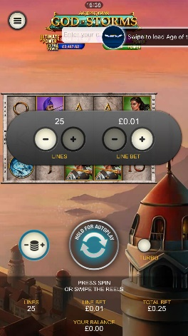
<game_code>_icon_10x10 | 540 x 540 | PNG | Main WL layout: game tiles icons in Lobby, on Game Advisor, Broken games etc. | 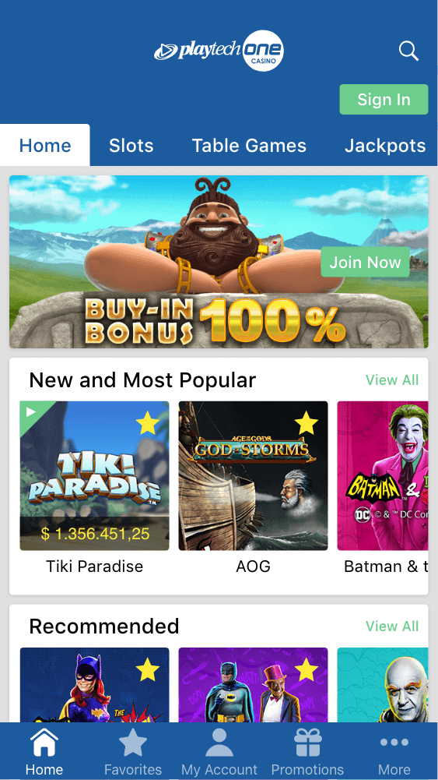  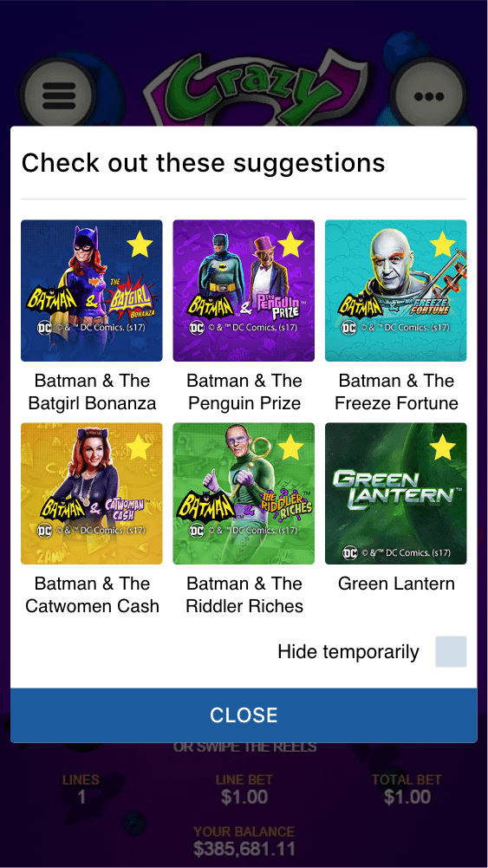
<game_code>_icon_30x5 | 1104 x 336 | PNG | Game Info screen header for tablets | 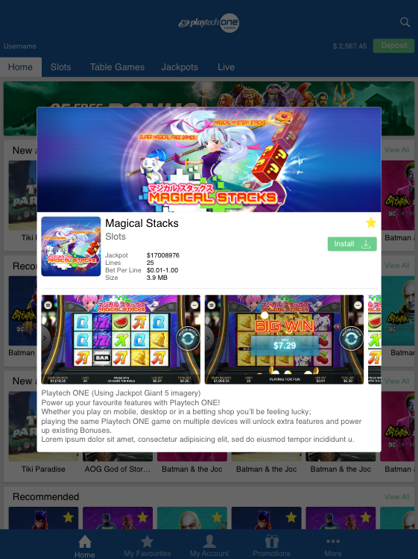
<game_code>_icon_30x10 | 1788 x 540 | PNG | My Favourites screen | 