PIGGY PAYOUT

Short Description

Piggy pays big with 25 Free Games and doubled prizes! Feel the excitement with multipliers up to 100X in the Prize Pick triggered by scattered Sheep! It’s payday on the farm with 25 lines of fun over 5 reels! Get you big piggy payout today!

Marketing Materials

The materials can be downloaded from [here](https://files.eyecon.com/index.php/s/d7vLlUGNyQNOtov)

Screenshots

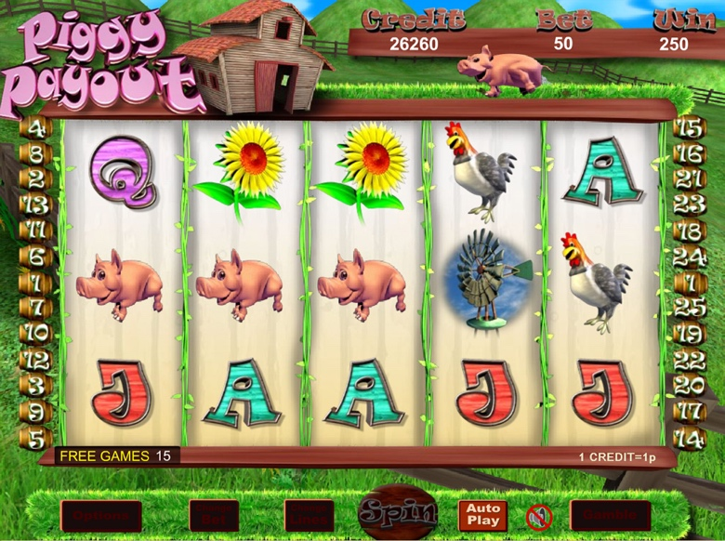

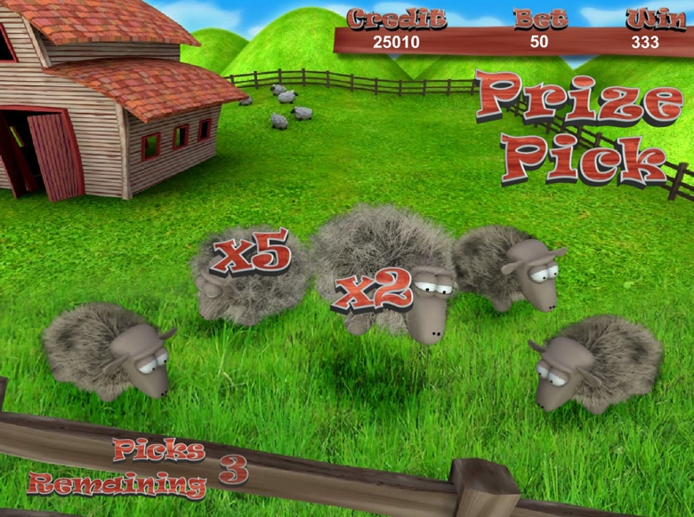

Game Properties & Features

|  |  |
| --- | --- |
| **Properties** | |
| Versions | Standalone, Mini, Mobile |
| RTP (%) | 95 |
| Number of Reels | 5 |
| Number of Lines | 25 |
| Min. Bet | 1 credit |
| Max Bet | 1,250 credits |
| Game Play | Medium |
| Volatility | Medium |
| Hit Rate playing 1 line | 1 in 8.5 |
| Combined Feature Hit Rate | 1 in 80 |
| Default Bet | 1 credit per line |
| Supports Free Spins | Yes |
| Recommended Categories | * Popular * Cute Animals * Progressive Jackpots |
| **Features** | |
| Free Spins | Up to 10 |
| Substitute | Prizes are doubled |
| Prize Pick Feature | Up to 100X the feature triggering bet |