PIRATE PRINCESS

Short Description

Ahoy Me Hearties! Blast your way through up to 9 fun Free Games! Battle other pirates to victory and search for buried treasure! Discover a wealth of fun and excitement with the Pirate Princess!

Marketing Materials

The materials can be downloaded from [here](https://files.eyecon.com/index.php/s/xnAEOFDQD77DESI)

Screenshots

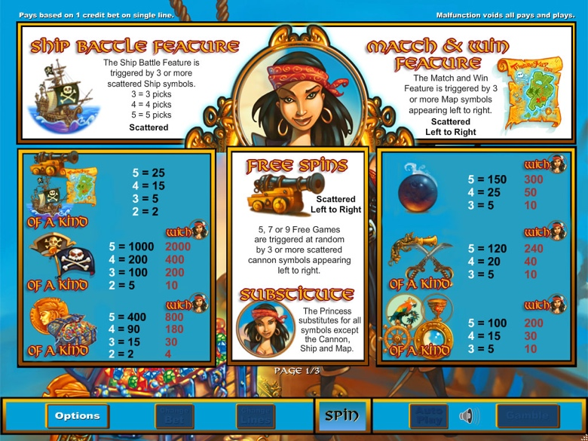

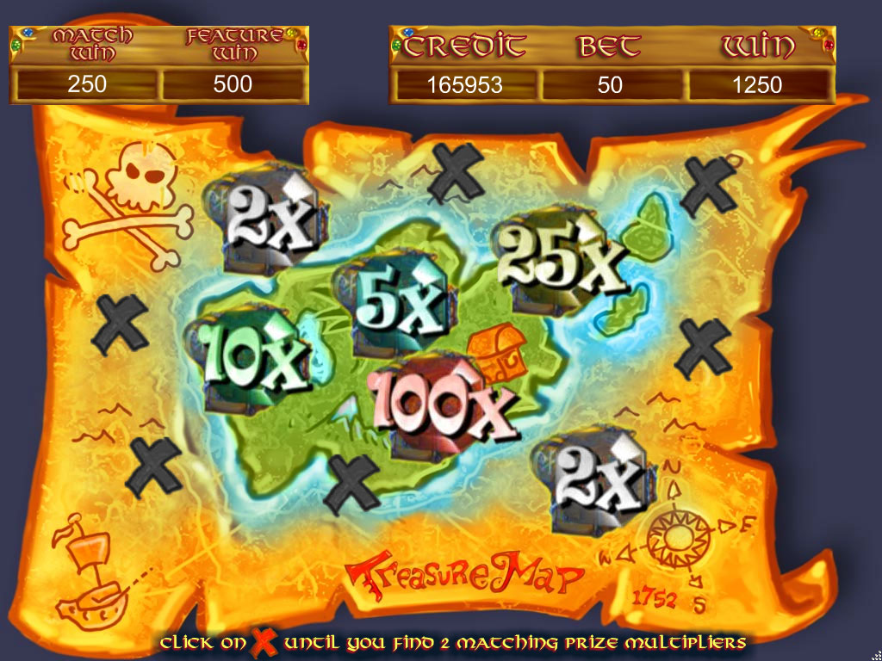

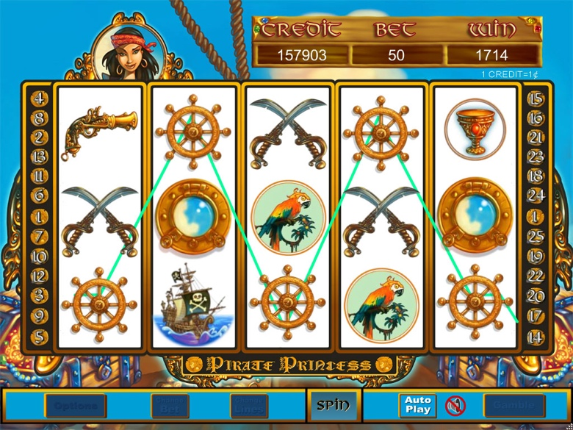

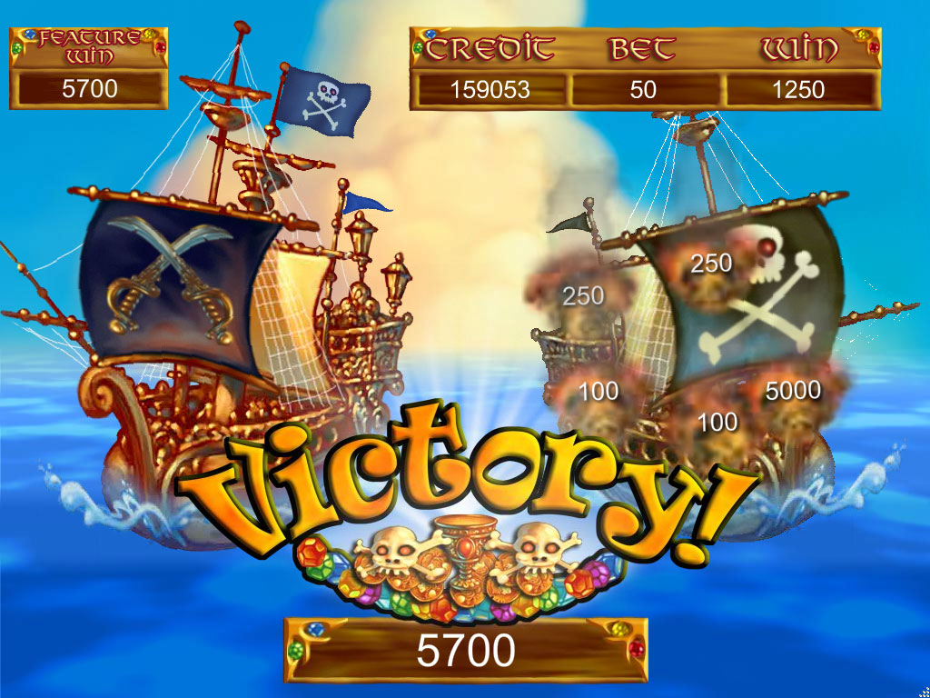

Game Properties & Features

|  |  |
| --- | --- |
| **Properties** | |
| Versions | Standalone |
| RTP (%) | 95 |
| Number of Reels | 5 |
| Number of Lines | 25 |
| Min. Bet | 1 credit |
| Max Bet | 1,250 credits |
| Game Play | Soft |
| Volatility | Low |
| Hit Rate playing 1 line | 1 in 8.6 |
| Combined Feature Hit Rate | 1 in 110 |
| Default Bet | 1 credit per line |
| Supports Free Spins | Yes |
| Recommended Categories | * Adventure |
| **Features** | |
| Free Spins | Up to 9 |
| Substitute | Pirate Princess Symbol |
| Prize Pick Feature | Ship Battle triggered by Ship Symbols |
| Match & Win Round | Triggered by 3 or more Map Symbols |