QUEST FOR THE GRAIL

Short Description

Meet your favourites from Camelot – Sir Lancelot, Merlin, King Arthur and Genevieve – on your epic Quest for the Grail! Draw Excalibur from the stone and double your prizes! Increase your wins by up to 5X with the Super Substitute during Free Games! Join the adventure and claim your royal riches!

Marketing Materials

The materials can be downloaded from [here](https://files.eyecon.com/index.php/s/3PGkS7g2k19DiVm)

Screenshots

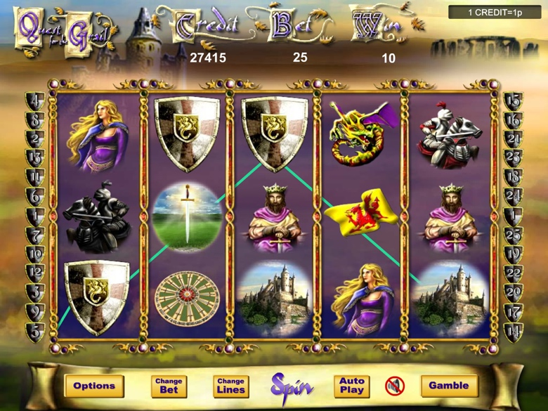

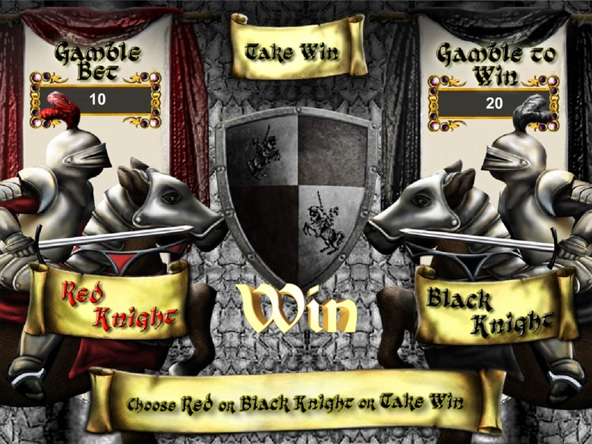

Game Properties & Features

|  |  |
| --- | --- |
| **Properties** | |
| Versions | Standalone |
| RTP (%) | 95 |
| Number of Reels | 5 |
| Number of Lines | 25 |
| Min. Bet | 1 credit |
| Max Bet | 1,250 credits |
| Game Play | Medium |
| Volatility | Medium |
| Hit Rate playing 1 line | 1 in 30 |
| Combined Feature Hit Rate | 1 in 116 |
| Default Bet | 2 credits/line playing 25 lines |
| Supports Free Spins | Yes |
| Recommended Categories | * Adventure * Action * Treasure |
| **Features** | |
| Free Spins | Up to 100 |
| Substitute | Excalibur Symbol |
| Super Substitute | Triggered by 3 or more scattered Grail Symbols |