Game Information for Native Casino App

Introduction
This document aims to capture game information and images for the Native Casino app. Please fill out all the yellow boxes.
This document is required for each game.

General information

Game name
What is the name of your game and the translation to Simplified Chinese? Include a trade mark if applicable.
English | Rebets Splendour
Simplified Chinese | 华丽重转
Traditional Chinese | 紙醉金迷
Japanese | リベットスプレンダー
Korean | 리벳 스플렌더
Malay | Kegemilangan Rebet (Rebets Splendour)
Spanish | El esplendor de Rebets (Rebets Splendor)

Game code
What is the game code?
pop_rbtssplndr_eye

Winning lines or ways (slot games only)
How many winning lines or ways does your game have?
25 lines

Jackpot
Are jackpots supported in your game? If so, state the jackpot identifier.
Via another game code yes – but this game code is for the non jackpot version

Bet per lines
What is the default bet per line ranges? Please provide in different currencies if such information is available
GBP|EUR|USD [ 1, 2, 3, 4, 5, 6, 8, 10, 15, 20, 25, 30, 40, 50, 100, 200 ]

Game descriptions
Provide a description of your game in a few sentences for all the lobby languages:
Languages | Description
English (International) | Rebets Splendour Slots is a one of a kind online slot game with an incredibly rewarding Re-spin Feature. If you’re unfamiliar, that means that every time you spin but don’t get a winning line, you can re-spin specific reels, giving you extra chances to win! So, dress to impress and play today! There are yachts, diamond rings and blocks of gold across the reels, in addition to the 2 main characters. Pour yourself a martini and get ready for the most lavish gaming experience online. Plus, you can play on your mobile anytime, anywhere, so you’ll never miss a win!
Chinese Simplified | 《华丽重转》老虎机游戏是 款在线老虎机游戏，其重新旋转功能可带来令人难以置信的奖励。如果您不熟悉，意思就是每次您旋转却没有出现任何一条奖励投注线时，您可以重新旋转特定滚轴，让您有额外机会赢得奖励！那么，现在就盛装打扮，尽情玩乐吧！除了两个主要特征外，还有可出现在卷轴上的游艇、钻戒和金块。给自己倒一杯马提尼，准备好享受最奢华的在线游戏体验。此外，您可以随时随地在移动端进行游戏，因此永远不会错过任何一场胜利！
Chinese Traditional | 《紙醉金迷》是一款獨一無二的線上老虎機遊戲，帶有獎勵豐厚的重新旋轉玩法。簡而言之，就是如果你的旋轉沒有湊成獲勝線組合，可以重新轉動特定的捲軸，為你帶來額外的獲勝機會！趕緊盛裝出席，大顯身手吧！捲軸上的圖案有遊艇、鑽戒和金磚，且遊戲中還有兩位主要人物角色。倒上一杯馬蒂尼酒，坐下來感受下最盛大奢華的在線遊戲體驗吧。另外，你還可以在行動設備上隨時隨地遊玩，抓住一切獲勝的機會！
Japanese | リベットスプレンダースロットは凄まじくやりがいのあるリスピンフィーチャーを搭載した唯一無二のオンラインスロットです。もしご存知ないのなら説明を。スピンしてウィンラインがなかった時、特定のリールだけをリスピンすることができます。つまりはウィンの可能性が上がるのです！正装して今すぐプレイしよう！ヨットにダイヤの指輪、金の延べ棒が、メインキャラクターの二人とともにリール上に広がっています。マティーニを入れたらオンラインで一番豪華なスロットを楽しもう。しかもモバイル端末でいつでもどこでもプレイ可能。チャンスを逃すことはありません！
Korean | 리벳 스플렌더 슬롯은 놀랍도록 보상하는 재스핀 기능이 있는 친절한 온라인 슬롯 게임 중 하나입니다. 스핀할 때마다 승리하는 라인을 얻지 못하는 것을 의미하는, 익숙하지 않은 경우, 특정 릴들을 재스핀시켜, 추가로 승리할 수 있는 기회들을 얻을 수 있습니다! 그래서, 인상적인 드레스를 입고 오늘 플레이하세요! 2 개의 주인공 외에도, 릴들에 요트, 다이아몬드 반지 및 금 블록들이 있습니다. 마티니를 따라 마시고 온라인에서 가장 호화로운 게임 경험을 준비하세요. 또한, 언제, 어디서나, 모바일에서 플레이할 수 있으므로 ,승리를 놓치지 않을 것입니다!
Malay | Slot Rebets Splendour ialah permainan slot dalam talian unik yang mempunyai Ciri Putar Semula yang sangat mengganjarkan. Jika anda tidak biasa dengan permainan ini, itu bermakna bahawa setiap kali anda memutar tetapi tidak mendapat baris menang, anda boleh memutarkan semula gelendong khusus, memberikan anda peluang tambahan untuk menang! Jadi, cepat bersiap untuk menarik perhatian dan main hari ini! Terdapat kapal layar, cincin berlian dan bongkah emas di seluruh gelendong, selain 2 watak utama. Tuang martini untuk anda dan bersedia untuk pengalaman permainan dalam talian yang paling mewah. Tambahan pula, anda boleh bermain pada mudah alih anda pada bila-bila masa, di mana0mana jua, jadi anda tidak akan pernah terlepas untuk menang!
Spanish | Rebets Splendor Slots es una tragaperras única en su clase, con una Función de Regiro increíblemente gratificante. Si esto no les familiar, significa que cada vez que gira sin obtener una línea ganadora, puede volver a girar rodillos específicos, lo cual brinda oportunidades adicionales de ganar. ¡Ponte tus mejores galas y empieza a jugar hoy! En los rodillos verás yates, anillos de diamantes y lingotes de oro, además de a los 2 personajes principales. Sírvete un martini y prepárate para la experiencia de juego en línea más lujosa. Además, puedes jugar en tu móvil en cualquier momento y en cualquier lugar, ¡para que nunca te pierdas un premio!

Images
Note: the assets should be placed in the folders which have the following structure:
- icons with game names should be placed here: games\<game_code>\icons\icons_with_game_names\

Screenshots
The following screenshots are required on mobile in landscape. In case game is available in Portrait only, then screenshots in Portrait (461 x 819) should be provided.
Image type | Screenshot name | Dimensions | Format
Main game in English | screen_<game_code>_main | 819 x 461 | PNG
Significant win in English | screen_<game_code>_big_win | 819 x 461 | PNG
Bonus scene in English | screen_<game_code>_bonus | 819 x 461 | PNG

Game icons
The following game icons are required:
Image Name | Dimensions | Format | Where used in app | Screenshot
<game_code>_icon_5x5 | 240 x 240 | PNG | Quick Switch between games feature | 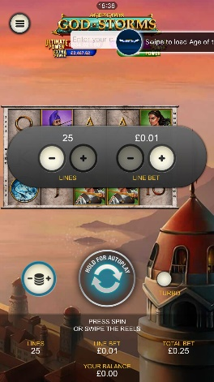
<game_code>_icon_10x10 | 540 x 540 | PNG | Main WL layout: game tiles icons in Lobby, on Game Advisor, Broken games etc. | 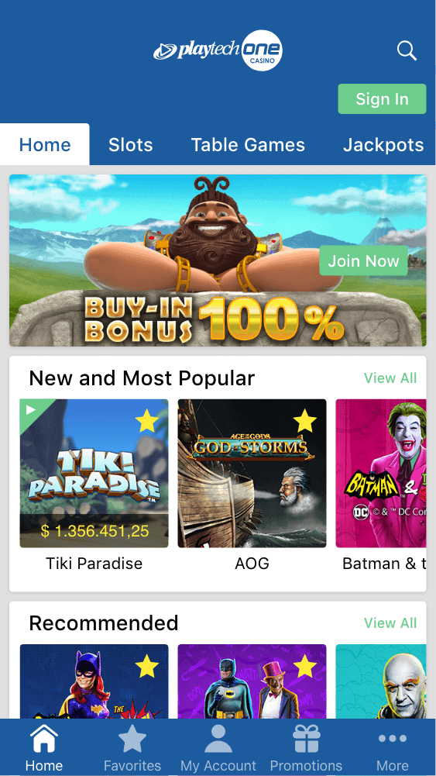  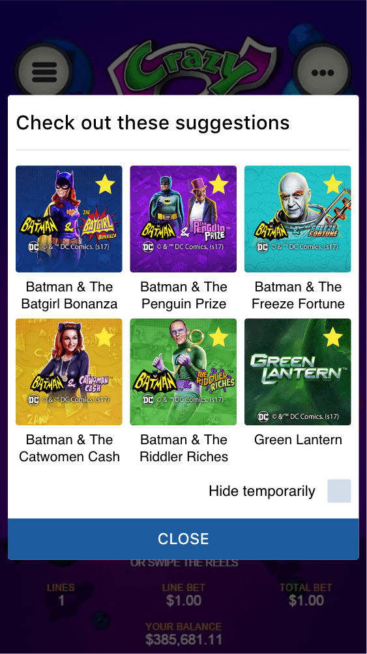
<game_code>_icon_30x5 | 1104 x 336 | PNG | Game Info screen header for tablets | 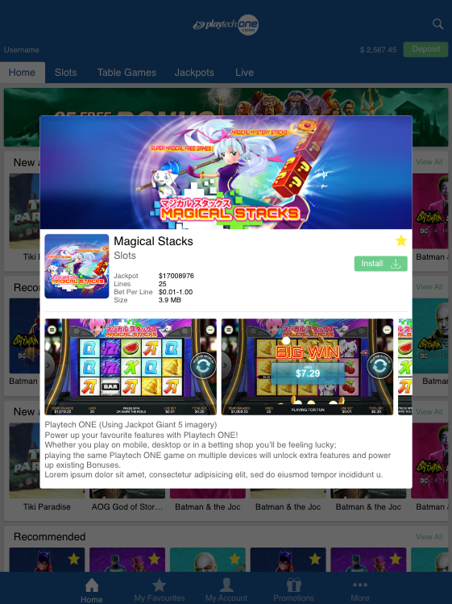
<game_code>_icon_30x10 | 1788 x 540 | PNG | My Favourites screen | 